Financial capability- where we are now and
is Open Banking a game changer?
Report of OU Workshop held on 21 July 2017
_______
The workshop was organised as part of the Open University IKD (Innovation, Knowledge and Development) research centre series: Evidence-Informed Policy and Practice. The series brings together academics and practitioners to exchange knowledge and explore solutions concerning issues of the day. This workshop concerned the introduction of Open Banking from 13 January 2018 and what implications this might have for our understanding, initiatives and evaluation of financial capability.
Two workshopping sessions were preceded by stimulus presentations from: Dr Pushpa Wood, Massey University; David Haigh, Money Advice Service; Will Brambley, Open University; Dr Caroline Marchant, University of Edinburgh Business School; Jonquil Lowe, Open University; Jon Hart, Moneyhub; and Richard Syers, Information Commissioners Office. Presentation slides are available on the IKD website.
In addition to the presenters, workshop participants were: Hor Chan, Open University; Teresa Fritz, Financial Services Consumer Panel; Nick Hill, Money Advice Service; Ariane Hillig, Open University; Frank Hobson, The Money Charity; Nick Lee, Harmoney; Christy McAleese, Citizens Advice; Abigail Montrose, Royal London Group; Jonathan Puttick, Association of British Insurers; Thomas Ridley-Siegert, Fairer Finance; Professor Janette Rutterford, Open University; Alan Shipman, Open University; Hedley Stone, Open University; Mel Tynan, Royal London Group; and Martin Upton, Open University.

Summary
There is consensus that financial capability goes beyond knowledge and skills, or even attitudes, and should be measured in terms of behaviours and outcomes. Evidence so far is scant but it seems that the impact of financial education is positive, albeit small, and cumulative. The Money Advice Service What Works Fund aims to build the evidence base around the sort of interventions that are most effective. Trials with an appropriate control group, especially randomised controlled trials, are likely to offer the best evidence of whether interventions work, while qualitative evidence can tell us how and why they do.
Digital innovation is already bringing consumers new ways to keep track of and manage their money but take-up so far is relatively niche. Open Banking, which goes live in January 2018, is a package of technical and regulatory changes that should make it easy and secure to share bank information with third parties and enable third parties to initiate payments direct from your bank. It has the potential to accelerate the availability and use of apps that, for example, aid debt avoidance, automate saving, shop around for personal product matches and even automate regular switching. These can be viewed as time-saving and (mentally) labour-saving devices that could make some current financially capable behaviours redundant. On the other hand, consumers may require greater savvy-ness about the value and safeguarding of their data. There are questions too about how consumers - and even regulators – can evaluate and compare these services and apps, given a lack of transparency in their algorithms and business models. For now, in this OU Workshop, the jury is out on whether Open Banking is a game changer, but it calls for more capable use of comparison websites, greater clarity on intermediaries’ hidden fees and a clearer interface between regulators once Open Banking starts.

Session 1: Where are we now with financial capability?
A couple of presenters offered this widely accepted definition of financial capability (generally attributed to the Center for Financial Inclusion) as a starting point:
‘Financial capability is the combination of attitude, knowledge, skills, and self-efficacy needed to make and exercise money management decisions that best fit the circumstances of one’s life.’
Will (OU) stressed that the focus is on behaviours and outcomes – simply acquiring knowledge or even feeling inclined towards capability is not enough. However, both Pushpa (Massey U) and David (MAS) pointed out that different stakeholders may gauge success in different ways, for example, financial firms running corporate social responsibility programmes may be satisfied with wide reach rather than focusing on long-term behavioural impact.
David (MAS) pointed to the huge rise in initiatives aimed at improving financial capability but scant evidence on what works. There have been a couple of meta-analyses (combining evidence from multiple studies) and the most recent from Germany suggests that the impact of financial education on behaviour is positive but small but what matters is the overall cumulative effect – this is pretty much in line with the impact of teaching other school subjects such as maths and science. The Money Advice Service What Works Fund aims to build an evidence base regarding the most effective types of initiatives and share its findings widely. The What Works Fund is supporting a diverse range of projects across the UK, as shown in Figure 1 overleaf. Working with service delivery organisations multiplies the impact of the Fund because finding an approach works may transform delivery across the whole organisation. Unclear whether financial firms and other organisations would follow suit.
Will (OU) offered insights on how to build robust evaluation programmes. There is a spectrum of techniques. The weakest is simply to survey participants after the event on how useful they found it, which is unreliable and tends to overestimate impact. The gold standard is randomised control trials (RCTs) where the key element is splitting participants into two as-far-as-possible identical groups, one of which is subjected to an initiative, the other not. Data are gathered from each participant before and after the event, with objective data, such as customer data from financial firms being much more robust than survey data. If a survey is used, the same questions should be asked before and after and those questions should not refer to the intervention. RCTs can provide robust, quantitative data on what works. Will also referred to the usefulness of supplementing quantitative data with qualitative research which can answer questions on why and how something works.
Caroline (Edinburgh) provided an example of such qualitative work with young adults – the generation that has missed out on financial education in schools. Their main sources were family and the internet; their learning was incidental and experiential. Their time horizons were short, focused on managing money day-to-day. This chimed with experience from New Zealand – so maybe young people are the same the world over!

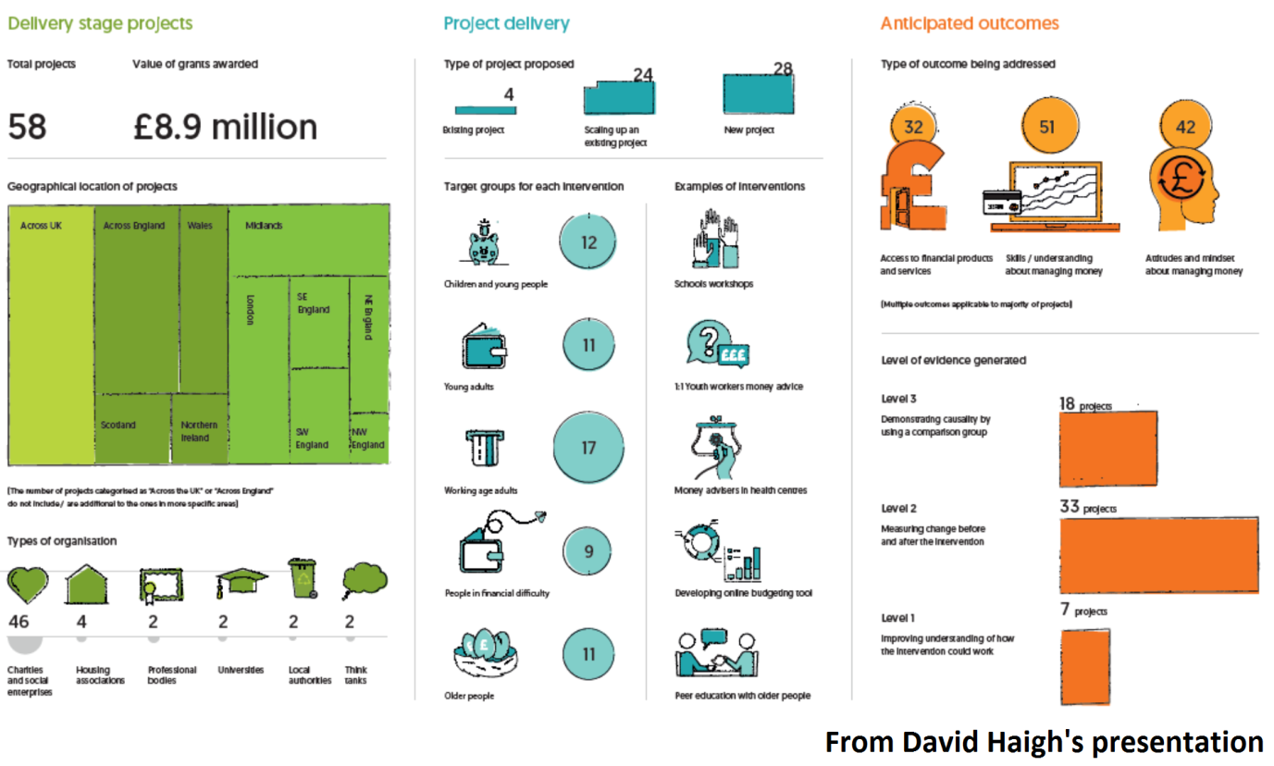
Figure 1: Projects being supported by the Money Advice Service What Works Fund

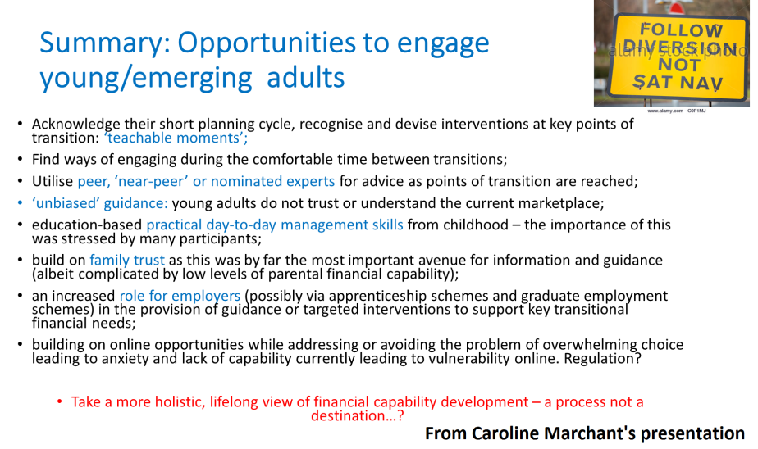
Figure 2: Possible opportunities to develop young adults’ financial capability

Several presenters, including Caroline, emphasised the importance of ‘teachable moments’, in other words delivering financial education at points in life when it is most relevant, such as the transition from school to university or reaching retirement. Pushpa (Massey U) described how in New Zealand the Ministry of Social Development’s Youth and Young Parent Paymant system works. Young people not-in-education-employment-or-training (NEETs) need to complete a budgeting course (called Money Smarts) and are not able to gain full control of their benefit/payment unless they have completed the course to show that they are capable of managing their own finances – an interesting example of creating ‘teachable moments’. Pushpa’s centre is working with one of the Youth Service providers to measure the change in young people’s way of managing money 12 months after attending the Money Smarts course.
Pushpa and Will both emphasised the importance of creating positive engagement with finance to foster a ‘want to do this’ attitude. Will suggested content should contain nudges to change behaviour. Pushpa described how her initiatives are conversations rather than formal learning that start with the individual’s own ‘dream-board’ of goals to be tested for feasibility with a ‘money sieve’ as the conversation develops. Two particular initiatives in New Zealand that harness the power of this individualised, conversational approach are:
- MoneyMates A new peer-led support arrangement that is based around the concept of sharing and learning together as a group. This type of approach has proven successful in both large and small communities (as seen with programmes such as Weight Watchers). Facilitators encourage clients to learn from others and gain control over their financial lives to make longer term behavioural changes.
- Financial mentors A scheme that has reframed budget advisors as financial mentors to take into account the complexity of people's needs and to recognise the fact that many advisors provided more than budget advice alone.Financial mentors focus on empowering people and making connections with a range of social services to ensure people get the right support.

Workshopping Session 1
Overview: A dominant theme was that the complexity of retail financial markets and incentives for firms and intermediaries worked against consumers being able to develop sufficient financial capability to achieve good outcomes. There is a tension between affordable mass market solutions (typically digital) and the one-to-one, face-to-face guidance and mentoring that was seen as the ideal.
Relevance of financial education: Is there a tension with financial education in schools between focusing on ‘teachable moments’ (which may be scarce at primary level especially) and building a cumulative effect? Use of pocket money may provide timely and relevant teachable moments – MAS research shows most children (98%) have some money of their own. Early teaching may usefully focus of gaining a sense of self and control rather than financial matters. Greatest impact of financial education thought to be 16-plus when young people start to manage finance. Citizens Advice find focus on specific events is more effective – e.g. change of relationship status, employment status, having a child, i.e. life events are the drivers for changing financial perspective.
Access to financial education/capability: Gold standard might be through services that people connect with through life events, since these are already trusted intermediaries. However, this may overload the intermediary’s role and there may be a conflict between the financial actions suggested and the mainstream help. Signposting and referrals to expert organisation might be more effective – though at each hand-over some people drop out. People learn from each other – in New Zealand, there is a system of ‘money mates’ (mentors) for 12 months. People in the role of financial capability trainers or facilitators need practical experience.
Mode of delivery: Citizens Advice finds one-to-one face-to-face guidance and tailored support through structured conversations are the ideal. This could be preceded by some form of quick check to identify the appropriate routing. One-to-one phone advice can also work, but harder to show empathy. But these are costly modes of delivery – can mass-market algorithms work equally well?
Evaluation: Difficult for advice services to follow up clients, especially longitudinally. Need is to change behaviour over the long-term and provide ability to cope with changing circumstances, so interventions are needed over a long time period and therefore evidence also needs to relate to the long term. Could the MAS What Works Fund £8.9 million generate greater benefits if spent another way?
Intermediaries and advisers: Comparison sites are inadequate because not whole of market. Plenty of apps available but too complicated and people find it hard to assemble and input their data. ‘Independent’ advice still not impartial and still product-driven.
Wider context: Financial capability should enable people to make decisions when faced with choices, but should not absolve suppliers of responsibility. In general, firms do not educate their clients – not in their interest to because of competition issues? Impossible to reach large numbers of clients? In fact, it may be in firms’ interests to make products excessively complex, which undermines consumers’ confidence in shopping around and trust in providers (for more on this, see a recent Financial Services Consumer Panel paper). Low-income households are often charged more and firms may even not want to serve them because they are low-profit.
Other barriers: People are generally good at budgeting and short-term saving, not at planning for the long-term or building financial resilience (even if they can afford to). May be little to demonstrate to consumers that such savings are worthwhile or that there are genuinely safe places to protect and grow savings.
Some things that need to change
- Develop overall value-for-money measures for products.
- More needs to be done to disclose hidden fees for intermediaries.

Session 2: Does our understanding of financial capability need to change?
Jonquil (OU) explained that Open Banking is a new, more secure way to share banking data with third parties that is due to launch on 13 January 2018, the date from which the Second Payments Services Directive (PSD2) becomes law. Data are already shared in two main ways:
- midata. A government initiative to make shopping around for bank accounts and utilities more efficient, where the best choice depends partly on pattern of usage. Usage data can be downloaded to the consumer’s own device as a CSV file and then uploaded to a comparison website. Disadvantages: labour intensive, takes a static snapshot that has to be repeated if usage changes; data are stored on the consumer’s computer - typically the least secure link in a data chain.
- Screen-scraping. This is used by account aggregators. The consumer passes account log-in details to the aggregator which logs into each account as if they were the customer, exporting data to the aggregator service where it can be displayed and analysed. Disadvantages: with early and some continuing services, log-in details are passed to the aggregator which may breach the account terms and conditions and expose the customer to liability - many aggregators have addressed this problem with downloadable software so log-in details remain on the consumer’s own device; aggregator has access to more data than necessary for their service, opening up e.g. product cross-selling; changes to the underlying accounts’ data arrangement or security lead to errors in the scraping and display process.
Open Banking enables data sharing to happen in a formalised and dynamic way that aims to be easy to use and secure. There is no sharing of log-in details, no clunky downloading and uploading CSV files, and sharing can be restricted to specified types of data only. The bank exchanges account information with third parties directly without any human intervention, using APIs (Application Programming Interfaces). APIs can be thought of as pipelines along which three types of data flow:
- Personal transaction data can be transferred to a third party, such as an aggregator, comparison website or debt adviser.
- Aggregated anonymised transaction data and provider quality metrics can be transferred, for example, to comparison sites.
- Third parties can initiate payments from a customers’ account, creating a new way to pay that no longer needs intermediate steps such as PayPal or credit and debit cards.
The Competition and Markets Authority requires banks to implement Open Banking by 13 January 2018. PSD2 is ‘catch-up’ European legislation that addresses security and consumer protection, for example, requiring account aggregators and similar providers to be authorised by the FCA. Also a new General Data Protection Regulation (GDPR) takes effect from 25 May 2018. But consumer groups have a number of concerns as listed in Figure 3.

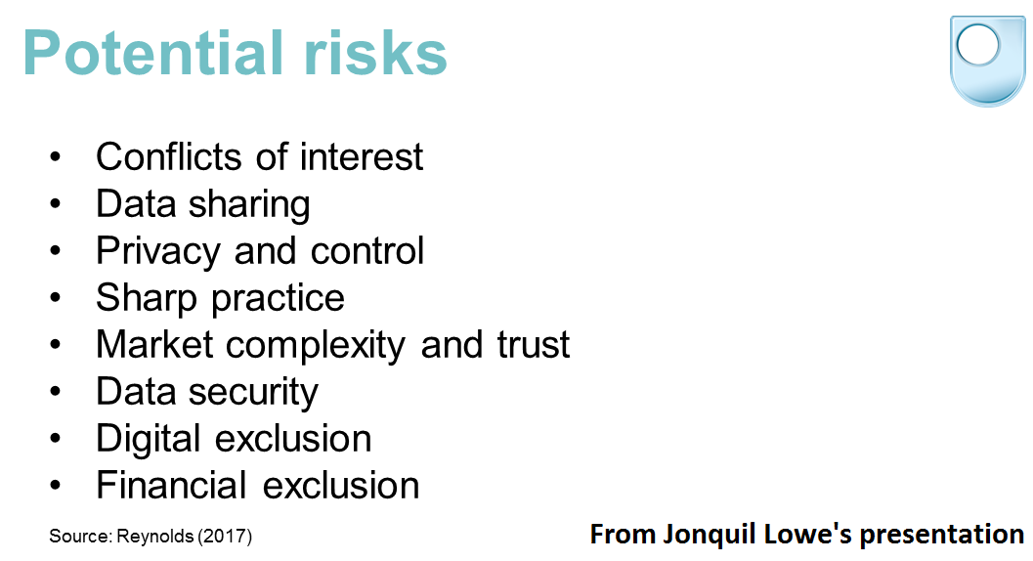
Figure 3: Consumer concerns about Open Banking (sourced from Reynolds, 2017)

Jonquil suggested that it may be only a matter of time before many of the skills that we currently think are essential parts of financial capability, such as money management and shopping around are routinely replaced by labour-saving and cognitive-saving apps. But consumers may have new needs to be more aware of the value of their data, how to exploit the data to their advantage and how to protect their data. She asked: is it time to rethink our concepts of financial capability and lead an evolution in the knowledge and skills we try to foster in consumers?
Moneyhub, an account aggregator founded in 2013, has been heavily involved in the Open Banking and PSD2 consultations (and also the development of the Pensions Dashboard, which aims to introduce similar API-enabled aggregation of individuals’ pension data). Starting with the definition of financial capability (as above), Jon (Moneyhub) suggested that capability requires self-belief that a person can change their behaviours and control their finances. A holistic view of one’s finances is needed, which in the past has meant, keeping receipts, locating multiple statements, entering them into a spreadsheet, shopping around…in fact, a process that requires a lot of time and effort, with potentially fearful outcomes, that works against belief that the consumer can change. Moneyhub replaces that with a process that is easy to use. It not only collates financial information in one place, but provides timely notifications to prompt action, and uses machine-learning algorithms to recognize and categorise transactions and learn the user’s preferences.
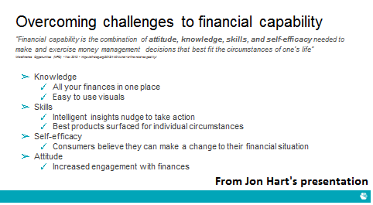
Figure 4: How aggregator services can improve financial capability
Prior to Open Banking, Moneyhub relies on screenscraping. This requires consumers to pass their log in details to the aggregator and Moneyhub sees a big drop off in potential customers at the point where these details are requested. Once Open Banking is introduced, Moneyhub will be authorised; customers will give consent to Moneyhub accessing their data and can revoke this access at any time. Under Open Banking, the log-in details are no longer shared with the aggregator and this removes the need to update the aggregator if the consumer changes the log-in details for their underling accounts.
Moneyhub already aids financial capability. For example, it is able to: predict up to five days in advance where the user’s finances are heading and recommend transfer or spending changes; analyse spending by categories and, in some cases, on specific items (such as energy) and suggest switching to more suitable products and services; recommend cheaper modes of spending; connect to mortgage lenders and trigger searches for better products; and plug in to other services, such as robo-advice. Open Banking will take such services to the next level. Since Open Banking is not just about sharing account information but also payment initiation, there is scope to create end-to-end customer journeys, going beyond nudges to frictionless outcomes. For example: more complex algorithms can surface new insights into spending; a sweeper service can scoop up and transfer spare cash, making saving little and often; transfer recommendations can go further and become seamless switches. Jon suggested that these services do not replace the need for financial skills, but supplement them.
The Moneyhub business model is currently business-to-business not direct-to-consumer, enabling Moneyhub to take advantage of existing customer relationships. So Moneyhub is available, for example, to the clients of financial advisers who sign up and is moving into the employer space with the Moneyhub service becoming an employee benefit (recognising that there is an advantage for employers in employees being financially unstressed since this reduces absenteeism).
Richard (ICO) completed the Open Banking jigsaw by explaining the impact of the GDPR. This is an evolution, rather than revolution, from the existing Data Protection Act 1998 regime. Both are principles-based, but the key differences the GDPR makes are: emphasis on control and rights for ‘data subjects’, clarifed definition of personal data, higher standard of consent, greater transparency and accountability shifting the burden of proof to data controllers to demonstrate compliance, obligations on data processors not just data controllers as now, and substantially increased upper limits on fines for breaches, which can be turnover-related. Under both regimes, financial data from which (either alone or in combination with other information) a person can be identified are likely to be ‘personal data’ but not usually ‘sensitive’ personal data in themselves (i.e. about racial or ethic origin, political opinions, religious beliefs, trade union membership, health, sexual life, offences). However, financial data could be sensitive if they related to, say, payment of trade union subscriptions.
Richard described how Open Banking has potential benefits, giving individuals increased power to access, transfer and benefit from their own data, greater control over that data and consequent innovative products and services. For example, consent to use data must be informed and granular (i.e. requiring separate consent for each type of data). However, there are risks too, as summarised in Figure 5. Richard emphasised that it will be important to get the balance right, with service providers building in privacy by design and giving clear information to individuals, and to raise public awareness of Open Banking. Financial capability could not be considered in isolation – understanding privacy rights is an inherent part of it. A potential area for confusion could be which regulator to turn to if things go wrong: the FCA or ICO.
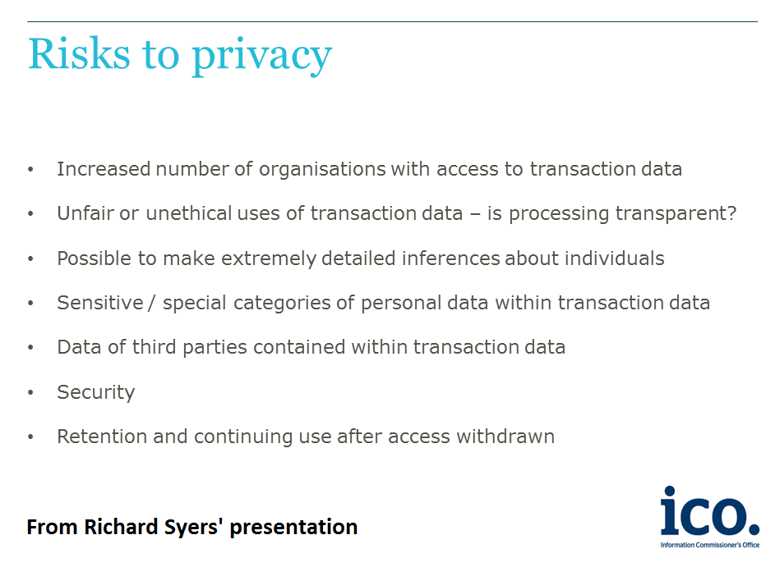
Figure 5: Potential data risk from Open Banking

Workshopping Session 2
Overview: Unclear whether Open Banking will be a mass-market phenomenon. If so, many of the current concerns about complexity and conflicts of interest in financial services markets may simply shift to the (digital app) intermediary market. Concern over financial exclusion is linked to digital exclusion. Greater clarity required over how data risks and regulation will be managed.
Possible changes: Could lead to personalised financial services. On the other hand, some scepticism about the value of Open-Banking services – just an advanced price comparison service? Younger people especially will develop relationship with app providers rather than banks and insurers – happening already.
Impact on financial capability: Might digital apps make people more passive, removing the need to learn to be financially capable? Or do they just provide more/simpler information with consumers still having to decide? Analysis by new apps won’t necessarily prompt cutting unnecessary spending or increasing saving – could redirect spending or highlight new ways to spend. What language should be used with consumers – ‘Open Banking’ might be off-putting?
Evaluation: Currently, there is a moral dimension to financial capability (good to be in control, good to save) – if people opt for automation, is that still a demonstration of financial capability? (Some comparison with automatic enrolment, where many opt for the default without engaging.) If end-to-end journeys became the norm, how do you demonstrate outcomes of financial capability and whether interventions are successful? But choosing e.g. automated savings still requires capability to decide that.
Shifting the competition problem: Does the problem of shopping for complex financial products simply get replaced by shopping for intermediaries (aggregators, comparison sites etc)? Will their business models be just as confusing – e.g. hidden prices, ostensibly ‘free’ services paid for with data or commission leading to conflicts of interest (as with comparison sites now)?
Who will use Open Banking? Only already engaged people? Does this mean there will need to be two-tier financial capability training, for those who use Open banking and those who don’t? Apps can create improved access to financial services for some groups – e.g. voice activation helps people with impaired vision.
Financial/digital exclusion: Those without smartphones, mobile internet access and electronic transaction records will be left out. This digital divide may especially affect older customers and households on a low income. People who do not use social media and loyalty cards may be excluded from Big Data analyses and tailored products that could potentially be useful for them. Open Banking may accelerate demise of cash even for those who would prefer cash management. Will app firms shun e.g. low income households as not profitable? Might households self-exclude if they think Open Banking is only for people with assets?
Guidance-advice perimeter: Algorithms will offer information and what look like recommendations, but these will not count as regulated advice. What happens if people feel they have been misled or mis-sold?
Safety: PSD2 and GDPR will make it safer to access Open Banking and to submit data to new third party apps, but safety concerns about what is done with data after that. Who will be liable if things go wrong e.g. if data are stolen? Appears to be massive scope for data loss and hacking and intrusive target marketing. These are not new problems – they already exist, but may become larger scale if Open Banking takes off.
Some things that need to change
- Financial capability needs to teach people how to use comparison sites – competition is more than just price, product and service quality too.
- FCA needs to use its powers under PSD2 to regulate areas concerning liability where data are lost and misleading ‘advice’ from third-party services.
- The interface between the regulators (FCA and ICO) needs to be worked out.

This report has been prepared by Jonquil Lowe with the help of the Workshop participants and, in particular, our scribes on the day: Alan, Ariane and Hor. The Open University would like to thank everyone who took part and especially our distinguished presenters.

