Title of paper (Poppins bold 30pt)

Author 1 name, author 1 email address
Author 2 name, author 2 email address
Add additional authors and email addresses. (Poppins 12pt)

Abstract (Poppins bold 20pt)

The abstract should give a brief overview of the paper including results, giving enough information so that a reader can conclude whether the paper is relevant and worth investigating further. It should be written as a single paragraph of 100-200 words. Do not put equations, diagrams, or references in the abstract. (Poppins 12pt)

Keywords: List up to 5 key words that are directly relevant to the content within your paper, punctuated with commas and a full stop. (Poppins 12pt)

Introduction and Literature Review (Poppins bold 20pt)

This should introduce your project and the issues connected with it, saying why they are important. Describe the context briefly for an external audience, remember not to use any OU speak. Highlight a few key pieces of externally published research and how they relate to your project. This should be approximately 300-600 words. (Poppins 12pt)

Main body of paper (Further Sections) (Poppins bold 20pt)

The section headings will depend upon your individual project, but may include, Methods, Findings and Interpretation, or Description of activity and results. Titles of the sections can be more descriptive based on your scholarship.
Total number of students and average number of students at tutorials run at different times of the week 2019/20 (Poppins 12pt Bold)
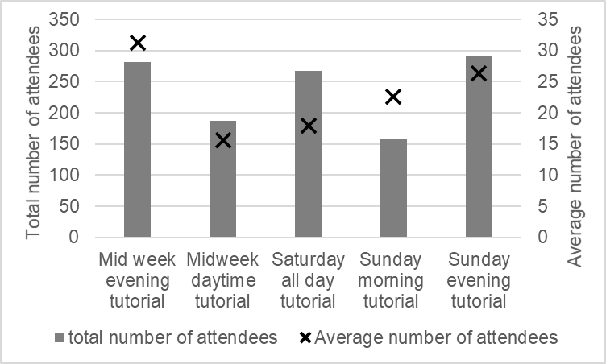
Figure 3: Total and average attendees of tutorials run at different times throughout the week 2019/20
A list or set of bullet points may be formatted as:
- Bullet point one
- Bullet point two
- Bullet point three
Then text continues here. The “further sections” should total approximately 800-1400 words. (Poppins 12pt)

Conclusions and Discussion (Poppins bold 20pt)

This section should include a summary of your paper, with links to any relevant literature mentioned earlier that backs up your conclusions. It should also suggest areas for further discussion or work. It should be approximately 300-600 words. (Poppins 12pt)

Acknowledgements (Poppins bold 20pt)

This section should include any person or entity you wish to thank who has helped with your scholarship but is not listed as an author. If you have received funding from anybody it should be noted here. If it is eSTEeM funded, an appropriate acknowledgement could be “Project supported and funded by eSTEeM – The OU Centre for Scholarship and Innovation in Science, Technology, Engineering and Maths. Project Reference XXXX-XXXX-XXXX.” Contact esteem@open.ac.uk if you do not know your project reference number.

References (Poppins bold 20pt)

Olney, T., Rienties, B., Chang, D. and Banks, D., 2023. The Learning Design & Course Creation Workshop: Impact of a Professional Development Model for Training Designers and Creators of Online and Distance Learning. Technology, Knowledge and Learning. DOI: https://doi.org/10.1007/s10758-022-09639-1
Pawley, S. and Neate, A., 2024. The new normal: What does maths and stats support and teaching look like post pandemic?. MSOR Connections, 22(1) pp. 69–75.

