User Guide to Elicitation Programme for Multinomial Sampling Models with Gaussian Copula Priors (PEGS-Copula Software)

7 April 2015

Introduction

A multinomial model is appropriate when an observation may fall in exactly one of a number of different categories. For example, if interest focuses on the way that people travel to work then the categories might be: train, bus, car, cycle, walk, other, and an observation would be a person’s most common method of travelling to work. The proportion of people in each category would be the quantities of interest. Note that these proportions should add to 1 (or add to 100% if expressed as percentages).

The purpose of this elicitation program is to quantify an expert’s opinion about these proportions. Opinion will be quantified as a probability distribution that satisfies the laws of probability. This probability distribution will take the form of a Gaussian copula prior distribution. This gives a more flexible representation of an expert’s opinion than the standard Dirichet distribution. The expert’s opinion about one category may relate to their opinion about other categories and the copula prior can capture this dependence through a covariance structure.

Preparation before using the elicitation program

The primary purpose of the elicitation programme is to form of a Dirichlet or Gaussian copula prior distribution that adequately reflects your opinions about the multinomial probabilities. Before using the program you need to know:
- The number of categories in the multinomial model.
- The name of each category.
It is generally best if you choose the most common category (or one of the most common categories) as the first category. Hence, you should also consider which category you would expect to contain most observations.

Important. Often a prior distribution is to be combined with data. Make sure the model you specify for the prior distribution is consistent with the data you will be using. For example, the number, the order and the names of the categories in the elicitation must be the same as the categories the data uses.

Using the programme

All screens contain a help button. This gives guidance for what you should do. The contents of all the help information is reproduced below, though it is probably better to read this information on the computer when you need it.

Almost all tasks involve assessing medians or quartiles. You make most of your assessments by drawing bar-charts and marking quartiles on them.

In general, clicking on a button that has gone green will lead to the next step in the elicitation process.
Output

The output from the program includes code that can be copied into WinBUGS. Data that is input to WinBUGS must have a form consistent with the prior distribution. The elicitation program will convert any data you enter (you simply type it in) into a suitable format – this can be done at the end of the elicitation session or at a later time by re-running the program (you won’t need to quantify your opinion again).

Information in the Help System

The remainder of this document lists the contents of the help notes contained in the program.

Help Button (1) Selecting the required wizard

- Unless output has previously been saved from this program that you want to load again, don’t un-check “Start the data wizard for a new assessment session”. Just click “Next”.
- The second button should be checked if you want to combine the output from an earlier elicitation session with data. The prior distribution assessed earlier and the data will be written in a single file that can be used as input for WinBUGS. You will be asked to specify an input file and this should be the output file from the elicitation session. (It should have a .txt extension.) You will also be asked to type in the data. The data will simply be the number of items that occurred in each category. After specifying the input file and giving the data values, click “Next”. (You will be able to save the file in a form suitable for copying and pasting into WinBUGS.)

Help Button (2A) Screen to input the number of categories

Type in the number of different categories in the present problem. This number should match the number of categories used in coding data.
Note: “Next” will turn green when you can click it.

Help Button (3) Screen to name categories.

Type in the names of the different categories (up to 8 characters in a name).
The first category plays a slightly different role to the other categories and it is generally best if you choose the most common category as this category.
Note: “Next” will turn green when you can click it.

Help Button (4) Choosing the Dirichlet or Gaussian copula distribution.

You could give assessments to form either a Dirichlet prior distribution or a Gaussian copula prior distribution, or both.
(In each case, some additional checks will be made before the distribution is fitted.)
Choose the distribution that you currently want to fit and click 'Next'.

Help Buttons (5) to (9) are for the Dirichlet prior

Help Button (5) Median assessments

This is where assessments are elicited to quantify your opinions.

Median. To assess the median for the first category, start by asking yourself the question “What will be the proportion of items that fall in that category?”
The value you think of should be quite close to your median. A slight difference may occur because of skewness. By definition, you should consider it equally likely that the true proportion is above the median or below the median. For example, suppose you assess the median as 0.6. If you looked at a large number of items then the proportion of them in the first category will not be exactly 0.6. However, you should think it equally likely that the proportion will be above 0.6 as that it will be below 0.6. Hence, if you were asked “Would I rather bet on the proportion being above 0.6 or below 0.6?”, you should find it hard to decide.
It is worth asking yourself that type of question after you have assessed the median. If you decide that you would rather bet on the proportion being above the median, then increase your assessment of the median. Similarly, if you decide that you would rather bet on the proportion being below the median, then reduce your assessment of the median. Keep changing your assessment until you are undecided on which way to bet.

Give your median assessment by clicking the right-hand mouse button with the pointer on the vertical line though the first category. You may revise your assessment as often as you like by re-clicking on this line.

Give your median assessments for the proportions in each of the other categories. Make these assessments, as before, by clicking on the vertical lines.

Your assessments appear as blue boxes, as shown in Figure 1. Look over them to check that they represent your opinions. Adjust them if you are not content with them, and click on “Next” when you want to move on to the next stage.

Help Button (6) Quartile assessments

The blue bars show your median assessments for the proportion of items in each category. We now require your upper and lower quartiles for these proportions.
Click on the vertical line through the blue box to make these assessments.
There are two short orange horizontal dotted lines across the vertical line – usually your quartile assessments should be between these vertical lines as otherwise your marginal distribution for the proportion will have a peak at 0 or 1, which probably does not represent your opinion.
Quartile assessments are shown as horizontal dark blue lines in Figure 2, where quartile assessments for the last two categories have still to be made.

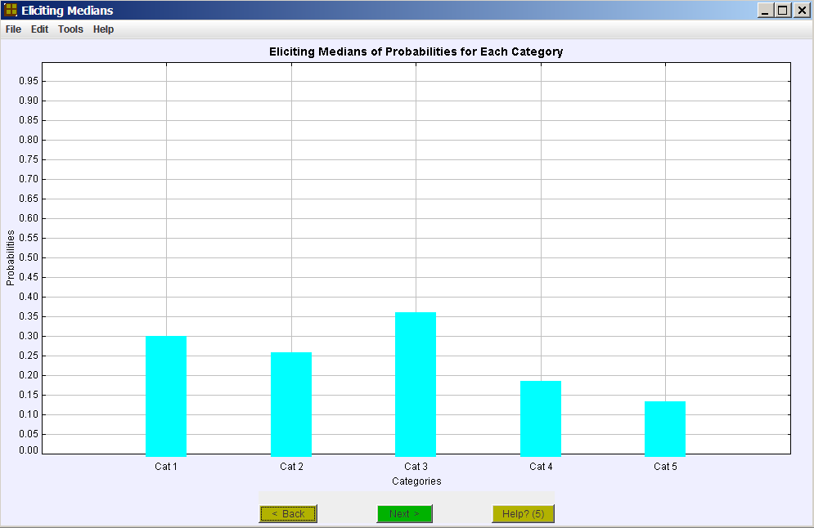

Figure 1: Median assessments for the Dirichlet prior distribution

- Lower quartile assessment. The lower quartile divides the probability below the median in half. To assess your lower quartile for the proportion of items in the first category, suppose you were told that your median assessment for this proportion is too high – the proportion is actually less than your median. Given this information, what would now be your estimate of the proportion? Your response should be close to your lower quartile.
Suppose your assessed median is 0.3 and your assessed lower quartile is 0.2. Then your probability that the proportion is below 0.2 should equal your probability that it is between 0.2 and 0.3.
As when assessing the median, for the lower quartile you can consider bets you would make to improve your first assessment. If you would rather bet that the proportion is below your lower quartile than bet on it being between your lower quartile and median, then reduce your lower quartile.
On the other hand, if you would rather bet that the proportion is between your lower quartile and median than bet on it being below your lower quartile, then increase your lower quartile.
Increase/reduce your lower quartile until you cannot choose between the two bets.

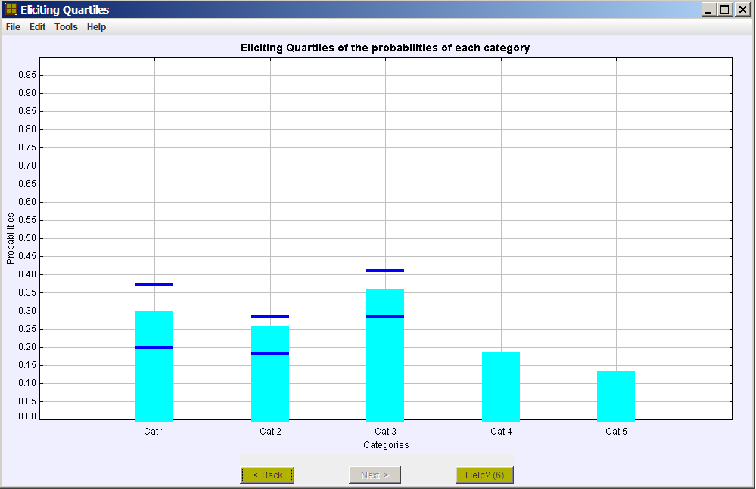

Figure 2: Assessing quartiles

- Upper quartile assessment. The upper quartile divides the probability above the median in half in the way that the lower quartile divides the probability below the median in half. Similar strategies can be used to assess it.
Thus, to assess your upper quartile for the proportion of items in the first category, suppose you were told that your median assessment was too low – the proportion is actually greater than your median. Given this information, what would now be your estimate of the proportion? Your response should be close to your upper quartile.
As when assessing the median or lower quartile, for the upper quartile you can consider bets you would make to improve your first assessment. If you would rather bet that the proportion is above your upper quartile than bet on it being between your median and upper quartile, then increase your upper quartile. On the other hand, if you would rather bet that the proportion is between your median and upper quartile than bet on it being above your upper quartile, then reduce your upper quartile. Increase/reduce your upper quartile until you cannot choose between the two bets.

Note: “Next” will turn green when you can click it.

Help Button (7) The small screen showing the assessed beta distribution

This screen (as in Figure 3) shows the probability density function that you have assessed. The curve is shown below. The three vertical blue lines are your assessed quartiles and median. Ideally they should divide the area below the red line (the pdf) into four equal areas.
Usually the pdf should have a single mode that is neither at 0 or 1, if the pdf is to correspond to your opinion.
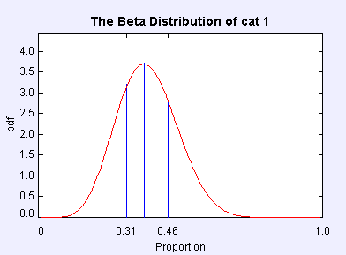

Figure 3: The assessed beta distribution

Help Button (8) Reconciling medians

The probabilities of the different categories must add to one.
The quartile assessments for the different categories must also meet certain requirements in order to be internally consistent.

This program gives three options for reconciling your assessments to meet these requirements.
Clicking in the square box given with an option will display (remove) the medians and quartiles that will be taken as representative of your opinions if that option is selected.
Look at the different medians and quartiles that the different options offer.
Click in the round circle to select the option you want and then click 'Next'.

Further detail: A mean and equivalent sample is calculated for each category, using just the assessments for that category.
The average of the samples sizes is taken as the best representation of the expert’s opinion of the equivalent sample size.

Option 1 normalizes the means by dividing each by their sum;
Option 2 minimises the sum of squared differences between the assessed mean and the adopted mean, subject to them adding to one;
Option 3 is similar to Option 2 except a weighted sum of squares is minimized, with weights proportional to precisions.

Help Button (9) Revising medians and quartiles

This screen shows the medians and quartiles that the software has determined for your prior distribution.
You should change them if they do not form a reasonable representation of your opinion.
The grey boxes will not change as you make your revisions – they are there to show you your initial estimates.
The radio button on the left enables you to elect to change medians or quartiles.
With 'Change Medians' selected you can click on the vertical lines to specify a new median for any category or categories that you wish.
Your assessments must yield means that add to 1.
After making changes to medians you must click on the green 'Revise Suggestions' box and the computer will suggest medians (dull green boxes) that meet this requirement.
You may accept the suggestions or revise them again.
Changes to medians will also affect the quartiles.

With 'Change Quartiles' selected you can click on the vertical lines to specify new quartiles for any category or categories that you wish.
Your assessments must satisfy certain requirements because the true proportions sum to 1.
After making changes to quartiles you must click on the green 'Quartiles Suggestions' box and the computer will suggest quartiles (short horizontal grey lines) that meet this requirement.
You may accept the suggestions or revise them again.
Clicking 'Finish' takes you to screens for saving your results.

Help Buttons (10) to (19) are for the Copula prior.

Help Button (10) Eliciting unconditional median assessments for all categories

This is where median assessments are elicited to quantify your opinions. A strategy for assessing a median is described below. Give your median assessment for each category by clicking the right-hand mouse button with the pointer on the vertical line though the category. You may change your assessment as often as you like by re-clicking on the line.

The left-most box is in blue and this is the most important assessment – the other boxes (in orange) are not actually used but help you quantify your opinions. The sum of your assessed medians should be close to 1 and the computer actually suggests values that add exactly to 1.

If the “Revise suggestions” box is green, then you should click on it when you want the computer to re-calculate its suggestions. The “Accept suggestions” box will then turn green.

When you are satisfied with the suggested probabilities and the “Accept suggestions” box is green, then click on that box to move on to the next assessments.

It is possible (though unlikely) that the computer will keep suggesting values that do not represent your opinions – your opinions may correspond to medians that do not exactly sum to 1 while the computer’s suggestions always sum to 1 exactly. If that happens, click on “Accept suggestions” when the probability given by the blue box is an acceptable representation of your opinion.

Median. To assess the median for a category, start by asking yourself the question “What will be the proportion of items that fall in that category?”
The value you think of should be quite close to your median. A slight difference may occur because of skewness. By definition, you should consider it equally likely that the true proportion is above the median or below the median. For example, suppose you assess the median as 0.6. If you looked at a large number of items then the proportion of them in the category will not be exactly 0.6. However, you should think it equally likely that the proportion will be above 0.6 as that it will be below 0.6. Hence, if you were asked “Would I rather bet on the proportion being above 0.6 or below 0.6?”, you should find it hard to decide.
It is worth asking yourself that type of question after you have assessed the median. If you decide that you would rather bet on the proportion being above the median, then increase your assessment of the median. Similarly, if you decide that you would rather bet on the proportion being below the median, then reduce your assessment of the median. Keep changing your assessment until you are undecided on which way to bet.

Your assessments appear as blue or orange boxes, as shown in Figure 4.

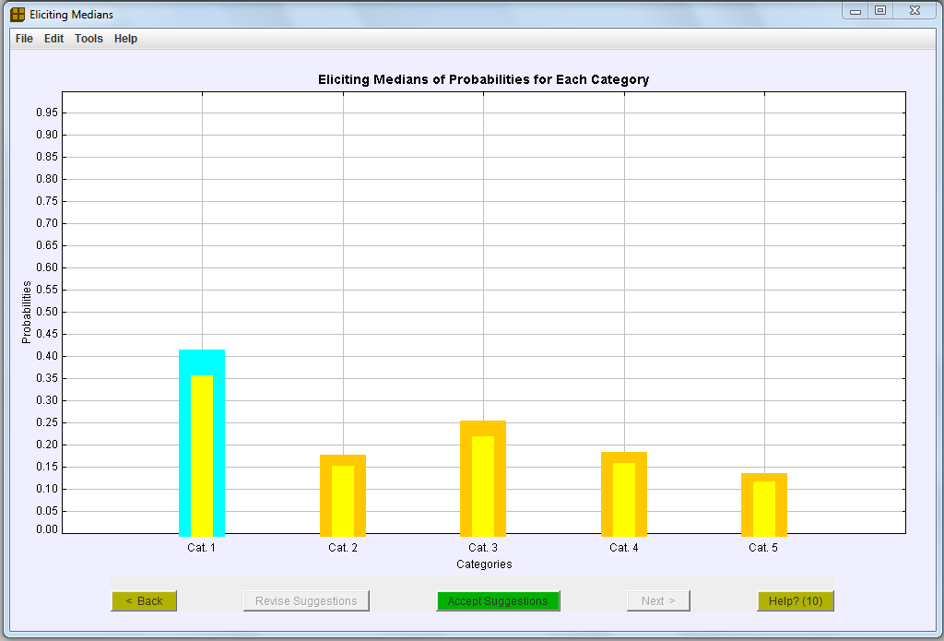

Figure 4: Unconditional median assessments

Help Button (11) Eliciting unconditional median assessments for the right-most categories

Median assessments are elicited to quantify your opinions. A strategy for assessing a median is described below.

Assessments are only required for the right-most categories – the categories that are labelled and have blue or orange boxes. In making your assessments, assume that you know an item falls in one of these categories. Given that information, what is the probability that the item will be in the first of those categories – the computer’s suggestion is given by the blue box. What about the probabilities of each of the other categories? – the computer’s suggestions for these are given by the orange boxes.

The suggestions are based on your earlier assessments and will usually be a good reflection of your opinions. If that is the case, click on the “Accept suggestions” box, which should be green. Otherwise, revise the probabilities by clicking on the vertical lines. Then click on the “Revise suggestions” box. You may change your assessment as often as you like by re-clicking on the lines vertical line though the categories.

When you are satisfied with the suggested probabilities and the “Accept suggestions” box is green, then click on that box to move on to the next assessments.

The left-most box is in blue and this is the most important assessment – the other boxes (in orange) are not actually used but help you quantify your opinions. The sum of your assessed medians should be close to 1 and the computer actually suggests values that add exactly to 1.
It is possible (though unlikely) that the computer will keep suggesting values that do not represent your opinions – your opinions may correspond to medians that do not exactly sum to 1, unlike the computer’s suggestions. If that happens, click on “Accept the suggestions” when the probability given by the blue box is an acceptable representation of your opinion.

Median. To assess the median for a category, start by asking yourself the question “What will be the proportion of items that fall in that category?”
The value you think of should be quite close to your median. A slight difference may occur because of skewness. By definition, you should consider it equally likely that the true proportion is above the median or below the median. For example, suppose you assess the median as 0.6. If you looked at a large number of items then the proportion of them in the category will not be exactly 0.6. However, you should think it equally likely that the proportion will be above 0.6 as that it will be below 0.6. Hence, if you were asked “Would I rather bet on the proportion being above 0.6 or below 0.6?”, you should find it hard to decide.
It is worth asking yourself that type of question after you have assessed the median. If you decide that you would rather bet on the proportion being above the median, then increase your assessment of the median. Similarly, if you decide that you would rather bet on the proportion being below the median, then reduce your assessment of the median. Keep changing your assessment until you are undecided on which way to bet.

Your assessments appear as blue and orange boxes, as shown in Figure 5.

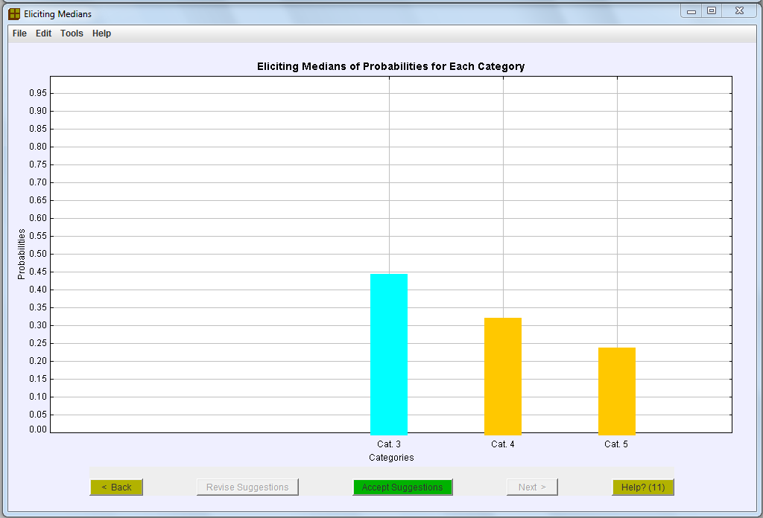

Figure 5: Unconditional median assessments for the last three categories

Help Button (12) Assessing marginal quartiles for the first category

First Category – further assessments: The blue bar, see Figure 6, shows your median assessment for the proportion of items that are in the first category. We now require your upper and lower quartiles for this proportion. Click on the vertical line through the blue box to make these assessments, these are shown as horizontal dark blue lines in Figure 6.

Lower quartile assessment. The lower quartile divides the probability below the median in half. To assess your lower quartile for the proportion of items in the first category, suppose you were told that your median assessment for this proportion is too high – the proportion is actually less than your median. Given this information, what would now be your estimate of the proportion? Your response should be close to your lower quartile.
Suppose your assessed median is 0.6 and your assessed lower quartile is 0.45. Then your probability that the proportion is below 0.45 should equal your probability that it is between 0.45 and 0.6.
As when assessing the median, for the lower quartile you can consider bets you would make to improve your first assessment. If you would rather bet that the proportion is below your lower quartile than bet on it being between your lower quartile and median, then reduce your lower quartile.
On the other hand, if you would rather bet that the proportion is between your lower quartile and median than bet on it being below your lower quartile, then increase your lower quartile.
Increase/reduce your lower quartile until you cannot choose between the two bets.

Your lower quartile must lie between the top of the blue box and the lower dotted orange line.

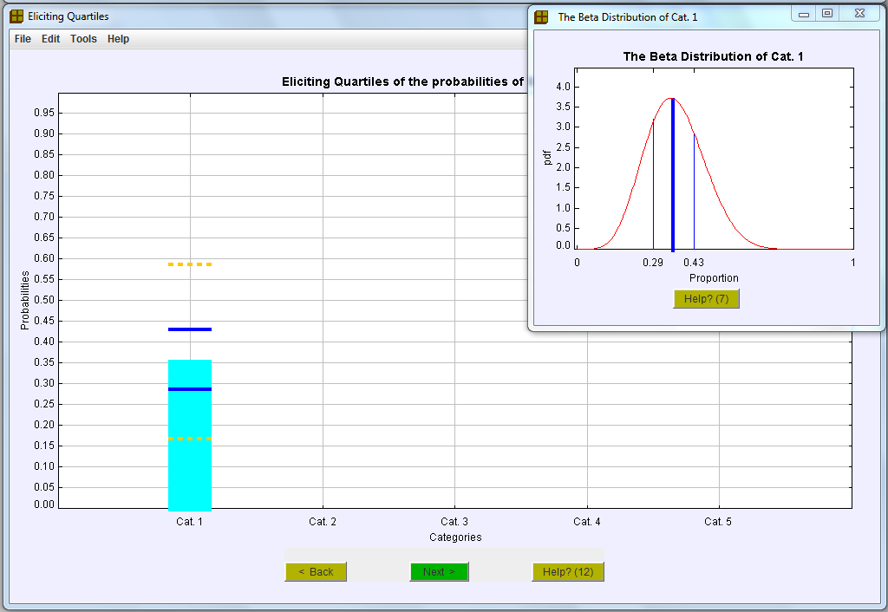

Figure 6: Assessing quartiles for the first category

Upper quartile assessment. The upper quartile divides the probability above the median in half in the way that the lower quartile divides the probability below the median in half. Similar strategies can be used to assess it.
Thus, to assess your upper quartile for the proportion of items in the first category, suppose you were told that your median assessment was too low – the proportion is actually greater than your median. Given this information, what would now be your estimate of the proportion? Your response should be close to your upper quartile.
As when assessing the median or lower quartile, for the upper quartile you can consider bets you would make to improve your first assessment. If you would rather bet that the proportion is above your upper quartile than bet on it being between your median and upper quartile, then increase your upper quartile. On the other hand, if you would rather bet that the proportion is between your median and upper quartile than bet on it being above your upper quartile, then reduce your upper quartile. Increase/reduce your upper quartile until you cannot choose between the two bets.

Your upper quartile must lie between the top of the blue box and the upper dotted orange line.

Note: “Next” will turn green when you can click it.
Help Button (13) Assessing marginal quartiles for second category

For the next assessments you must assume that an item did not fall in the first category, but fell in one of the other categories. Conditional on this information, you must now assess the lower quartile and the upper quartile for the proportion in the second category (the blue box in Figure 7 shows the median that you assessed earlier). Click on the vertical line through the blue box to make these assessments. These are shown as the horizontal dark blue lines on Figure 7. Your lower quartile must lie between the top of the blue box and the lower dotted orange line; your upper quartile must lie between the top of the blue box and the upper dotted orange line.

Note: “Next” will turn green when you can click it.

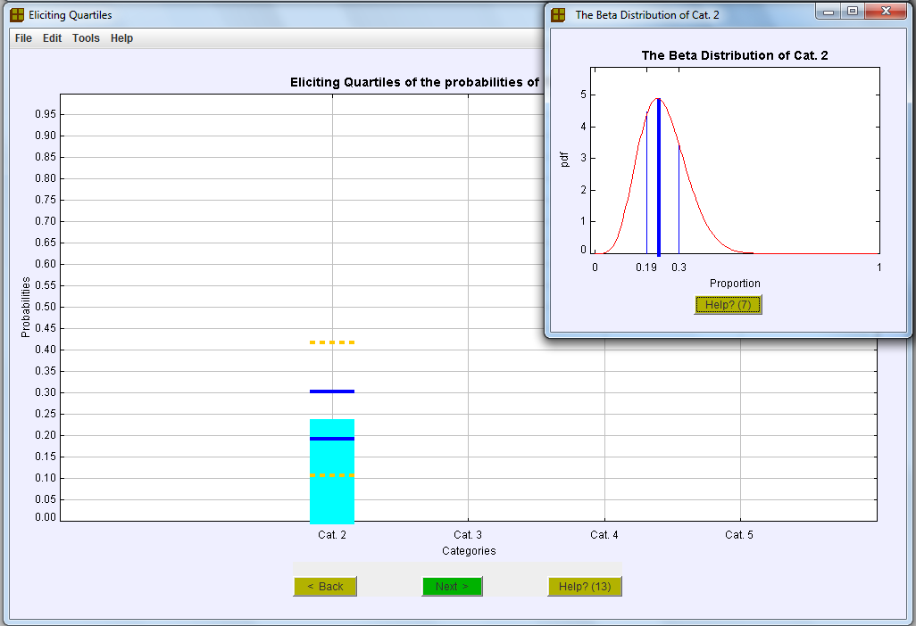

Figure 7: Assessing quartiles for the second category

Help Button (14) Assessing marginal quartiles for other categories

For other categories, suppose an item falls in one of the last few categories: those with labels and vertical lines.

For the next two quartile assessments you must assume that an item fell in one of these categories. Conditional on this information, you must assess the lower quartile and the upper quartile for the proportion in the left-most remaining category (the blue box in Figure 8 shows the median that you assessed for it earlier). Click on the vertical line through the blue box to make these assessments. These are shown as the horizontal dark blue lines on Figure 8. Your lower quartile must lie between the top of the blue box and the lower dotted orange line; your upper quartile must lie between the top of the blue box and the upper dotted orange line.

For the second last category, a yellow box will be drawn as well as a blue box. Quartiles for the second last category determine quartiles for the last category and these are displayed to help you quantify your opinions well.

Note: “Next” will turn green when you can click it.

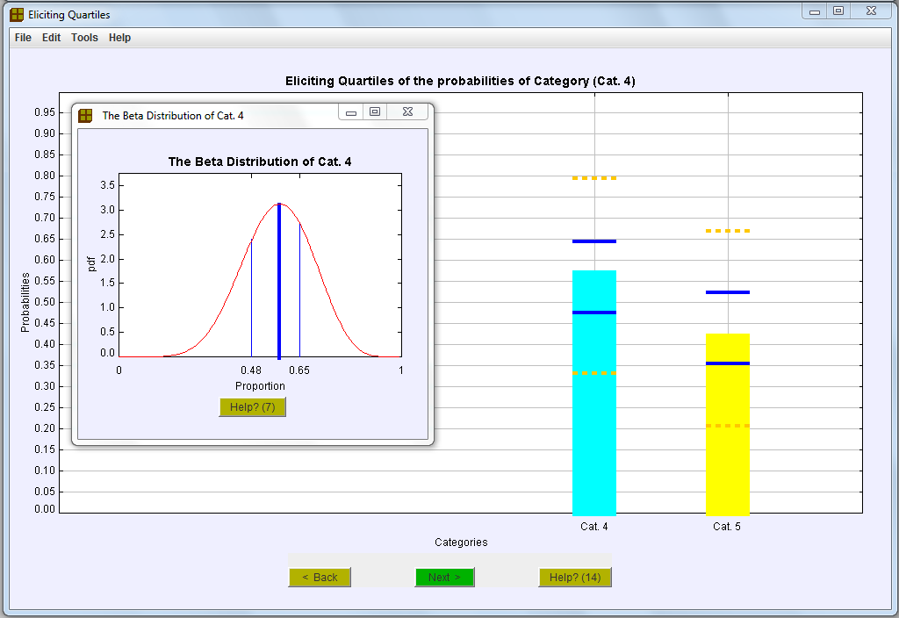

Figure 8: Assessing quartiles for the last two categories

Help Button (15) Assessing conditional quartiles for the second category

The red box shows your assessed median probability for the first category. See Figure 9. You should suppose that this is an accurate answer – that is, you should assume the true probability for the first category is the value you assessed. Under this assumption, you must give your upper and lower quartiles for the proportion in the second category category (the blue box on Figure 9 shows the median that you assessed earlier for the second category). Make these assessments, as before, by clicking on the vertical line. Your assessments should be between the dotted orange lines (and must be below the dotted red line).

Note: “Next” will turn green when you can click it.

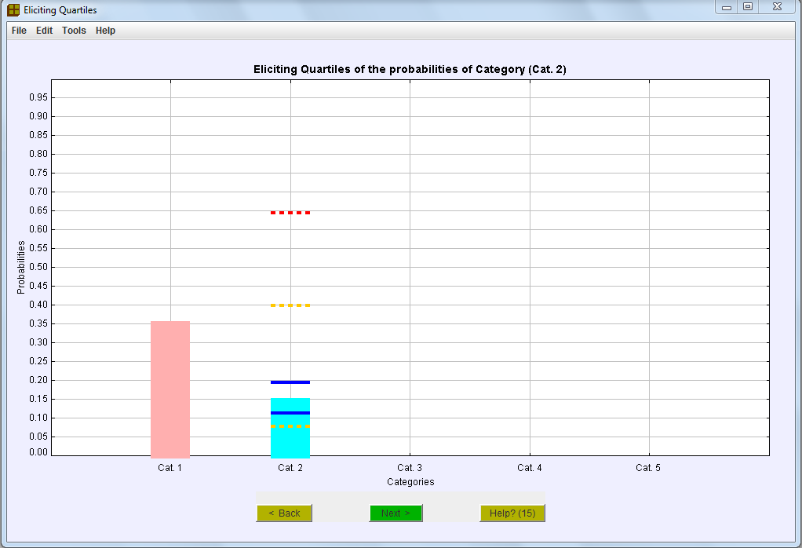

Figure 9: Assessing conditional quartiles for the second category

Help Button (16) Assessing conditional quartiles for all but the last two categories

Red boxes denote values that you should treat as being correct, see Figure 10. For the next assessments you must assume that your median assessments for the categories with red boxes are correct. Conditional on this assumption, you must now assess the lower quartile and the upper quartile for the proportion in the next category (the blue box on Figure 10 shows the median that you assessed earlier). Click on the vertical line through the blue box to make these assessments. These are shown as the horizontal dark blue lines on Figure 10. Your assessments should be between the dotted orange lines (and must be below the dotted red line).

Note: “Next” will turn green when you can click it.

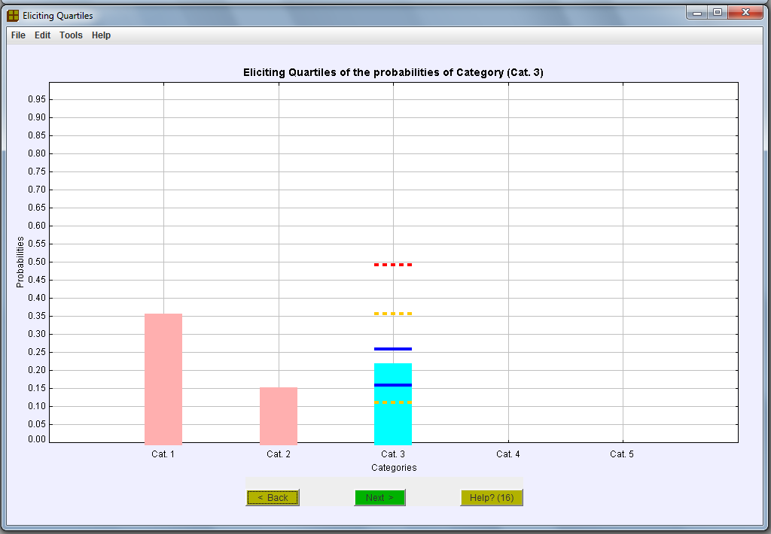

Figure 10: Assessing conditional quartiles for the third category

Help Button (17) Assessing conditional quartiles for the last two categories

Red boxes denote values that you should treat as being correct, see Figure 11. For the next assessments you must assume that your median assessments for the categories with red boxes are correct. Conditional on this assumption, you must now assess the lower quartile and the upper quartile for the proportion in the next category (the blue box on Figure 11 shows the median that you assessed earlier). Click on the vertical line to make these assessments. (These quartile assessments also determine quartiles for the last category because there are only two categories left. The implied quartiles for the last category – the yellow box on Figure 11 – are also shown.) Your assessments should be between the dotted orange lines (and must be below the dotted red line).

Note: “Next” will turn green when you can click it.
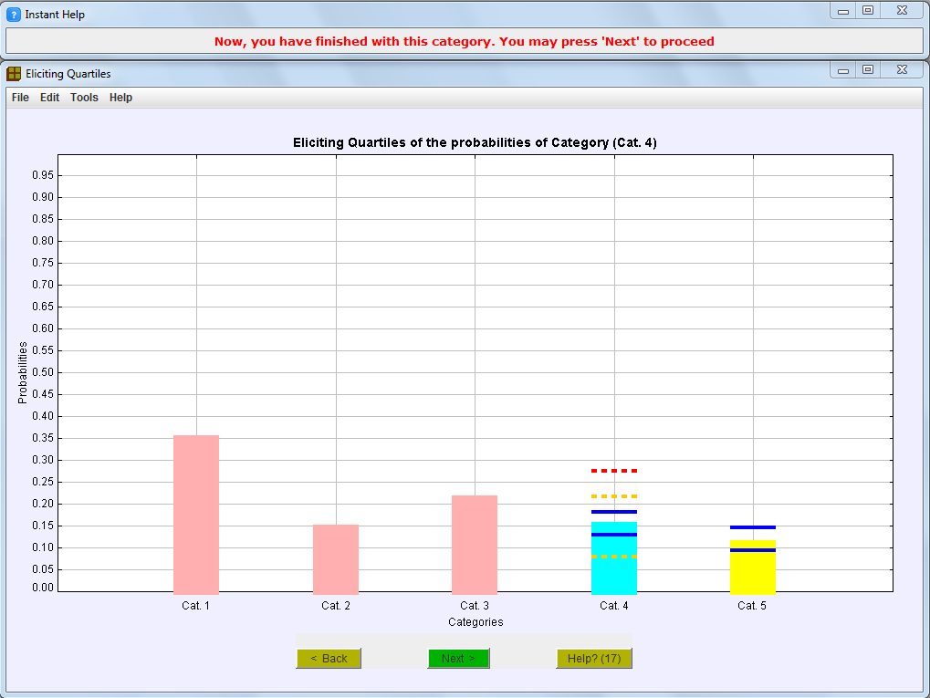

Figure 11: Assessing conditional quartiles for the second category

Help Button (18) Assessing conditional medians given a new median for the first category

The screen shows the last type of assessment required for the copula prior distribution. The grey boxes show your unconditional median assessments for each category (they will not change).

Suppose that the pink box gives the true proportion in the first category. This proportion is a little lower than the median you gave so, since the proportions in the different categories add to 1, some of the other categories should be given larger medians. Click on the vertical lines for each of the other categories to give your new assessments.

Your assessments appear as blue or orange boxes, as shown in Figure 12. (The value given by the blue box is used in further calculations while those in the orange boxes help you quantify your opinions well.) For your assessment to be internally consistent, the values given by the boxes (including the red box) must be close to 1. When you have given assessments for each category the computer suggests values that do add up to one and that are close to your assessments. These values are given in yellow. See Figure 12.

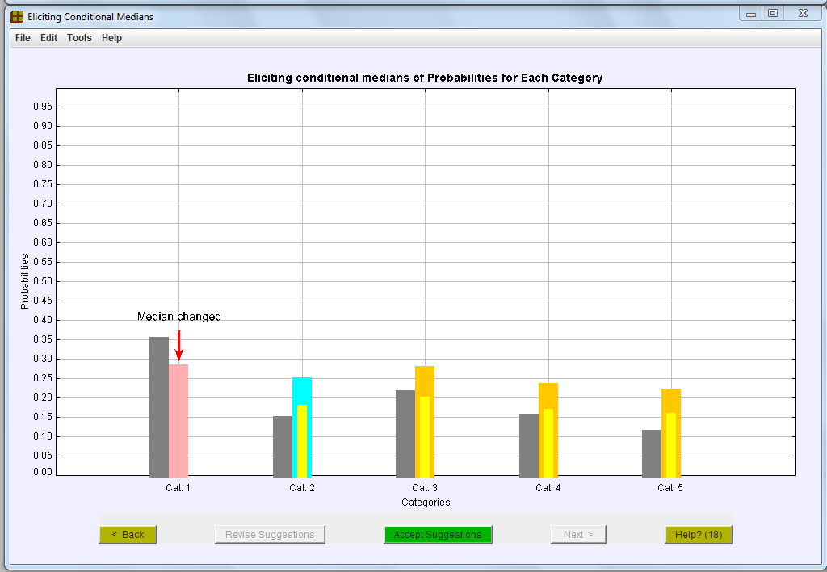

Figure 12: First set of conditional median assessments

When the computer gives these yellow boxes, a box turns green. This asks if you are happy with the computed suggestions. Click on the box if you are. Otherwise, modify your assessments by re-clicking on the vertical lines and then click on the box (now green) that is labelled “Revise suggestions”. Clicking on this box causes the computer to offer new median assessments (yellow boxes) that you may accept or revise. The cycle may be repeated as often as you like. It is possible (though unlikely) that the computer will keep suggesting values that do not represent your opinions – your opinions may correspond to medians that do not exactly sum to 1 while the computer’s suggestions always sum to 1 exactly. If that happens, click on “Accept suggestions” when the probability given by the blue box is an acceptable representation of your opinion.

After you click on “Accept suggestions” the computer changes the colour of another box to pink. Now you must suppose that each pink box gives the true proportion for the category. Does this change your opinions about the probabilities for the categories with blue or orange boxes. If so, click on the vertical lines to change your medians. Otherwise click on “Accept suggestions”.

This continues until all but the last two categories have been given red boxes and acceptable medians for the last two categories have been found. (See Figure 13)

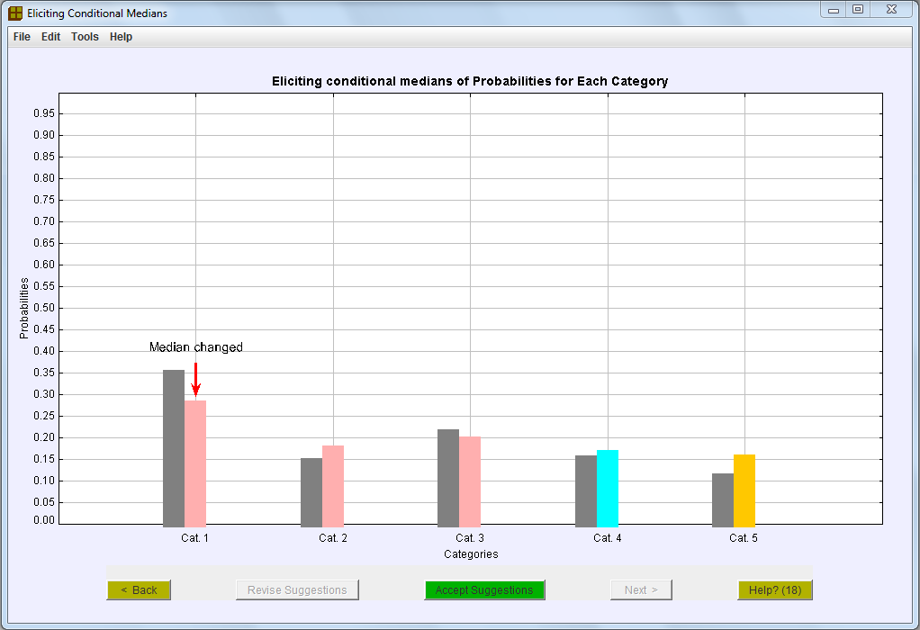

Figure 13: Conditional median assessments for the last two categories

Help Button (19) Assessing conditional medians given a new median for the second or subsequent categories

Two or more of the left-most boxes are pink. You must suppose that each pink box gives the true proportion for the category. Apart from the right-most pink box, the suggested values are the same as your initial assessments. The proportion given by the right-most pink box is a little lower than the median you gave so, since the proportions in the different categories add to 1, some of the other categories should be given larger medians. Click on the vertical lines for each of the categories without pink boxes to give your new assessments.

Your assessments appear as blue or orange boxes, as shown in Figure 14. (The value given by the blue box is used in further calculations while those in the orange boxes help you quantify your opinions well.) For your assessment to be internally consistent, the values given by the boxes (including the pink boxes) must be close to 1. When you have given assessments for each category the computer suggests values that do add up to one and that are close to your assessments. These values are given in yellow. See Figure 14.

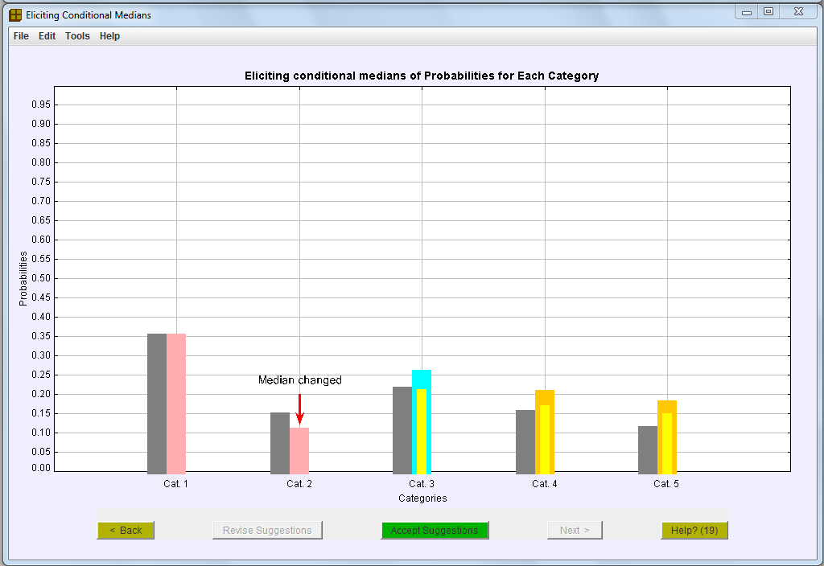

Figure 14: Conditional median assessments given a new value for the second category

When the computer gives these yellow boxes, a box turns green. This asks if you are happy with the computed suggestions. Click on the box if you are. Otherwise, modify your assessments by re-clicking on the vertical lines and then click on the box (now green) that is labelled “Revise suggestions”. Clicking on this box causes the computer to offer new median assessments (yellow boxes) that you may accept or revise. The cycle may be repeated as often as you like. It is possible (though unlikely) that the computer will keep suggesting values that do not represent your opinions – your opinions may correspond to medians that do not exactly sum to 1 while the computer’s suggestions always sum to 1 exactly. If that happens, click on “Accept suggestions” when the probability given by the blue box is an acceptable representation of your opinion.

After you click on “Accept suggestions” the computer changes the colour of another box to pink. Now you must suppose that each pink box gives the true proportion for the category. Does this change your opinions about the probabilities for the categories with blue or orange boxes. If so, click on the vertical lines to change your medians. Otherwise click on “Accept suggestions”.

This continues until all but the last two categories have been given red boxes and acceptable medians for the last two categories have been found. (See Figure 15)

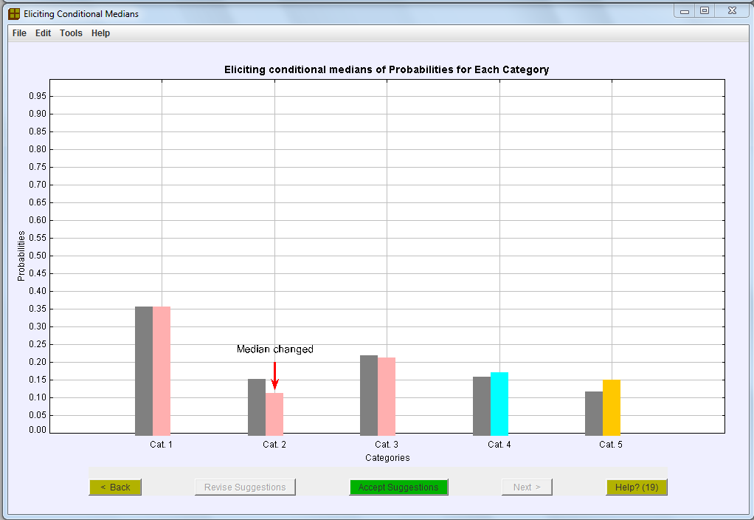

Figure 15: Conditional median assessments for the last two categories

Help Button (20) Saving output

We strongly recommend that you save these results for future reference.
If you would like to save them, then click the 'Yes' button.
The parameters of your prior distribution will be saved to the file you specify. This file is a .xls file.
Otherwise click the “No” button.

Help Button (21) More output options

If you have data that you would like to combine with your prior distribution using WinBUGS, then click the “Yes, I have data” button.

Otherwise click the “No, just save output” button. The parameters of your prior distribution will be saved as a .txt file in a form that can be copied and pasted into WinBUGS and/or later input into this program to combine with data when data become available.

Help Button (22) Screen to input data

Type in the data values specifying the number of items that fell in each category in your sample. The output is saved as a .txt file in a form that can be copied and pasted into WinBUGS. Then click “Next”.

Help Button (23A) Returning to assess a Gaussian copula prior

Your assessments have been used to form a Dirichlet prior distribution.
Should you wish, you could now give further assessments to form a Gaussian copula prior distribution.

Click on the bright green button to do that. Otherwise click on the “No thanks” button.

Help Button (23B) Returning to assess a Dirichlet prior

Your assessments have been used to form a Gaussian copula prior distribution.
Should you wish, you could now give further assessments to form a Dirichlet prior distribution.

Click on the bright green button to do that. Otherwise click on the “No thanks” button.

