IT for Research Students
Students starting October 2022 onwards
Graduate School
§

IT Support at the OU

IT Service Desk
IT support (including hardware) is provided by the IT Service Desk. When you contact the Service Desk, please ensure that you state that you are a postgraduate research student. You should also state whether you are attempting to access staff services or student-facing services (see Which OUCU should I use?)

Call the IT Service Desk
If you have an issue which is stopping you working or you are locked out of your accounts, you should call the IT Service Desk on 01908 654321
Monday to Thursday: 08:00 - 17:30
Friday: 08:00 - 17:00
Saturday and Sunday: Closed

Raising a ticket on the IT Self-Service Portal
For non-urgent issues/requests, you should raise a ticket via the Self-Service Portal askit.open.ac.uk. You will need to logon using your staff OUCU (see Signing in with your staff OUCU)
Issue ticket - When something is not working
Request ticket - When you want to ask a question or make a request

PGR Manager support
If you are having difficulty logging into PGR Manager, then you should contact the IT Service Desk and ask for help with your student logon.
The day-to-day use of PGR Manager is supported by the Graduate School via PGRManager@open.ac.uk

Logging In

Your OU computer usernames (OUCU)
As a postgraduate research (PGR) student, you will have two different usernames (OUCU) with different passwords. One is designated with staff permissions and the other with student permissions. These are used to access different services so make sure you keep a note of both and make sure you are using the correct OUCU.

Why do I have more than one username?
As a research student, your computing needs will be very different to the vast majority of OU students, who are taught at a distance. For example, you may need to use specialist software, access internal data, claim expenses for conferences and fieldwork, and work more closely with members of OU staff. You will also be held to more stringent standards of data protection. The permissions that you will need are much more closely aligned with those of OU staff.
However, as a student, you will also need to access many of the student-facing services offered by the OU, including PGR Manager. In addition, students are entitled to access disability support, the Careers and Employability Service, and also have enhanced library and journal access.
Unfortunately, the size and nature of the OU mean that it is not possible to combine staff and student permissions under one username; this is why research students have two OUCUs.

Which OUCU should I use?
Depending on the service you are trying to access, you will need to use a different login method. Student services require your student OUCU, whilst most other services (including email and other Microsoft services) require your staff OUCU.
Staff OUCU | Student OUCU
OU issued laptop and software  Microsoft Office 365 (email, Teams, OneDrive, SharePoint) www.office.com  OU intranet (OU Life) openuniv.sharepoint.com/sites/oulife  My Learning Centre (for mandatory compliance training) thelearningcentre.learningpool.com  SuccessFactors (personal and stipend information) performancemanager5.successfactors.eu  SAP Concur (expenses) eu2.concursolutions.com/home.asp | PGR Manager doctoral-research-system.open.ac.uk  Moodle sites (e.g., Moodle: Research skills and Professional Doctorate websites)  Library Services www.open.ac.uk/library  Graduate School Network www.open.ac.uk/students/research  Student Home msds.open.ac.uk/students  Help Centre help.open.ac.uk

Signing in with your student OUCU
When signing in as a student, you will need to use the option on the left-hand side and type in your student OUCU and password. If you cannot remember your password, the password reset option will send an email to whichever email you used when you first registered with the OU (usually your personal email).
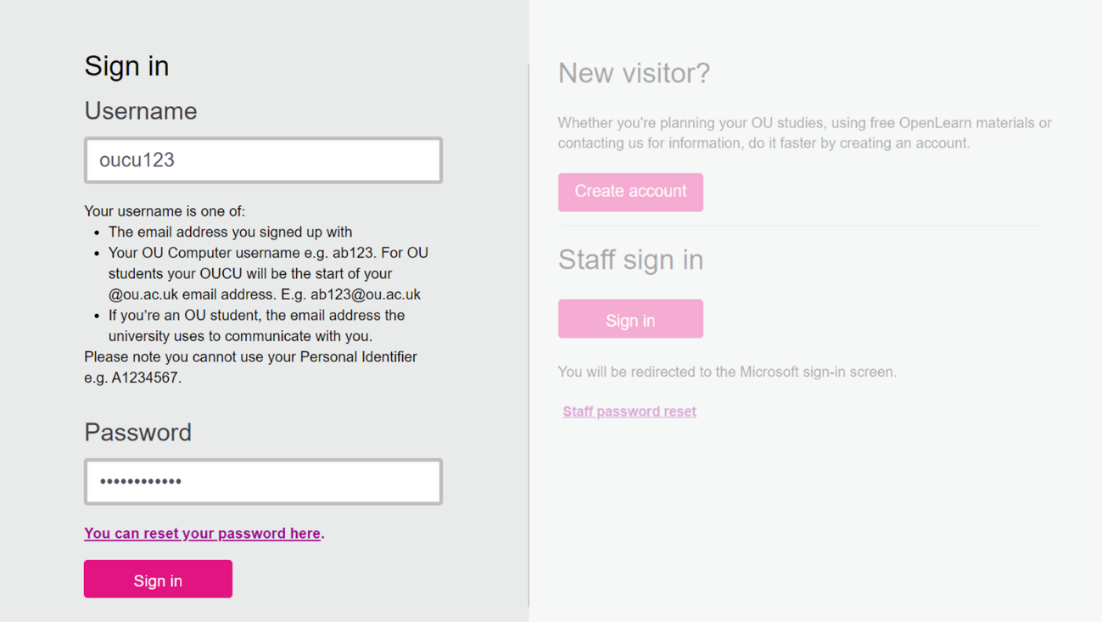

Resetting your student password
Your student password never expires and, if you forget your password, there is password reset option on the sign-in page. Your recovery email is usually the one you used when you first registered with the OU.
If you cannot reset your student password, you should contact the IT Service Desk for further support. You should make it clear that you are a research student who is trying to reset their student login.

Signing in with your staff OUCU
You will need to use the option on the bottom right-hand side under the heading ‘staff sign in’; you will then be re-directed to the Microsoft OU sign in pages. Your email/username is of the form oucu@open.ac.uk and you should use your staff password.

Continues with screenshots on next page.
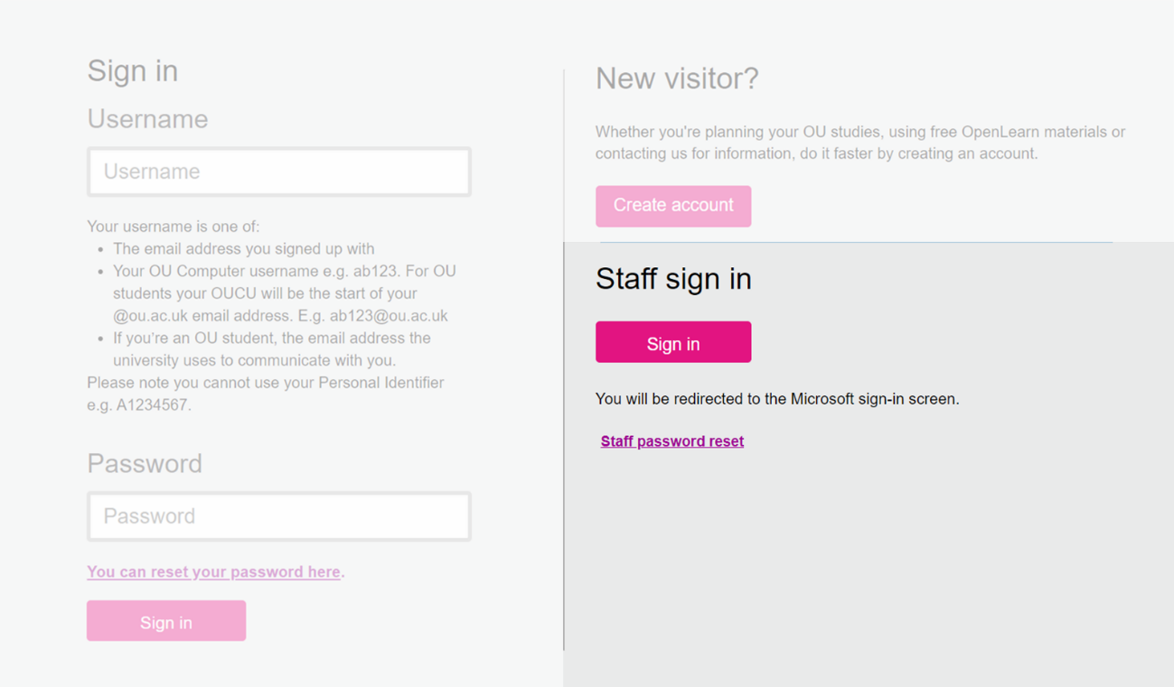

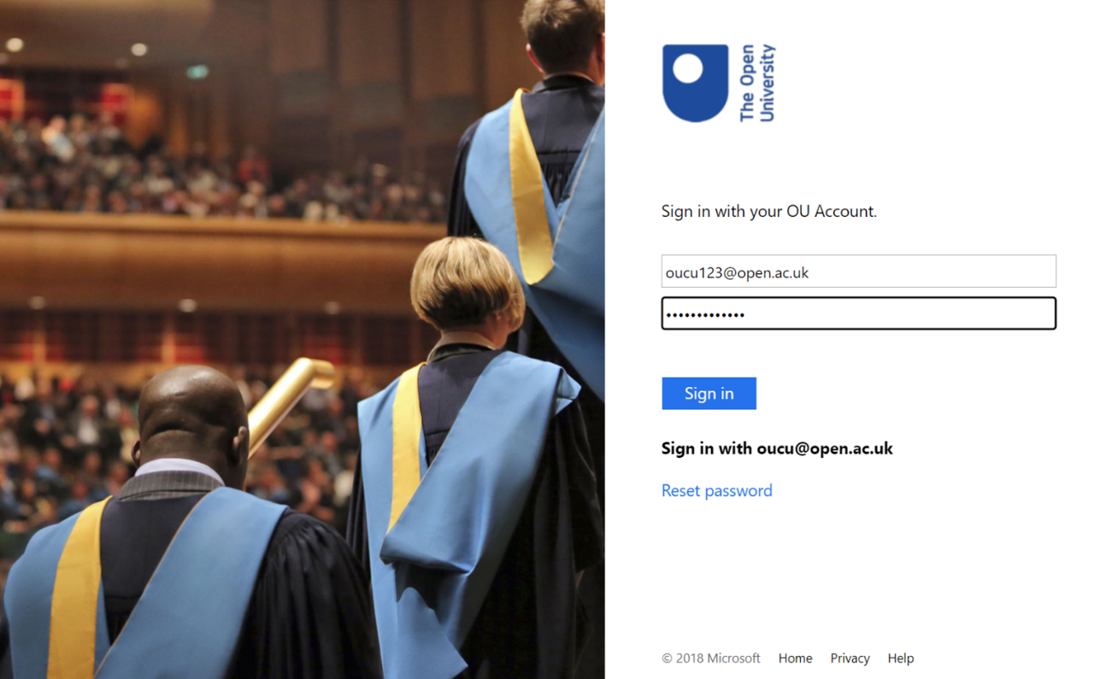

Resetting your staff password
You should register at least two sign-in methods on the Office 365 Security Info page. This will allow you to reset your own OU password if you forget it, or it expires. Your staff password will expire every 90 days, and you will be prompted to create a new password before this happens.

Troubleshooting tips – signing in
- Check that you are using the correct OUCU for the application you are trying to access; see the table on the preceding page
- Check that you are using the correct sign-in box on the login page; student sign-in is located on the left-hand side, whilst staff sign-in is located on the bottom right-hand side
- Check that you are using the correct username. For your student account, this is just your OUCU, but for your staff account, it is OUCU@open.ac.uk
- If you do not see the login page when you are trying to sign in, your browser may have stored one set of login credentials – usually your staff account as this is linked to your Microsoft account. You can solve this by:
  - Signing out of your browser
  - Using your browser in private/incognito mode
  - Using different browsers for staff and student services
  - Clearing your browser cookies/cache

If none of these options work, you should contact the IT Service Desk.

Accessing OU systems from outside the OU

Non-OU devices

What is mobile device management?
Mobile Device Management (MDM) is a security system which allows organisations to identify any devices that are used to access their data.
MDM also allows the organisation to see relevant security information about each device, for example, the device model and serial number and the operating system it uses. This checks that the software is up to date and receiving security updates with the necessary security settings in place to comply with existing OU security policies.
It allows us to reduce the risk of our data, and that of our staff and students, being accessed by cyber criminals through devices with compromised security.

If you have been provided with an OU issued laptop
You will usually be expected to access OU systems from your OU device and would therefore need to install MDM software on any personal devices used to access OU systems.
For MDM how to guides please click here: How to Install or Update MDM
You should ensure that all devices are always running on up-to-date operating systems for MDM, in line with existing Information Security Policy. For more about that, see Basic system Requirements
For more information on MDM please click here: MDM FAQs

If you have not been provided with an OU laptop/device
An MDM exemption has been requested on your behalf and you will not need to install any additional software on your device. If you encounter any issues, please contact the IT Service Desk.

Working remotely

What is multifactor authentication?
Multi-Factor Authentication (MFA) offers an additional layer of security when you use various OU systems. MFA significantly reduces the risks associated with some of the most common methods used by cyber criminals, such as username and password theft and password guessing.
If you are working remotely using a non-OU device, you will regularly be asked to use MFA when logging in. Guidance and information can be found here: Multi-Factor Authentication (MFA)

If you have been provided with an OU laptop
You will not need to use MFA - please contact the IT Service Desk if you have any difficulties.

If you have not been provided with an OU laptop
If you are working remotely on a non-OU device, you will need to use MFA. If you haven't used MFA before, you will automatically be directed to register when you log-in to a system that requires MFA verification.
You can select how the MFA is verified: via an app installed on your phone or tablet, a text message or a phone call to a mobile or landline number (not your OU work number). If you do not have access to these authentication methods, you can configure alternate methods for MFA.
We recommend using the Microsoft Authenticator app if you have a modern smart phone and then setting up an additional method as a backup. If you do not have access to one of the authentication methods, you should contact the IT Service Desk for advice.

