PGR Manager Events Management Guide

v2

Directly Supported and

Affiliated Research Centres (ARCs)

*PGR Manager can be accessed here:*

[*https://doctoral-research-system.open.ac.uk*](https://doctoral-research-system.open.ac.uk)

*Further Information can be found on the Graduate School Network.*

[*http://www.open.ac.uk/students/research/*](http://www.open.ac.uk/students/research/)

*For any communication related to PGR Manager please email*

[*pgrmanager@open.ac.uk*](mailto:pgrmanager@open.ac.uk)

Logging in

To log into the system or the first time you will be presented with a Login Page as shown below.

Use your [OUCU@open.ac.uk](mailto:OUCU@open.ac.uk) and OU password to login.

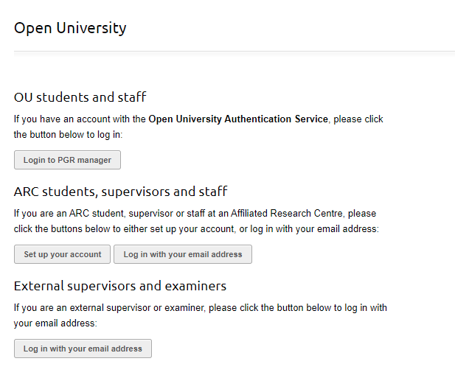

*.*

Figure 1 Login page

Adding an event

To add an event, click the Add button, then Event.

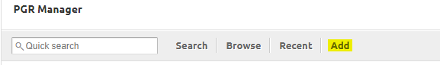

Then click ‘Add new’

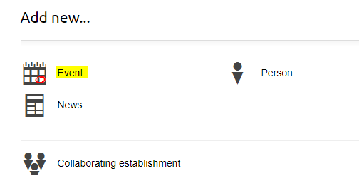

Figure 2 Adding an event

You will now see the form below. 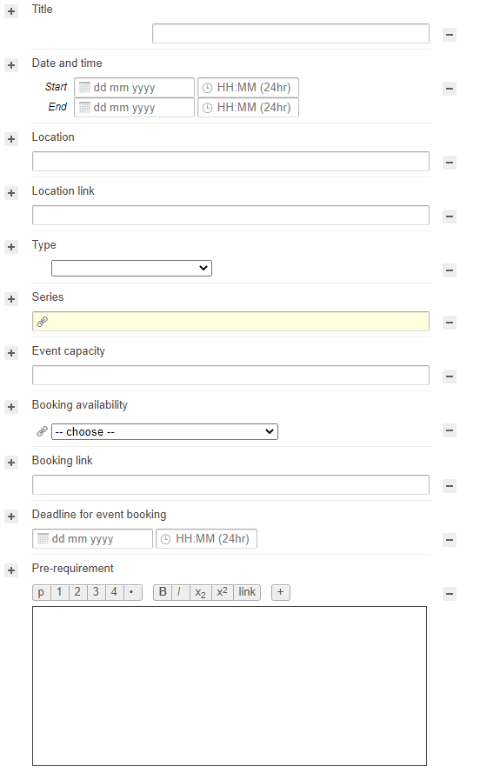

Figure 3 New event form

# How to fill in the fields

The form looks lengthy but the shaded fields below can be left blank unless otherwise specified by the event organiser.

|  |  |
| --- | --- |
| **Title:** | * Name of training session or event. |
| **Date and Time:** | * Start and end date/ time. |
| **Location:** | * If face-to-face, put room and location *(e.g. Charles Pinfold Room 111, Walton Hall)*; * If online, put ‘*Online – see location link’.* |
| **Location Link:** | * If training takes place online, put link here.   + MS Team, MS Team channel, direct meeting links all acceptable.   + Remember to give any access codes in the ‘Course overview’ if needed |
| **Type:** | * This field **must** be populated for all events. * We are not currently using all of the options in this list. * For scheduled events, pick from-   + **Graduate School event** foruniversity-wide events organised by the Graduate School, e.g. core training, poster competition   + **Faculty workshop** for seminars, lectures and workshops including those run within individual Schools   + **University workshop** for events run centrally e.g. by APD, KEE.   + **Social** * Please only use **Online** for non-scheduled online training materials completed at the student's own pace |
| **Series:** | * This field **must** be populated for every event in a series. * If training is part of a series/programme, type the name of the series into the box. You will then be able to either pick the series you need from the drop-down menu, or create a new series. |
| **Event Capacity:** | * If there are limited spaces, enter the capacity in numbers (e.g. 50). If there is no maximum capacity, leave blank. |
| **Booking availability:** | * Choose an option from the drop-down menu as follows-   + **Available** if you want PGRs to be able to book the event via PGR Manager;   + **Booking available outside of this system** if you will be handling bookings yourself. In this case you should either     - include a link in the ‘Booking Link’ field below (e.g. to Eventbrite or My Learning Centre), **or**     - give booking details in the *Course Overview* field |
| **Booking Link:** | * Give link, e.g., to EventBrite, My Learning Centre, or your own event page |
| **Deadline for event booking:** | * Ignore unless specified |
| **Pre-requirement:** | * Enter any prerequisites for the course *(e.g. must have completed PDF training part 1)* * Leave blank if not applicable |
| **Faculty:** | * This field **must** be populated for all events. * This field is pre-populated-   + de-select faculties to whom the session is not open/applicable   + leave all faculties checked if you want all PGRs to be able to see and book places on your event. |
| **Organised by:** | * Ignore unless specified |
| **Facilitator:** | * Add relevant OU staff with links to their OU people profile/website etc. |
| **Learning Objectives:** | * Ignore unless specified |
| **Course Overview:** | * Add your course description here * Include information about location/booking that is too complex to fit in Location/Booking fields * Include any other relevant information, e.g. cancellation procedure * If you need to include an email address-   type the address, select the text, choose ‘link’ and add the email address to the field including ‘mailto:’, e.g., <mailto:events-gradschool@open.ac.uk> |
| **Workshop Schedule:** | * Ignore unless specified |
| **Venue:** | * Ignore unless specified (e.g. it’s somewhere other than Walton Hall) |
| **Web Address (URL):** | * Ignore unless you are listing a purely online module. * We are using this field to populate [a list of asynchronous online resources](https://doctoral-research-system.open.ac.uk/do/phd-events-online-courses/listing) that students can work through at their own pace. |
| **Speaker:** | * Ignore unless specified * Please list session facilitators under ‘facilitator’, above. |
| **Attendees:** | * Ignore unless specified |
| **Notes:** | * Ignore this field. Use ‘Course overview’ for any additional information. |
| **Catering:** | * Ignore this field if no catering is provided. * Select from the drop-down menu if relevant. * More than one option can be chosen by clicking the + button on the left of the category. |
| **Student Project Type:** | * This field **must** be populated for all events. If student project types are not ticked then PGRs cannot register, so include all relevant student project types |
| **Programme:** | * Ignore unless specified |
| **Intended Audience:** | * Please specify if your event is particularly suitable for particular groups of PGRs, e.g.   + All PGRs   + Pre or post-upgrade PGRs   + Lab-based PGRs   + Part-time PGRs * Students appreciate this information and it’s likely to reduce the number of email queries you receive. |
| **Research Institute:** | * Enter the name of the organising faculty/school here |
| **Skill:** | * This field **must** be populated for all events. It makes the relevance of an event clear and allows PGR Manager to recommend events to students based on their skills audit and development plan. |
| **File:** | * Attach any flyers/slides/handouts/reading lists here * Can be left blank if necessary, or added at a later date. |

Table 1 how to fill in the new event form

**When you’ve finished adding your event:**

* Double-check that it’s clear where and when the event will be held, and how students can book their places. In particular-
  + Make sure that you haven’t confused **Location Link** with **Booking Link.**
  + If booking is by email, check that you have linked to the email address in **Course Overview**.
* Once you’ve published your event, check for stray headings with no content, like ‘Workshop Schedule’ and ‘Pre-requirement’ in the sample event below (Fig 4.)-
  + These appear because an invisible character such as a space or return has been accidentally added to the text boxes below each heading.
  + To remove these, choose ‘edit event’, delete any stray characters in the text box, then click the minus sign next the heading you want to disappear.

Figure 4 sample event with errors

Administering your event

Once your event is published you have various administrative options. These are found in a grey box on the right-hand side of the screen (see Figure 5, below):

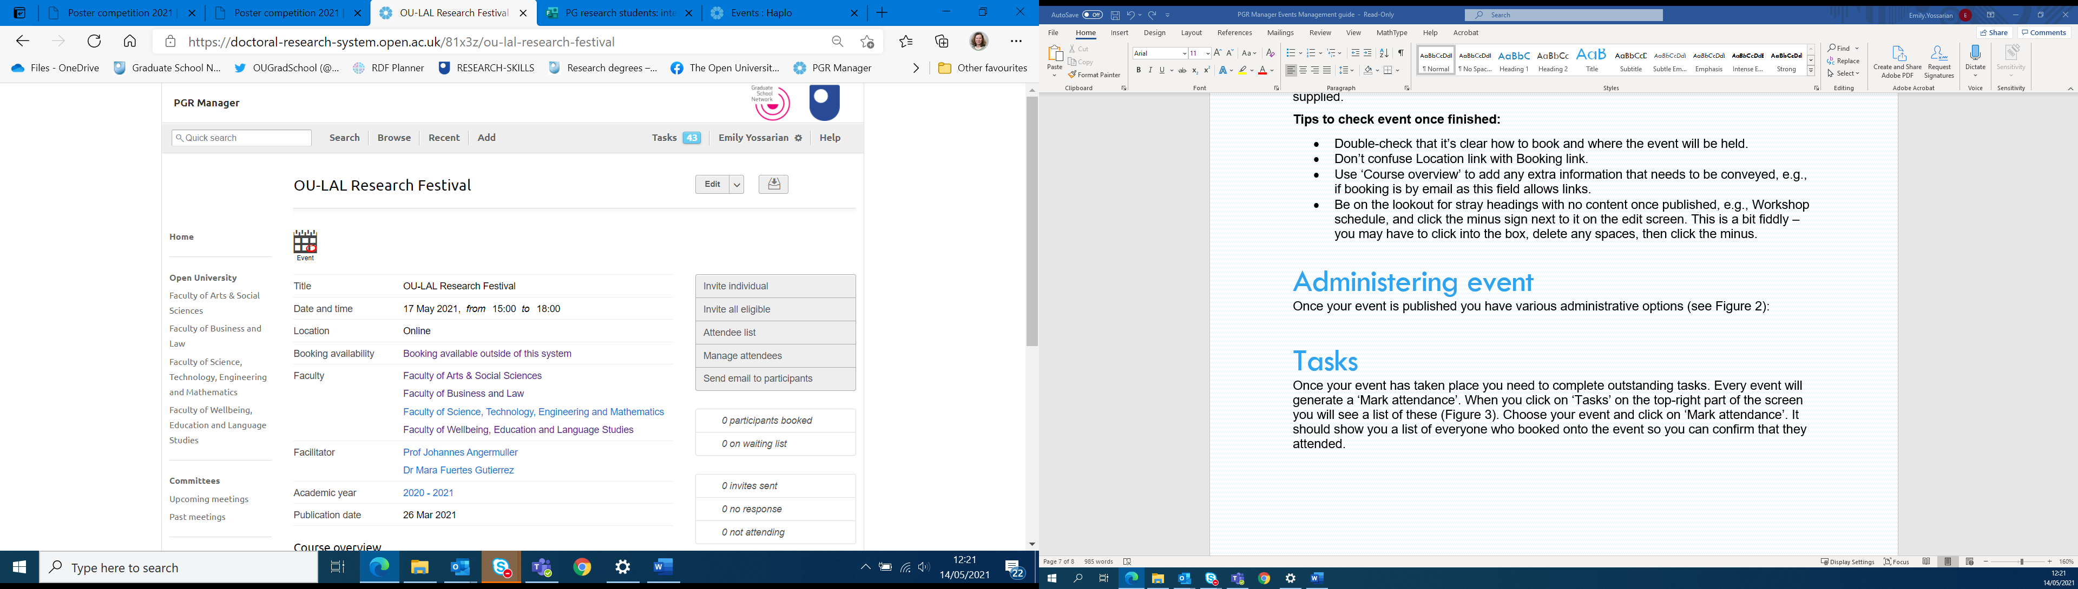

Figure 5 Administering event options

These options are fairly self-explanatory:

|  |  |
| --- | --- |
| **Invite individual:** | * Invite one or more individuals to the training event, adding additional messages and deadline for confirming. * This generates a notification email with any messages or information you’ve added (see Figure 3- ‘Hi Jeanette, did you get this?’ is the message we’ve added here.) |
| **Invite all eligible:** | * All eligible attendees (depending on which ‘Faculty’ options you have specified’) will receive a notification email- again, you can add a message or other information to this (Figure 3). * NB invitations sent this way will *not* reach ARC students |
| **Attendee list:** | * Click here to see a list of everyone who has booked a place on your event, plus those who have declined or cancelled. * You can also print off a sign-in sheet. |
| **Manage attendees:** | * Click here to mark attendance and/or manage a waiting list |
| **Send email to participants:** | * Click here to update your participants about any changes to your event. |

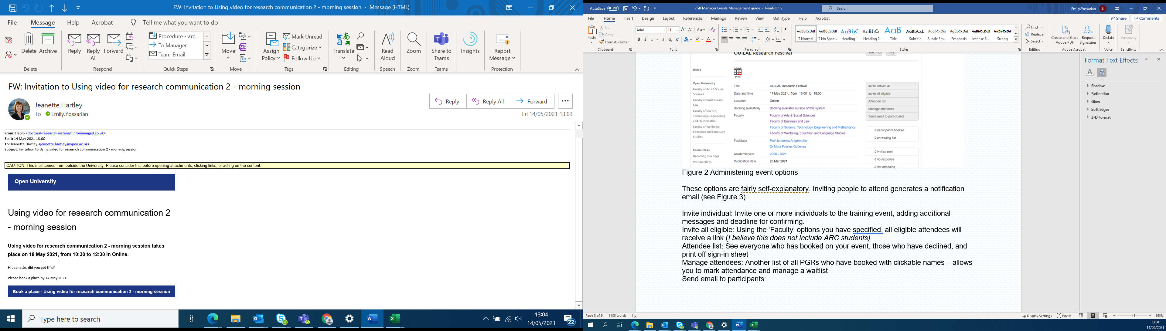

Figure 6 Email text when PGR is invited to event

Marking attendance at your event

**Once your event has taken place:**

* Mark attendance by clicking on ‘Tasks’ on the top-right of the screen and then selecting the ‘mark attendance’ prompt for your event (Figure 7).
* You will now see a list of everyone who booked a place on the event, so you can confirm that they attended.
* If you do not need to mark anyone as attending, just click on ‘Save attendance record’ and the Task will disappear. If it was an in-person event you should have an attendance list or note of who attended.

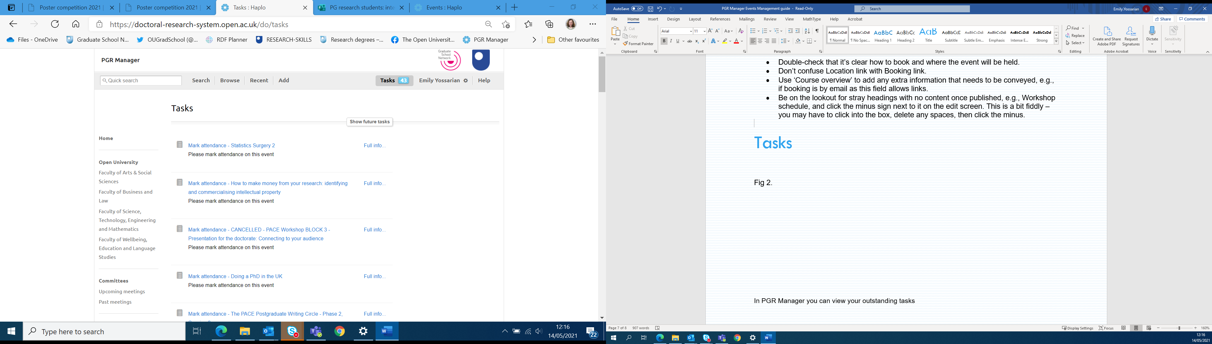   
Figure 7 Tasks for Event updaters

**For online only or hybrid training:**

* To find a participant list - go to the GS Training or your Teams calendar depending on who/how the invitation was set up.
* Go to date and find the meeting, either right click on the e.g. workshop below or click on ‘chat with participants’ or go to edit and pick up chat via options at top

|  |  |
| --- | --- |
|  | Once in chat, scroll down to near the end to the final attendance report. Click on attendance report to automatically download and pick up from downloads as an excel spreadsheet |

Alternatively, you can go into the Outlook calendar, go into the meeting and again pick up the attendance report from chat as below but you have to actually join the meeting so going in via Teams calendar then ‘edit’ or straight into chat can be easier. Whichever way go back to and follow ‘Mark attendance…’ above.

1. Once in the meeting, click or tap the Participants icon on the meeting controls to reveal the right column
2. From the "Participants" column, click or tap the three-dots icon
3. A drop-down menu appears. Click or tap Download the attendance list

Future of the PGR Manager Training and Development module

We’re just getting to grips with the best way to use this module, though in the long run we believe it will make adding and administering events easier for us and the PGRs.

We will be meeting with the third-party developer, Haplo, in early August to feedback on issues and ask for some tweaks.

Please let us know any questions you have or any improvements you’d suggest by emailing [pgrmanager@open.ac.uk](mailto:pgrmanager@open.ac.uk), and we’ll pass them on to Haplo.