Research Degrees Handbook
Directly registered PhDs
2023-24
This handbook has been prepared by the Graduate School at The Open University.

Graduate School
Phone +44 (0)1908 653806
Email research-degrees-office@open.ac.uk
For more information and opening hours https://www.open.ac.uk/students/research/content/contact-us

How to use this handbook
This handbook should be read together with the Conditions of Registration for PGR Students and the Research Degree Regulations prior to registration and subsequently referred to throughout the registered period. Upon acceptance of an offer of registration, students will be bound by the Conditions of Registration for PGR Students, the Research Degree Regulations and relevant policies on the Forms and Guidance section of the Graduate School Network website.
For readability, links have been embedded in the text. You will need to open a version online to click through to resources. Search for ‘Handbook’ on https://shorturl.at/jEQT3

Contents
Introduction 6
Part 1 Research degrees at The Open University 9
1.1 The Open University 9
1.2 Equality and Diversity 10
1.3 Research degree qualifications 10
1.4 Organisational structure 12
1.5 What a student should do if they need help 17
1.6 Administrative arrangements 18
Part 2 Essential information 19
2.1 University regulations, policies and codes of practice 19
2.2 Prevent principles 25
2.3 International students 26
2.4 Fees 29
2.5 Freedom of Information 29
Part 3 Studying for a research degree 30
3.1 Key milestones 31
3.2 Degree ceremonies 42
3.3 Directory of graduates 42
Part 4 Facilities and services 44
4.1 Library facilities and services 45
4.2 Computers 48
4.3 Statistics Advisory Services 49
4.4 Health and safety 50
4.5 Indemnity insurance 52
4.6 Studying with a disability or additional need 52
4.7 Mental health and wellbeing 54
4.8 Professional development as a researcher 54
4.9 Participating in Open University life 57
Part 5 Research degree complaints and appeals 62
5.1 Administrative appeals 62
5.2 Academic appeals 63
5.3 Complaints 63
5.4 Sources of advice 64
5.5 Other policies and statements 65
Part 6 Contact details 66
Research Enterprise and Scholarship Unit 66
Faculty offices 66
Other areas of the University 67
Appendix 1 Abbreviation list 69
Appendix 2: Timelines for first-year PhDs 71

Introduction

Welcome to The Open University
I’m Professor Lindsay O’Dell, Director of the Open University Graduate School, and I would like to welcome you to postgraduate research at The Open University (OU).
The OU’s mission is to be open to people, places, methods and ideas and this is reflected in its research which has the same openness and global reach.
You’re joining a research community of around 850 Postgraduate Research Students (PGRs), based at the state-of-the-art research facilities on campus in Milton Keynes, supported offsite, or working in one of the University’s Affiliated Research Centres (ARCs) around the world. Here are some (approximate) statistics about the make-up of this community:

Programme and mode of study
- Three-quarters of our PGRs are directly registered with the OU; one-quarter are based at ARCs.
- 85% are studying for a PhD; 15% are studying for a Professional Doctorate.
- Of directly registered PGRs, half are studying full time and half are studying part time.

Faculty breakdown
- The Faculty of Science, Technology, Engineering and Mathematics (STEM) has most PGRs (including most ARC students): about 50%.
- Then the Faculty of Wellbeing, Education and Language Studies (WELS) (including Professional Doctorate students) with just over 20% of PGRs.
- Faculty of Arts and Social Sciences (FASS) takes 18% of PGRs and then the Faculty of Business and Law (FBL) with 8%.

Research at the OU
The OU’s research shapes policy and practice, drives innovation and changes lives for the better throughout the UK and around the globe.
The latest Research Excellence Framework – the UK’s system for assessing the quality of Higher Education research – ranked the OU in the top third of UK universities for research power and 76% of the University’s research, which spans 21 broad and distinct disciplines, as world-leading or internationally excellent.
The OU’s Open Societal Challenges Programme, launched in 2022, aims to tackle some of the most important societal challenges of our time through impact-driven research.
The Programme’s focus on the themes of Tackling Inequalities, Living Well and Sustainability aligns well with the OU’s mission to be open to people, places, methods and ideas.
The Programme’s aim is to apply excellent research by OU academics to some of the most pressing challenges facing people across the UK and worldwide to transform lives and drive societal change.

General advice
We hope that you’ll refer back to this handbook throughout your programme with the OU, to check what to do around milestones and find sources of support when you need them. You may find the abbreviation list in Appendix 1 helpful while you’re getting used to the OU – we use quite a few!
We hope that you’re excited to get started on your research degree – it’s a joy to get immersed in a topic that fascinates you – but we know you may feel lonely or overwhelmed at times. We are especially conscious of the needs of our international students (making up 20% of directly registered students) who have travelled to the UK to enrich our research environment.
Treat yourself and others with kindness, and please be willing to reach out if you need help. Know that you have a team to support you in this journey – from your supervisory team and Faculty support; to the Graduate School team seeing you through general training, administrative processes and additional opportunities; to the wider University, including Library help, Disability Support and Careers advice. We’re looking forward to cheering you on!
Best regards,
Lindsay
Professor Lindsay O’Dell, Graduate School Director

Part 1 Research degrees at The Open University

1.1 The Open University
The OU is a world leader in modern distance learning, the pioneer of teaching and learning methods that enables people to achieve their career and life goals studying at times and in places to suit them.
It promotes educational opportunity and social justice by providing high-quality university education to anyone who wishes to realise their ambitions and fulfil their potential.
Through academic research, pedagogic innovation and collaborative partnerships, the University is a world leader in the design, content and delivery of supported open learning.
The University’s central headquarters is at Walton Hall, Milton Keynes, and it has four Faculty-aligned Student Recruitment and Support Centres (SRSC’s) and national centres located in Scotland, Wales and Northern Ireland. Over 1,000 academic and research staff are employed by the University, the majority of whom are based at Walton Hall which is the administrative and operational centre of the University, and where most of the research is undertaken.
The OU Graduate School launched in October 2016, and is a focal point for research degree community support. It leads on the development of research degree community networks, partnerships and training pathways to support an open, engaged and digitally literate research student community.
It promotes wellbeing and personal development and widening access to postgraduate opportunities.

1.2 Equality and Diversity
For more than 50 years, The OU has been promoting social justice and equality of opportunity which is core to our mission and is as important today as it was when The OU was founded.
The OU is creating an inclusive university community and a society, where:
- People are treated with dignity and respect.
- Inequalities are challenged.
- It anticipates and responds positively to different needs and circumstances.
For further details about equality and diversity at The OU, including its Equality Schemes, please visit the Equality and Diversity website.

1.3 Research degree qualifications
The University’s research degrees are:
- Master of Philosophy (MPhil) (full or part time)
- Doctor of Philosophy (PhD) (full or part time)
- Professional Doctorate, e.g. Doctorate in Education (EdD) (part time) and Doctorate in Health and Social Care (DHSC) (part time).

MPhil
For the Master of Philosophy a student must undertake a research programme leading to the submission of a thesis that is a distinct contribution to scholarship in the field. It needs to include a critical review of the literature and provide evidence of research ability. In order to be awarded the degree, students must demonstrate that they have met the expectations for the Master of Philosophy degree as specified in the QAA Framework for Higher Education Qualifications (see Appendix 1A of the Research Degree Regulations).

PhD
A thesis for the Doctor of Philosophy must be a significant contribution to knowledge, be worthy of publication and demonstrate the ability of the candidate to undertake further research without supervision. In order to be awarded the degree, students must demonstrate that they have met the expectations for the Doctor of Philosophy degree as specified in the QAA Framework for Higher Education Qualifications (see Appendix 1B of the Research Degree Regulations).
The OU also offers the opportunity for staff members to undertake a PhD by Published work. This is a separate degree pathway and any staff member intending to submit a portfolio of published works for consideration by the examiners must be registered on this degree pathway from the start.
Students registered on the MPhil/PhD pathway may include published work as appendices but cannot submit published work in lieu of thesis chapters.
The entrance requirements for all research degrees can be found in the Research Degree Regulations.

Professional Doctorate
Professional Doctorates are work-based programmes and studied part time. They offer students the chance to enhance their professional career to doctoral level enabling them to make a unique contribution to their profession, while continuing to work and progress in their field.
A Professional Doctorate may be awarded to a candidate who has demonstrated, through the presentation and defence of a thesis, to the satisfaction of the examiners, that the expectations outlined in Appendix 1B of the Research Degree Regulations have been met.

1.4 Organisational structure
Figure 1 shows the main teams and structures that support the research degree journey.
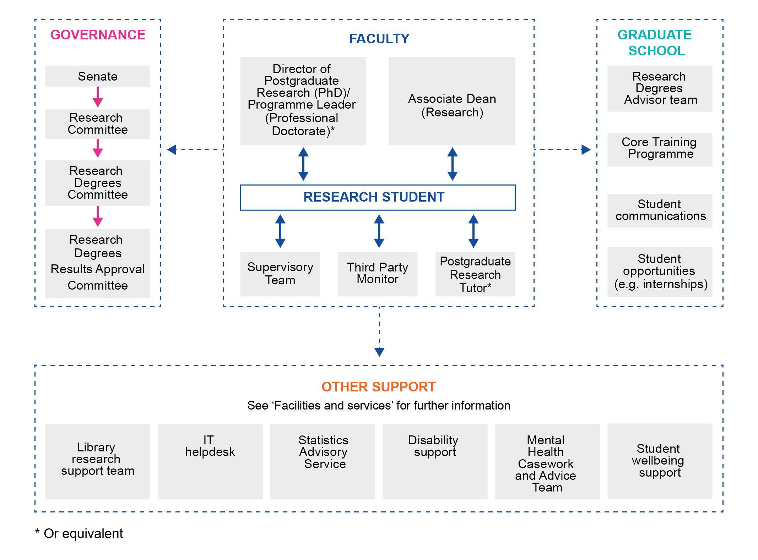
Figure 1 Organisation of research degrees

Governance
Senate retains overall responsibility for the governance and award of research degrees at the OU. It delegates responsibility for the development of research degree strategy, policy and regulations to the Research Committee and the Research Degrees Committee. Research degree policies, regulations and services for research students are reviewed annually and are aligned with the UK Quality Code for Higher Education. The Research Degrees Committee includes representatives of the University’s Faculties and research degree students (one full time and one part time).
Decisions about individual student cases are made by the Progress Board, chaired by the Graduate School Director with members including Head of Research Degrees, the Faculty Directors of Research Degrees and ARC Academic Lead.

Management in Graduate School and Faculties
The management of the day-to-day operation of the research degree programme is the responsibility of the Graduate School and the Faculties.
The Research Degrees Team within the Graduate School fulfils the registry function, providing quality assurance, managing student records and ensuring that student registration and progression is managed in accordance with the University’s regulations, policies, and legislation. The Graduate School runs the Graduate School Network (GSN) website and PGR Manager tool (more information about these in section 4).
Research students are recruited into research groups within a School in one of the University Faculties or Institutes. Where a research project spans more than one School, one School/Faculty will take the lead in all administrative matters relating to the registration.
Upon registration each student will be assigned a supervisory team and a third party monitor.
The Associate Dean (Research) or Director of Postgraduate Studies has oversight of all research students in their Faculty. This person is responsible for ensuring students are supported and progressing well throughout their studies. They work with administrative staff within the Faculty who help with the day-to-day management of the research student journey.

Supervision and third party monitoring
Supervision
MPhil/PhD research students have two internal supervisors who are members of the University’s academic staff and who are equally responsible for supervision. One of the supervisors will be the lead supervisor and will take day-to-day responsibility for the administrative issues and processes required for student registration, progression and completion. Students may also have an external supervisor appointed from an institution of higher education or a research institute who can provide additional expertise.
Supervisors and Faculty offices will make appropriate practical arrangements for students depending on the mode of study, e.g. office keys, security passes, library and computer access, health and safety training and any workstation assessment needed. Students will be introduced to staff and fellow students at an on-campus induction event and will be able to build networks of contacts at The OU and in the wider research community.
At the beginning of their studies, students and supervisors should discuss and agree day-to-day arrangements, including supervision meetings and key study milestones such as upgrade and progress monitoring, both of which are formally assessed in accordance with the regulations.
Full-time students should have a minimum of ten formal meetings per year and part-time students should have a minimum of five. It is expected that these meetings will be conducted in person. Students are expected to agree the outcomes of these formal meetings with their supervisors and it is the responsibility of the student to keep an agreed written record, which is uploaded onto the PGR Manager system. See more about PGR Manager in section 4.
At the first meeting, supervisors and students should discuss the direction of the research project and the amount and nature of communication, e.g., meetings, correspondence, email and video conferencing. Regular written reports and draft thesis chapters may be specified, or a student may spend a considerable period at the beginning of the project on a preliminary reading programme and literature survey before producing a significant piece of written work. All are uploaded onto the PGR Manager system under Supervision Meetings.
The process for progress reporting after upgrade is that an annual progress report is completed via PGR Manager by students and supervisors and signed off by their Faculty research degree leads. An informal progress report (not via PGR Manager) will be completed in Faculty before upgrade.
Students who have not made satisfactory progress will be provided with appropriate support but if unsatisfactory progress is sustained then registration may be terminated.
The Code of Practice for Supervisors and Research Students is detailed in Appendix 2 of the University’s Research Degree Regulations. This sets out guidelines for the conduct and responsibilities of the supervisors and students, and serves as a standard for external audits of research degree provision and research degree appeals. The University’s Supervision policy can be found on the Graduate School Network and serves as a standard for what is expected of students and their supervisors.
Third party monitoring
All students have an opportunity at least once a year to discuss their studies with a third party – someone other than the supervisors or head of discipline. Within The OU research degree programme, this opportunity is formalised through the appointment of a third party monitor by the Associate Dean (Research). The role of the third party monitor is to provide the student with independent support. The student should feel free to discuss with their third party monitor, in confidence, any matters that might affect their studies. Any records kept should be agreed by both parties.
Students should be advised of the name and contact details of the third party monitor during the first month of registration. The first third party monitoring session should take place no later than the fifth month of registration and, following this, sessions should be at least annually. Further details relating to third party monitors can be found in section 6 of the Research Degree Regulations.

1.5 What a student should do if they need help
Throughout a student’s studies, the University strives to provide the best support and guidance, in order to help towards the successful completion of their degree.
The University understands that sometimes a student may fall behind or have unexpected disruptions to their studies. Illness, bereavement, changes in domestic circumstances and financial difficulties can all impact on the ability to study. A student may also find that the project is not progressing as hoped.
Whatever the reason, a student should talk to their supervisor or third party monitor about the difficulties. The supervisor/third party monitor will help the student to find a way through the immediate problem and can ask for a study break and sometimes renegotiate deadlines. The student may also address concerns to the Postgraduate Research Tutor, Faculty Director of Research Degrees, Deputy Associate Dean (Research) or Associate Dean (Research) depending on the structure of the Faculty.
If a student needs help because they feel a process has gone wrong, they may want to appeal against an academic or administrative decision or complain about a service. Part 5 of this handbook explains the processes for appeals and complaints.
The University is committed to providing a high-quality service and will seek to resolve any problems as quickly as possible. The University considers all feedback to be an important source of information for improving services.
Students may contact the Graduate School directly. Contact details can be found in Part 6.

1.6 Administrative arrangements
The Research Degree Team within the Graduate School will be the main point of contact within the University on administrative matters. The Graduate School plays a major role in enhancing the quality of the University’s research degree provision and the experience of its research students and develops and implements policy that is approved through the governance structure. The Graduate School can also provide letters in support of visa applications, transcripts, and stamps for railcard and Oyster card applications.
The team of Research Degree Student Advisors provides advice and guidance on a wide range of topics before, during or after a student registers. This includes information on registration and fees, payment of grants and expenses, financial support, and key points in a student’s studies such as upgrade, progress reporting and examination.
The Graduate School is based in the Betty Boothroyd Library Building; see contact details and opening times.
The Graduate School is part of the Research, Enterprise and Scholarship (RES) unit, which is responsible for the Research Code of Practice, which sets out the standards that govern the conduct of research at the OU. The code is available on the Research policies website.
Also part of RES, the Research and Enterprise team at the OU supports academic staff, research staff and students with their endeavours in seeking external funding for research, and advice on intellectual property assignment and knowledge transfer.

Part 2 Essential information

2.1 University regulations, policies and codes of practice

Regulations
The Research Degree Regulations form part of a student’s contract with the University and any questions about them should be addressed to the Graduate School.
The Research Degree Regulations should not be read in isolation. It is important they are read in conjunction with other documentation including the University’s general regulations, the Conditions of Registration for PGR Students, the Code of Practice for Student Discipline, this handbook, and other relevant documents referred to therein. Below is a non-exhaustive list of the documents that students should refer to:
• Code of Practice of Research
• Fee rules on Forms and Guidance (Graduate School Network)
• Student Privacy Notice
• Complaints and Appeals Procedure
• Procedure for Dealing with Allegations of Research Malpractice or Misconduct on Research policies site
• Code of Practice for Student Discipline
• Student Computing Policy
• Open University Student Charter
• Academic Conduct Policy
• Research Ethics
• Fitness to Study Policy
Policies are inclusive of all OU Students, Learners, Enquirers and Alumni, regardless of age, civil status, dependency or caring status, care experience, disability, family status, gender, gender identity, gender reassignment, marital status, marriage and civil partnerships, membership of the Traveller community, political opinion, pregnancy and maternity, race, religion or belief, socio-economic background, sex, sexual orientation or trades union membership status.

Safe Space Reporting
The OU is committed to creating a diverse and inclusive environment in which everyone feels safe and is treated with dignity and respect. Unlawful discrimination of any kind across The OU will not be tolerated. Safe Space Reporting is available through an online tool Report + Support through which staff, students, learners and visitors are encouraged to report incidents of assault, bullying, harassment, hate crime, or sexual harassment. It also provides information about what you can do if these incidents happen to you, or to someone you know, and where you can find support.

2.1.1 Attendance and residence requirements
Attendance and residence requirements are outlined within section 8 (for MPhil/PhD) of the Research Degree Regulations.
Exceptions to the residency requirements can be considered where a student needs to be based at a distance from the University campus in order to undertake their research, or to fulfil work or caring responsibilities. In such cases it is imperative that the Faculty can demonstrate that regular and adequate supervision can be maintained and that the student remains fully integrated into the research environment.
There is also an Academic engagement and attendance policy (under ‘A’ in Forms and Guidance) that applies to all students and explains expectations around engagement and attendance.
How do I request annual leave?
Annual leave must be agreed with supervisors and therefore all students should log their absences/annual leave on PGR Manager (select ‘Absence’ on the ‘Student Project’ page). For students who are on a Student oute visa, approval is also needed from the Graduate School; this is due to our legal responsibilities as a visa sponsor.
We do sometimes encounter students who request annual leave where a study break would be more appropriate (or vice versa) and would therefore advise the student accordingly.
How many hours of paid work can a full-time student do?
The Regulations say that full-time students can work up to six hours a week (RD 8.6). This guideline was developed based on Research Council advice about how many hours paid work were advisable for someone doing a full-time doctorate. You need to declare any paid work to your supervisors and the Graduate School. In exceptional circumstances, you may submit a request for taking on paid work of over six hours in one week - contact the Research Degrees Team to discuss this.

2.1.2 Study hours, annual leave and paid work
Section 8 (for MPhil/PhD) of the Research Degree Regulations provides information on the expectations regarding minimum study hours, annual leave entitlement and paid work.
Please note, however, that regardless of mode of study, where a student is funded they must comply with the terms and conditions of their offer letter.

2.1.3 Absences and other disruptions
A student must inform their supervisors and the Research Degrees Team in the Graduate School if they are absent, or if their studies are disrupted for any reason including illness or injury for a week or more and a study break request should be submitted as soon as possible thereafter. A student who knows in advance that they are going to be absent for a month or more should request a study break ahead of time. Overly late requests for study break are not assured.
Supervisors and Associate Deans (Research)/Deputy Associate Deans/Directors of Postgraduate Studies are required to notify the Research Degrees Team in the Graduate School of any unauthorised absences or if they have concerns about disruptions to a student’s attendance or progress.
All information disclosed will be treated confidentially and sensitively.

2.1.4 Study break
A student may submit a request for a study break to suspend their registration via PGR Manager, in accordance with section 9 (for MPhil/PhD) of the Research Degree Regulations. Suspensions of registration are not punitive but are designed to provide the student with a break in studies during times of need, e.g. to cover a period of ill health.
For a student in receipt of a stipend there are financial implications of taking a study break. There is no additional funding to cover the period of the study break; however, it is possible to stop the stipend payments until such a time as the student returns to study. Alternatively a student may wish to continue to receive payments for up to two months of the study break. In this case, the total period of funding will not increase, even though the maximum registration date will be extended for the duration of the study break.
Upon return students will be required to have a ‘Return to Study’ meeting with their supervisor(s).

2.1.5 Extensions
In exceptional circumstances a student may extend their registration in accordance with section 10 (for MPhil/PhD) of the Research Degree Regulations though extensions to registration are not an automatic right. Where study has been disrupted students are expected to have requested a study break at the point of need. Students and supervisors are responsible for managing the research within the registration time frames and for flagging any issues to the Graduate School in a timely fashion.

2.1.6 Maternity, paternity and adoption leave
Students are entitled to maternity leave plus unpaid maternity leave, in addition to standard study break entitlement, if they meet the following eligibility criteria:
- currently registered and actively studying
- have been registered with the University for a minimum of 1 year full-time or 2 years part-time
- have not withdrawn or completed their studies.
The same applies where a child is being adopted if the student is the carer. Two weeks of unpaid paternity leave may be taken in addition to the standard study break entitlement. Self-funded students are not entitled to maternity pay but may take maternity, paternity or adoption leave.
Full details of maternity, paternity and adoption leave and stipend payments are available on the Graduate School Network (under ‘M’ on Forms and Guidance).

2.1.7 Withdrawal
Students who are considering withdrawing from their research degree should contact their supervisors in the first instance to discuss options.
Where a student decides to withdraw, the supervisor or student will need to submit a withdrawal request and input it onto the PGR Manager system under change requests/withdrawals where they are reviewed by Progress Board for approval.
Students who allow their registration to lapse without having submitted their thesis, or fail to return from a period of study break, will be deemed to have withdrawn from their research degree registration.
New students who accept a place on the programme but withdraw before their start date, will receive a full refund of any fees paid. For students in receipt of a grant, further payments will be stopped once appropriate notification has been received from the Faculty.

2.1.8 Appeals and complaints
Students can appeal against administrative and academic decisions of the University. For information on this and on the University’s Complaints procedure please refer to Part 5 of this handbook.

2.1.9 Feedback
The OU welcomes feedback from students regarding any aspect of their time as an OU research student, including any suggestions and ideas for improvements.
The Postgraduate Research Experience Survey (PRES) is carried out by universities across the UK and administered by Advance HE. The OU participates in PRES every two years. PRES feedback helps us to understand what is working well and what is not, so we can make improvements where they will be most relevant and useful.
The postgraduate research student-Graduate School (PGR-GS) liaison group exists to facilitate communication between students and the Graduate School on institution-wide issues affecting research students. We encourage you to let your representative know if you have some feedback on an issue that is affecting all or some students (specific problems are best directed to your supervisor or Faculty postgraduate tutor).
You can also email Graduate-School-Communications@open.ac.uk with any direct feedback.

2.2 Prevent principles
As an institution of higher education, the OU has an important role in providing appropriate platforms to challenge extremist views and ideologies. It achieves this through the provision of learning and research and the protection of academic freedom and promotion of free speech, debate and liberal values. Preventing people from being drawn into terrorism is synonymous with our concern for student and staff welfare and wellbeing. These factors and other important aspects of our response are contained in a set of OU Prevent Principles agreed by The Council November 2015. For further details please visit Prevent Principles.

2.3 International students

2.3.1 UKVI (UK Visas and Immigration)
The OU welcomes students from all over the world to its research degree programme. It recognises that coming to the UK to start a degree programme is exciting but can sometimes be overwhelming. The University can help the student to settle in, and provide help and support, including a dedicated induction session for students from overseas, documents in support of visa applications, support with finding private accommodation and information on opening a UK bank account.
The OU is a Student Route Visa Holder Sponsor, licensed by UK Visas and Immigration (UKVI), and sponsors full-time students from outside the UK and EU to study in the UK on Student Route visas. Full details of the immigration regulations for students can be found at UKVI.
A student requiring a Student Route visa will need to demonstrate that they can meet the UK Visas and Immigration requirements and The OU’s minimum English Language entry requirements (RD 2.4 in the Research Degree Regulations).
There is an Academic engagement and attendance policy (under ‘A’ in Forms and Guidance) that applies to all students; this helps Student Route visa holders ensure that their attendance and/or engagement pattern meets UK Visa and Immigration (UKVI) standards.
In order to fulfil its responsibilities as a Student Route Sponsor the University will need to copy and verify a student’s passport and visa for each year that they are registered as an OU student. The University keep records of attendance/absence and monitors these to ensure compliance and make them available to the UKVI.
A student studying on a Student Route visa must tell the Graduate School immediately if:
- their contact details change at any point in their studies
- they are leaving the country (even for short periods)
- they are going to be absent from studies for more than a week, including conference attendance and field study.
If a student needs to extend their student visa, they should scrutinise the guidance notes and application form on the UKVI website and then contact the Graduate School. The University reserves the right to withdraw sponsorship of a visa and refuse visa extension requests where a student is found to be in breach of national legislation and/or OU requirements. Therefore it is imperative that a student ensures that they are compliant with the up-to-date national and OU requirements, as they may change during the registration period.

2.3.2 Residency waivers
Residency waivers will not be accepted for Student Route students at any stage of their study. This includes the writing-up period.

UKVI say that I can do paid work for up to 20 hours a week under the terms of my visa, but the Regulations say only 6 hours a week - which is right?
The Research Degree Regulations (RD 8.6) are the guidelines you should follow in this case. They were developed based on Research Council advice about how many hours paid work were advisable for someone doing a full-time doctorate. You need to declare any paid work to your supervisors and the Graduate School. In exceptional circumstances, you may submit a request to take on paid work of over six hours in one week - contact the Research Degrees Team to discuss this.
Why does the University need to monitor Student Route students?
We understand that the monitoring of attendance and engagement can make International PGRs feel uncomfortable. However, we need to comply with external rules as part of our role as sponsors of your Student Route visa.
We do not have undergraduate or taught postgraduate international students at the OU; our compliance is only demonstrated by our relatively small number of international research students, so a small deviation from the rules by a PGR is much more serious for the OU’s sponsor status than for an institution with many international students on taught courses.

2.3.3 Study break
Students who entered the UK on a Student Route visa sponsored by the OU and are considering suspending their registration as a study break should consult the Graduate School as it may affect the terms and conditions relating to their leave to remain in the UK.

2.3.4 Maternity, paternity and adoption leave
Any Student Route students considering taking maternity, paternity or adoption leave must consult the Graduate School as it affects the terms and conditions relating to their leave to remain in the UK.

2.4 Fees
Fee Rules for Postgraduate Research Students, which includes information on sources of financial support, can be found at Fee rules under ‘F’ on Forms and Guidance. All students should read the policy prior to registration. The University will provide reasonable notice of any changes to the policy and the date that they will take effect.
From 2018, the UK government has introduced Doctoral Loans for study of doctoral programmes. The loans will provide a contribution towards the cost of study but they will not cover the full fees and living costs. Links to the product and eligibility criteria are available under ‘L’ on the Forms and Guidance.

2.5 Freedom of Information
The University has a Freedom of Information Publication scheme that provides a general right of public access to many types of information. The scheme can be accessed through the Freedom of Information website.

Part 3 Studying for a research degree

Part 3 contains information about the key milestones in research degree registration and information on sources of support and guidance; Figure 2 shows the key milestones and timings in full-time and part-time PhDs.

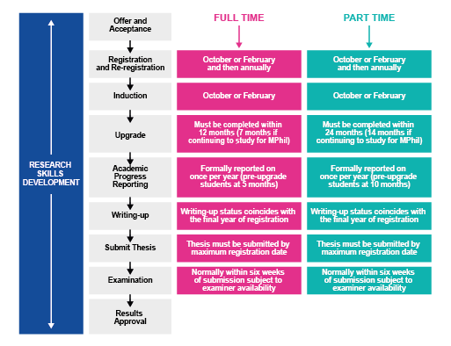
Figure 2 Key milestones during the registered period

3.1 Key milestones

3.1.1 Offer and acceptance
Prior to acceptance of an offer of registration students are expected to familiarise themselves with the Conditions of Registration for PGR Students, the Research Degree Regulations and the Fee rules on Forms and Guidance. Once a student accepts an offer of registration, the University will send information on completing registration and beginning life as an OU research student. Advice on getting started and networking at the OU, Milton Keynes and/or the UK can be found in the Advice pages of the Graduate School Network.

3.1.2 Registration
Students may register to start on either 1 October or 1 February each year. Students must come on to campus to register, to complete the relevant paperwork and to provide original proof of identity and original copies of qualifications for verification. Self-funded students will need to pay their fees prior to registration – information on the different ways you can pay will be included with your offer letter. Table 1 shows the range of periods of registration:
Table 1 Periods of registration
Type of Degree | Minimum | Maximum
MPhil Full-time | 15 months | 36 months
MPhil Part-time | 30 months | 72 months
PhD Full-time | 24 months | 48 months
PhD Part-time | 48 months | 96 months

Upon registration, all students will be given a ‘maximum registration date’ by which they must submit their thesis for examination. A student who fails to submit their thesis by this date will be deemed to have withdrawn from the course. The maximum registration date will be adjusted to take into account any periods of suspended registration or changes to mode of study. Minimum periods of study can be found in section 7 (for MPhil/PhD) of the Research Degree Regulations.
A student may not be registered for any other degree or qualification at any other institution, during their registration as an OU student (this applies also to multiple registrations at the OU).
The different timelines for a research student’s first year can be found in Appendix 2 of this handbook.

Upgrade and continued registration
As explained in more detail in section 3.1.4, all students start off registered for the degree of Master of Philosophy (MPhil) and must pass an ‘upgrade’ assessment to be eligible for continued registration.
For those students whose aim is to obtain an MPhil, confirmation of continued registration must be completed within the following time frames:
- 7 months for a full-time student
- 14 months for a part-time student
For students intending to read for a PhD, this will follow the upgrade process.
Where a student successfully completes upgrade or has confirmed continuation of registration, registration will continue until submission of the final thesis or until the maximum registration date as set out in the offer letter (or any subsequent correspondence from the Graduate School). This is subject to the proviso that the student continues to maintain satisfactory academic progress, adheres to the Conditions of Registration for PGR students, the Research Degree Regulations and the Codes of Practice listed therein and in section 2.1.

3.1.3 Induction
There will be several induction events that newly registered students are expected to attend.
The Graduate School works together with Faculties and Units to organise induction events in October and February for each new intake of students. At Induction, students are shown how to access the Graduate School Network (GSN) and PGR Manager, assess their training needs, and book places on relevant training courses.
International students who are new to the UK are invited to attend bespoke induction events to help them get settled in the UK, direct them towards sources of support and information, and ensure that they are supported to meet visa requirements.
In addition, Faculties and Schools will provide local induction activities to ensure students are settled and ready to begin their studies. For example, supervisors and Faculty offices will make appropriate practical arrangements for students depending on mode and place of study, e.g. any keys, security passes, library and computer access, health and safety training and any workstation assessment needed.
Students will be introduced to Graduate School staff, Faculty staff and fellow students and will be able to build networks of contacts at The OU and in the wider research community.
In addition, and as part of Induction, students should consider their training needs with their supervisors and conduct a skills audit which should be updated regularly during studies and forms a requirement for passing upgrade.
Skills training is available at University, Faculty and School levels to enable students to develop subject-specific and widely transferrable skills during their studies. Details are available via the Training page in the Advice section of the Graduate School Network.
Many Faculties/Schools have their own peer-mentorship or ‘buddy’ systems for new starters. The Graduate School also operates a University-wide student ‘buddy’ scheme, through which new PGRs can be put in touch with student mentors (see Connecting with the research student community).

3.1.4 Upgrade
Upon admission to the research degree programme, regardless of the qualification aim, all students are registered for the degree of Master of Philosophy (MPhil).
Student registration at this stage is probationary. Continued registration beyond year 1 for full-time students and beyond year 2 for part-time students intending to read for a PhD is dependent on the student passing upgrade. This requires the student to be assessed and a recommendation made about continuing registration and specific degree registration to Progress Board. Students who do not pass upgrade will not be eligible for continued registration.
Upgrade is a precursor to progression to PhD registration. Students are responsible for carrying out their upgrade assessments within the appropriate time frames with the support and guidance of their supervisors. If any ethical reviews or approval is required for the research study the expectation is that this will be completed prior to upgrade (see section 3.1.4.1). As part of the upgrade process, students are asked to confirm that they have undertaken plagiarism training (see section 3.1.4.2) and completed a skills audit.
The criteria for the upgrade assessment and confirmation of continued registration are outlined in detail in Research Degree Regulations RD 15.3–15.4 for MPhil students and RD 15.6–15.7 for PhD students.
Deadlines
The deadline for the completion of the upgrade process is as follows:
- full-time students – 12 months from the initial date of registration
- part-time students – 24 months from the initial date of registration.
It is imperative that upgrade reporting on PGR Manager reaches the Graduate School in time for the process to be completed (i.e. by the 11th month for full-time students and by the 23rd month for part-time students). The Research Degrees Team does not have the authority to accept late submissions and any extension can only be granted in exceptional circumstances, and requires prior approval, by Progress Board.

Outcomes
Based on the evidence obtained during the upgrade assessment the outcome will be one of the following:
- registration for the degree of Master of Philosophy (MPhil)
- registration for the degree of Doctor of Philosophy (PhD)
- the student is asked to make revisions to their upgrade report which will be reviewed; further registration will depend on it having been completed to the satisfaction of the assessors and confirmed by Progress Board
- registration should be terminated due to failure to make satisfactory academic progress and a failure to meet the upgrade criteria.

3.1.4.1 Ethics review/approval
The Human Research Ethics Committee Chair at the OU provides advice and support on ethics aspects of individual research projects.
All research degree students planning any research involving human participants, data gathered from human participants or human tissue, must carry out a thorough assessment of any ethics implications associated with their research, in discussion with their supervisors. As an integral part of this process students should request a human research ethics review.
The HREC IT system allows you to easily submit applications for human research ethics review using an online form. Web links to the system and applicant guidance are available through the HREC website.

It is imperative that no potential research participants are approached to take part in any research until formal ethics approval has been granted by the Human Research Ethics Committee, so the ethics review must take place before the data collection phase of the research project commences.
Information about policies supporting research, governance, integrity and ethics is on the OU’s intranet site and OU Research Website. More about the human research ethics review process is on the Research Ethics website.
3.1.4.2 Plagiarism
Plagiarism is the use of the work of other people (including text, images and ideas) to gain some form of benefit without formally acknowledging that the work came from someone else. The OU takes allegations of plagiarism very seriously and is making increasing use of plagiarism detection software. It is expected that a student develops and maintains best practice in their writing throughout the research and undertakes plagiarism training. In cases of suspected plagiarism, the University will follow ‘The Procedure for Dealing with Allegations of Research Malpractice or Misconduct’ (see Research policies). The plagiarism policy and the disciplinary procedures can be found in the Forms and Guidance section on the Graduate School Network.

3.1.5 Progress monitoring
Progress monitoring provides regular opportunities for a student and their supervisors to review work and to make plans on the future direction of the research. It also provides an opportunity for the student and all of the supervisory team to reflect on academic progression. Re-registration is conditional on a student maintaining academic progress. If there are any concerns about a student’s progress, they will be given the opportunity by the University to get back on track via support from the Faculty and School support network. The supervisors and the student should plan any remedial action with reference to the Procedures for addressing failure to make satisfactory academic progress, Appendix 3 of the Research Degree Regulations.
Progress monitoring reports are required for all MPhil/PhD research students and are submitted via PGR Manager. Progress is formally monitored once per year and should encompass a student’s progress throughout the previous year. A single report should be submitted by the Faculty to the Graduate School, with oversight of progress by the Research Degrees Committee.
The regulations relating to academic progression can be found in section 16 (for MPhil/PhD) of the Research Degree Regulations.
Where can I get advice on managing my research data?
The Research Support Team in the Library can help with Research Data Management (see section 4.1).

3.1.6 Writing-up period
A funded student will be encouraged to complete their thesis within their period of funding. Prior to starting to write the thesis, which should take the form of a monograph, students and supervisors should refer to the OU Thesis Submission Guidelines which provide information on the presentation of the thesis. These guidelines are available under ‘T’ in the Forms and Guidance section on the Graduate School Network.
Reference may be made in documentation (e.g. Fee rules on Forms and Guidance) to the writing-up period. This is a time-limited period in which the student is solely engaged in writing their thesis and is not undertaking any substantive research. The writing-up period normally coincides with the final year of registration and may incur a reduced fee liability. For full-time students this may be year four of registration. For part-time students the writing-up period may be year eight of registration. For any student to be designated as being in the writing-up period the student and the supervisor must confirm that the student will submit the thesis within that year.
What structure should my thesis take?
We don't have thesis templates, as it is impossible to suggest these across all fields and disciplines. Structures emerge with the work and in discussion with supervisors. Ask your supervisor to suggest a completed thesis to look at if you want a better idea of what is expected.
The Thesis Submission Guidelines (under ‘T’ in Forms and Guidance) give the typical basic elements of what a thesis should contain.

3.1.7 Thesis submission
Section 17 (for MPhil/PhD) of the Research Degree Regulations provides detailed information as to what is required for thesis submission. Additional information is provided in the Thesis Submission Guidelines which are available in the Forms and Guidance section on the Graduate School Network.
A thesis can be submitted at any time during the year, although those submitted during the summer may be subject to some delay if examiners are not available for the oral examination – the viva.
When the notice to submit is received, normally in advance of submission by three months, the supervisors will nominate an exam panel which is assessed by the Associate Dean (Research) (or delegate) and, if it meets the criteria, will be submitted to the Research Degrees Committee for approval. A minimum of two examiners is required. An Independent Examination Panel Chair will also be appointed. It is their role to make the examination arrangements and to ensure that the examination is run in accordance with the University’s regulations, policies and procedures. Once the examination arrangements are finalised, confirmation of the date, time and place of the viva examination will be communicated to all relevant stakeholders.

3.1.8 Examination
Section 19 (for MPhil/PhD) of the Research Degree Regulations provides detailed information as to what is required during the examination process. Additional information is provided in the ‘Examination guidelines for research degrees’ which are available in the Forms and Guidance section on the Graduate School Network.
Students and supervisors should read the Regulations and the guidelines carefully. These include information on the publication of papers, originality and joint work, the length and format of the thesis and any non-book components. The thesis must take the form of a coherent and cohesive monograph. Any additional material, e.g. non-book component or appendices including publications, data etc., must be clearly presented in relation to the argument of the written thesis and the creative work should be set in its relevant theoretical, historical, and critical or design context.
The student is required to attend the entire examination in person and defend the thesis to the examiners. A supervisor may be present as an observer at the oral examination. Invitation to attend is at the student’s discretion and should form part of the Examination Panel Nomination process.

3.1.9 Results approval
The examiners will normally advise the student of the recommendation at the end of the examination. At this stage the outcome is only a recommendation and must be approved by the Research Degrees Examination Results Approval Committee (RDRAC). At this point the Committee will confirm the outcome of the examination in writing.
Where further amendments are needed in order to meet the academic requirements of the award, the student will be informed in writing as to what is required. Students will continue to receive advice from supervisors whilst undertaking any corrections and amendments. Details are outlined in section 19 (for MPhil/PhD) of the Research Degree Regulations.

Award of degrees
If no corrections are required, the degree is awarded with effect from the date the examiners recommendations are approved by RDRAC. Where post-examination corrections are required, the date of the degree awarded will correspond to the date that the examiners approve the corrected thesis.
When RDRAC confirms that the thesis meets the requirements for the award of a degree, the student must submit an electronic copy (see ‘Thesis Submission Guidelines’ in Forms and Guidance) before the degree can be conferred. The degree and title of Doctor or Master of Philosophy are conferred in absentia by Congregation. The student will receive confirmation in writing of completion of the degree. At this point the student may use the title ‘Dr’ if awarded a Doctor of Philosophy.

3.2 Degree ceremonies
The University holds an annual series of degree ceremonies for the presentation of graduates. These are held in March to June and September to November in towns and cities across the UK. Graduates are presented to the Chancellor, the Pro-Chancellor, the Vice-Chancellor or one of the Pro-Vice-Chancellors or Executive Deans. The student may, if they wish, be presented at one of these degree ceremonies. They are always memorable and inspiring occasions. Details will be sent to the student when they become eligible.
More information about degree ceremonies can be obtained from the Ceremonies website or by contacting the Ceremonies Centre. Contact details are in Part 6. Information about the accessibility of each venue and hiring academic dress at the ceremony is also available on the Ceremonies website or by contacting the Ceremonies Centre.

3.3 Directory of graduates
The names of graduates attending each degree ceremony are produced and handed out as souvenir publications on the day of the ceremony. A full listing of the year’s graduates is also compiled by the University but is not available in printed format. These lists are all public documents. The University may also release names of graduates to be printed in national or regional newspapers and other publications.
A student who does not wish their name to appear in any of these publications must tell the University by writing to the Manager in the Ceremonies Centre.
Unless such notification is received the University will consider that it has consent to include a student’s name.

Part 4 Facilities and services

Research facilities
For funded students the University provides research facilities (laboratories, computers, workstations). For studentships that are not covered by a stipend, arrangements for access to research facilities is by negotiation with the relevant Faculty and should be agreed prior to the University issuing an offer of registration.

Online resources
These key websites support research students and collate links to services:
Graduate School Network (GSN)
The Graduate School Network is the gateway to forms, advice, opportunities, and links to training and development resources, as well as relevant University policies and regulations.
PGR Manager
PGR Manager is a bespoke system for managing your PGR student journey – bringing all information into one safe, secure and easily accessible system, streamlining administration processes, and simplifying progression monitoring and reporting. It also contains a Calendar that advertises training and development events, and a skills audit tool.
OU Life
OU Life is the OU’s intranet, which is accessible to both staff and PGR students. It contains lots of useful news, information, and resources, including a detailed IT Support A-Z. Students based on campus may also wish to visit the Estates section of the intranet, which has information on travel, catering, safety and security.

4.1 Library facilities and services
OU research students will need to make use of library resources as part of their research project. Library Services at the OU provides students with access to high quality and trusted resources that will support their research by enabling them to explore and keep up-to-date with the subject and undertake a structured literature review.
They include primary and secondary resources such as:
- academic journals
- newspapers
- academic books.
The Library also provides access to specialist resources, e.g. statistical databases, legislation, conference proceedings and datasets.
The OU Library’s collection of resources is available from the online library.
The document delivery service and inter-lending library service provides access to items that are not available in the Library’s online and print collections.
Reference management tools enable you to store and organise your references and automatically generate in-text citations and bibliographies in a variety of styles.
Library Services offers a programme of online training sessions which is open to all students. This includes an introduction to Library Services and Smarter searching with Library databases.
There is also a programme of face-to-face training and online training tailored for research students. Details can be found via the Training area of the Graduate School Network and Events on PGR Manager.
The OU’s open-access database of peer-reviewed research publications, Open Research Online (ORO), shows the range and depth of recently published OU research. Research students are required to upload their eThesis to ORO and are encouraged to deposit their publications. The Library Services Research Support team can give advice and guidance on where to publish, and dissemination of publications: email library-research-support@open.ac.uk.
Doctorate projects can create large amounts of research data, and this may be the student’s first experience of working with data on a large scale. The Library Research Support team provide advice, guidance and support in the management of research data. Open Research Data Online (ORDO) is the OU's research data repository.
EThOS, a service from the British Library, provides free online access to a large selection of UK PhD theses from participating universities. ORO provides access to a growing collection of Open-University-awarded theses. These will give an insight into the structure of theses, different approaches to research, and how to develop a thesis. More information about the library services and resources available for research students can be found on the Library page of the Graduate School Network.

Using the Library at Walton Hall
The OU Library provides a modern, spacious environment for study, research and collaboration.

Access to other libraries
Library Services is a member of SCONUL Access which enables access to, and borrowing of, books at other libraries which belong to the scheme. The scheme covers most of the university libraries in the UK and some in Ireland. The Libraries near you webpage also give details of access to other libraries including National Libraries.

Getting help
The Library Helpdesk, which provides specialist information advice, is available to support students with all library needs, seven days a week. The helpdesk contact details can be found on every page of the Library website. An out-of-hours webchat service is also provided to support students when the main helpdesk is closed.
For enquiries about Open Research Online and Research Data Management please contact the library research support team: library-research-support@open.ac.uk.

Conditions for use of Library facilities
Access to the University’s Library Services described above requires students to be bound by a copyright declaration.

4.2 Computers
Once a student has been registered, they will be given OU computer usernames (OUCUs) and passwords that allow them to access some OU systems including the PGR Manager system. Further IT guidance on signing on and passwords can be found under ‘I’ in Forms and Guidance on the Graduate School Network. It is the student’s responsibility to keep the password secure and confidential. In particular the student must:
- never tell anyone else the password, even University staff
- use the password in line with accepted best practice.
Advice on safe and secure computing is given in the Help Centre. If a student thinks that someone else knows the password, they should tell the IT Helpdesk by phoning +44 (0)1908 654321.
Students are expected to comply with the University’s Computing Code of Conduct.
How do I contact IT for help?
You can submit tickets about IT problems/questions via the AskIT ticketing service.
You can also contact the IT Service Desk on 01908 654321 (see IT Service Desk and Opening Hours).
If you cannot easily call the IT Service Desk and an issue is stopping you working (e.g., you work in a different time zone) then please email IT-Service-Desk@open.ac.uk with your username, any screenshots of errors being received or how far you are able to get.

4.3 Statistics Advisory Services
Advice about statistical aspects of research is available to all registered OU research students from the Statistics Advisory Service which is part of the School of Mathematics and Statistics. A major aim of the service is to encourage students to learn to deal with the statistical aspects of their research effectively and efficiently, by providing statistical advice both at the planning and at the data analysis stages of research. At the planning stage statistical advice can help to:
- ensure that the research study is efficient from the point of data collection through to completion and beyond, and that the design enables the student to address the research objectives
- identify best practices for data management.
At the data analysis stage the service can help to:
- identify suitable statistical methods to properly address the research objectives
- understand outputs from statistical computing software
- ensure that evidence-based conclusions can be drawn from the analysis.
Students are advised to seek statistical advice as early as possible, preferably while planning the study and before collecting the data. The Statistical Advisory Service is operated by email and commonly agreed appointment only.
Email stats-advisory@open.ac.uk to find out more.

4.4 Health and safety
The OU is committed to ensuring the health, safety and welfare of all those involved in the discharge of its undertakings, both within its designated premises and at external locations. Risk assessment is one of the main tools used in order to ensure adequate control measures are in place to manage the safety of individuals and is of particular importance when considering higher risk activities/environments such as laboratories or fieldwork.
The Management of Health and Safety at Work Regulations 1999 requires risk assessments to be completed to identify significant risks. The assessment must:
- identify significant hazards
- decide who might be harmed, e.g. students, and how they might be harmed
- evaluate the risks arising from hazards and decide if existing precautions are adequate or if more are needed
- record the significant findings if five or more people are employed
- review the assessment from time to time especially after a significant change or if there is reason to believe it is no longer valid and revise as necessary.
Risk assessments must be completed with supervisors prior to work/travel commencing. Any significant risks identified must be documented and the associated control measures identified. This may then require follow up with a documented Safe system of Work/Method statement. All of this information must be formally communicated to the students in order to provide them with the relevant information and instruction to allow them to work safely in their particular environment, ensuring the safety of them and those around them.
The OU laboratories are covered by a Safety Code of Practice which applies to all users, including students and their internal supervisors. Those responsible for the laboratories are responsible for ensuring that all users have been informed of the Code of Practice and the requirement to follow it.
The University has a specific duty under The Control of Substances Hazardous to Health Regulations 2002 (COSHH) to prevent exposure to substances hazardous to health or, if prevention is not reasonably practicable, to undertake an assessment to adequately control exposure. No work shall be commenced involving any activity likely to be hazardous to health until a suitable and sufficient assessment of the risks has been carried out. This process will identify measures required to control any activity involving a potential hazard to health.
Students and supervisors are formally responsible for ensuring that a written COSHH assessment is prepared for all experiments involving the use of substances conducted within The OU, at a host institution or in an external environment. They are expected to be familiar with, and ensure compliance with safety regulations applying to any laboratory and/or equipment used as well as the COSHH 2002 Regulations. More information is available at Health and Safety Executive and also at the Open University Health and Safety website.
The OU also requires risk assessment to be produced where fieldwork and international travel are involved. Guidance is available on both the Health and Safety intranet above and on the People Services website. It is standard practice within the OU to consult the Foreign Office website where international travel is involved as part of the travel risk assessment.

4.5 Indemnity insurance
The University has indemnity insurance for full-time and part-time directly supported students carrying out research related to their studies on University premises or carrying out University business (specifically on behalf of the University) elsewhere. (Note that this insurance is subject to the normal terms and conditions that apply to the University’s other insurances.) This insurance does not cover off-site fieldwork. An appropriate risk assessment should be carried out for all off-site fieldwork.

4.6 Studying with a disability or additional need
The University is an inclusive community and welcomes research students with disabilities or other requirements.
Whether a student is studying full time on campus or as a part-time student using their own research facilities, the University responds positively to the different needs and circumstances of the students. Where possible, the University will, for example, make reasonable adjustments:
- for students with a disability, health condition, mental health difficulty or specific learning difficulty (such as dyslexia)
- for students with other requirements such as:
  - pregnant or breastfeeding students
  - students with specific needs related to their religion or belief
  - students transitioning to a different gender
  - students with caring dependency responsibilities.
The student should inform the University as early as possible if support is needed as some services may take several months to arrange. The information the student provides will be used only to help the University to assist them in their studies.

Referral process
If a student has a disability or additional needs, they should discuss with their supervisor how these might impact on their studies and inform the Graduate School. Any information that they disclose will be confidential.
Some adjustments can be made immediately, such as making changes to the student’s workstation, arranging meetings in particular rooms to take account of sensitivity to sound or light levels, producing printed information in large format.
If the student is likely to need equipment, personnel or services to support them, the University will ask them to apply for a Disabled Students’ Allowance (please see Fee rules in Forms and Guidance on the Graduate School Network) to help with any costs arising from meeting their needs. Assuming they are eligible, the student will undergo an assessment and the University will discuss the recommendations with the student. The University will make reasonable adjustments to enable the student to study and the University will do so in consultation with the student and the School/Faculty.
If the student is not eligible for a DSA, the University may still be able to provide equipment, personnel and support – the Graduate School will liaise with the student, the student’s supervisor and Academic Services to discuss how best to support the student.

4.7 Mental health and wellbeing
It is not uncommon for research students to experience difficulties during their studies, e.g., disruptive life events, uncertainty or feeling that you can't go on. If you have a problem please let us know. You can talk to your supervisors, your third party monitor, postgraduate tutor, Associate Dean Research, the Graduate School or Student Services.
There are also a range of services available to support directly registered PGRs with their mental health:
- Employee Assistance Programme (online and phone support)
- OU Wellbeing app (online tools and resources)
- TalkCampus (online support network)
- SHOUT (text message support)
- Mental Health Casework and Advice Team (specialist one-to-one support service; available by referral).
To find out more about these support services and links to additional resources, please visit Student wellbeing on the Graduate School Network.

4.8 Professional development as a researcher

Research skills development
The Vitae Researcher Development Framework, (RDF) endorsed by Research Councils UK, informs The OU’s career development programme for research degree students. Vitae is an international programme dedicated to active career learning and development for professional researchers. In addition to supporting PGRs who are looking to pursue careers in research or academia, the Framework emphasises employability and transferable skills, and its employability lens provides an overview of the knowledge, behaviours and attributes most frequently desired by employers of doctorate holders. Students, as early career researchers, can expect to acquire these over the lifetime of their research degree programme.
You can audit and log your skill development using the tools on PGR Manager (access the ‘Development’ section in your ‘Student Project’ page).
The Graduate School Network (GSN) and Events on PGR Manager are gateways to online training and development resources at the OU, co-ordinating a wide range of professional development opportunities which are intended to support and supplement the research skills training available in the Faculties.

Career development
Students may access advice on all aspects of careers and employability planning and development via The OU Careers and Employability Services website.
OU research students can also access careers advice via the Graduate School Network:
- enhancing employability
- finding employment after a PhD
- CVs for PhD researchers
- applying for jobs
- job interviews
- resources for PhD researchers.
You can also request a consultation with the Career Team.
As a member of the OU research student community there are many opportunities to build networks and professional relationships. Students will normally join an established research group in their Faculty. This ensures that a student is placed within an appropriate, supportive environment from which to build and establish their identity as an independent researcher.

Teaching
The OU is a unique institution which has successfully developed its own style of teaching and module design; teaching opportunities at the OU are not conventional but will equip you with a distinct set of skills for the academic job market. Each Faculty offers the opportunity to get teaching experience and the schemes are outlined at Teaching opportunities.
There is also the opportunity to join The Brilliant Club for paid opportunities to deliver academically rigorous programmes to small groups of high potential pupils from low HE-participation backgrounds.
See more at Teaching opportunities.

Entrepreneurship
The OU organises an annual entrepreneurship competition seeking the top ideas from within the University’s student population. PGRs are encouraged to enter an idea, especially if there is the possibility of commercialising an element of their research. The OU can provide feedback on business models and expert advice on intellectual property. PGRs are also encouraged to take advantage of unique entrepreneurial skills training at various points throughout the year.
If you have any questions please get in touch with RES-student-programmes@open.ac.uk.

4.9 Participating in Open University life

4.9.1 Graduate School
The Graduate School’s PGR community organisers set up regular social events at our campus in Milton Keynes and online: see Connecting with the research student community for further information about these and other community options.
The Graduate School operates a lively Twitter account and we encourage PGRs to share their research degree experience by tagging us with @OUGradSch. There is also a Facebook page @OUGradSchool and non-OU-moderated Facebook group for postgraduate research students: PGRs at the OU.
Poster Competition and Bake Your Research
The Graduate School runs an annual Postgraduate Research Student Poster Competition which offers a unique way to engage the wider University community with your research. Researchers need to be able to convey their research ideas to a broad audience. This competition, judged by academic and academic-related staff from across the OU, provides students with the opportunity to practise these skills.
It also gives students the opportunity to meet other students from across the University and make useful contacts whilst raising their own profile. When the competition is finished the posters can be used at further networking events, conferences and displayed within schools.
We also run an online Community Choice category alongside the in-person Poster Competition so students who can’t make it onto campus can display their posters.
Each November sees our very exciting Bake Your Research event, where PGRs display research-inspired baked creations.

4.9.2 Open University Students Association
The Open University Students Association is here to provide a voice for all OU students (undergraduate, taught postgraduate and postgraduate research) and provide a vibrant community to support students during their studies. All students are automatically a member of the Association and there are plenty of ways to get involved.
The Students Association exists to ensure The OU is more than just a place of learning – it’s a student community. On social media these can be found here:
- Facebook @OUstudents
- Twitter @OUstudents
- Instagram @OUstudentslive.
Societies
Over 20 student-led societies are currently affiliated to the Association. From psychology to bell ringing – there’s something for everyone and staff are welcome too! There are also more informal, common interest groups: Clubs.
Student voice
The Association enables students to influence how the University is run by representing the collective needs of OU students. The OU Students Association provides many different routes for research students to be involved in student voice activity and have their voice heard: Get involved (oustudents.com).
There are many other ways to shape the work of both the Students Association and The OU and every two years, students have the opportunity to stand for election to become part of the Student leadership team.
For other volunteer roles check out the volunteering pages of oustudents.com.
Disabled Students Group – Student Support Group
The Disabled Students Group are a support group for students with additional challenges that affect their studies. They support each other to attain their individual study goals through closed online forums and a variety of other closed social media platforms.
OU Pride – LGBTQI+ Support Group
OU Pride is the OU Students Association LGBTQI+ group. It is open to all students, whether they self-define as LGBTQI+ or are an ally of the LGBTQI+ community. OU Pride’s aim is to educate and raise awareness of issues affecting their members and create social opportunities for LGBTQI+ students and their allies.
Shop and Discounts
Our OU Students Shop sells a wide range of OU-branded clothing and merchandise.
OU students are eligible for a TOTUM card which gives access to a wide range of discounts in the UK and abroad.

4.9.3 OU Club
For campus-based students, the OU Club has affiliated clubs for OU Staff and PGRs that may suit your interests, e.g. Orchestra, Choir, Yoga, and Hula Fitness. You can also find discount offers and hire games through the OU Club pages. Two STEM-based clubs that have a greater PGR mix include ROC SOC Club (Earth Sciences) and Hooke Society (Physical Sciences).

4.9.4 The OU Alumni Association
Joining The OU is the beginning of a lifelong relationship. Even when not studying, an OU qualification holder remains part of a vibrant learning community through The OU Alumni Association, set up by the University and staffed by a professional team. All graduates (and everyone who has successfully completed an OU qualification) have automatic free membership of the Association.
Members will be sent communications including the regular email newsletter OpenNews which contains the latest OU developments.
Members will also have access to the Alumni Association's website with opportunities to share their OU story, receive free career tips and advice and keep in touch by email. All that’s needed is the student’s OUCU and password (if these have been lost or forgotten, please contact the alumni team). Users will be able to access the site, set up groups, contribute in the forum areas, write blogs or simply look around at what’s on offer.

4.9.5 Association of Open University Graduates (AOUG)
The Association of Open University Graduates offers graduates the opportunity to keep in touch with other like-minded graduates with similar experiences. It is an independent, subscription-funded Association run by OU graduates for OU graduates. Members can maintain their links, while fostering new ones, and stay connected with the OU. AOUG supports the OU by giving awards to research students in Faculties and research centres and to new graduates in each region and nation.
Members’ benefits include:
- opportunities to network with OU graduates in the UK and internationally
- a website and forum, Facebook and Twitter, AOUG’s magazine OMEGA and local e-newsletters
- academic and social events including meetings, trips and weekends away.

Part 5 Research degree complaints and appeals
The OU aims to provide all students with an excellent learning experience that enables them to achieve their academic goals. The University recognises that sometimes things go wrong and, when they do, it welcomes the opportunity to put them right as soon as possible.
The Student Complaints and Appeals Procedures apply to all enquirers, applicants and research students. Students can obtain this procedure in alternative formats and seek help, advice and guidance on making a formal complaint or appeal from the Complaints and Appeals area of the Help Centre, and from either the Student Casework Office or the Graduate School.

5.1 Administrative appeals
The University defines an administrative appeal as ‘a request for a review of a decision taken by an individual or body charged with making decisions about any aspect of a student’s access to learning or learning experience with the University which is not an academic decision’.
Decisions about registration processes, fee liability, financial support, exceptional arrangements and reasonable adjustment which are not academic in nature are covered by the Administrative Appeals Procedure.
More information on administrative appeals can be found in the Help Centre.

5.2 Academic appeals
The University defines an academic appeal as ‘a request for a review of a decision of an academic body charged with making decisions on admission, assessment, student progression and awards’.
Decisions about entry requirements, reasonable adjustments for assessment for students with disabilities, progression rules, academic misconduct, thesis submission and the award of qualifications would be covered by the Academic Appeals Procedure.
More information on academic appeals can be found in the Help Centre.

5.3 Complaints
The University defines a complaint as ‘an oral or written expression of dissatisfaction concerning the provision of a programme of study or related academic or administrative service, which is not an appeal against a decision’.
Concerns about the provision of a service or facility or the failure to provide a service or facility, where the standard of the service or facility has fallen below the standard that might reasonably be expected, or where there is a reasonable expectation that the service or facility would be provided, would be covered by the Complaints Procedure.
More information on the complaints procedure can be found in the Help Centre.

5.4 Sources of advice
Advice is available from:
The Research Degrees Team
The Open University
Milton Keynes
MK7 6AA
Phone +44(0)1908 653806
Email research-degrees-office@open.ac.uk
The Student Casework Office
The Open University
PO Box 5155
Milton Keynes
MK7 6YJ
Phone +44(0)1908 659535
Fax +44 (0)1908 659536
Email studentcaseworkoffice@open.ac.uk
The Open University Students’ Association
Central office at Walton Hall, Milton Keynes
Email ousa@open.ac.uk

The Office of the Independent Adjudicator
Second Floor
Abbey Wharf
57–75 Kings Road
Reading
RG1 3AB
www.oiahe.org.uk
Casework Support Team: +44 (0)118 959 9813
(Calls to and from this office may be monitored for quality control and training reasons.)

5.5 Other policies and statements
A student can access the University's other regulations, policies and statements on the Student Policies and Regulations website.
All policies and statements relevant to research students can be found on the Graduate School Network.

Part 6 Contact details

OU postal address
The Open University
Walton Hall
Milton Keynes
MK7 6AA

Research Enterprise and Scholarship Unit

Graduate School
Phone +44 (0)1908 653806
Email research-degrees-office@open.ac.uk
For more information and opening hours https://www.open.ac.uk/students/research/content/contact-us

Enterprise Team
Email RES-Research-Enterprise@open.ac.uk
Website https://www.open.ac.uk/research/engagement

Research Ethics
Email research-ethics@open.ac.uk
Website https://www.open.ac.uk/research/governance/ethics

Faculty offices
Contact details for all research areas can be found on the research website.

Other areas of the University

Ceremonies Centre
The Open University
PO Box 123
Milton Keynes
MK7 6DQ
Phone +44 (0)1908 541079
Email ceremonies@open.ac.uk

Student Casework Office
Email studentcaseworkoffice@open.ac.uk

Data Protection Coordinator
Email data-protection@open.ac.uk

The Open University Library
Walton Hall
Milton Keynes
MK7 6AA
Phone +44 (0)1908 659001
Email form https://www.open.ac.uk/library/help-and-support/contacting-the-helpdesk

IT Helpdesk
Phone +44 (0)1908 654321
Website https://openuniv.sharepoint.com/sites/intranet-it/Pages/it-helpdesk-opening-hours.aspx

Open University Students Association
Email ousa@open.ac.uk
Website https://www.oustudents.com/contact-us/

Statistics Advisory Service
Email stats-advisory@open.ac.uk
Website https://www.open.ac.uk/students/research/OU/content/services/statistics-advisory-service

OU Alumni Association
Email alumni@open.ac.uk
Website www.open.ac.uk/alumni

Association of Open University Graduates
Phone +44 (0)1908 653316
Email aoug@open.ac.uk
Website https://www.aoug.org.uk/

Appendix 1 Abbreviation list
Abbreviation | Stands for…
ADR | Associate Dean Research (Faculty)
ARC | Affiliated Research Centre
DHSC | Doctorate of Health and Social Care
DRD | Director of Research Degrees (Faculty)
EdD | Doctorate in Education
ETHOS | E-Theses Online Service (British Library)
FASS | Faculty of Arts and Social Sciences
FBL | Faculty of Business and Law
GSN | Graduate School Network (website)
HREC | Human Research Ethics Committee
MPhil | Master of Philosophy
ORDO | Open Research Data Online (Library)
ORO | Open Research Online (Library)
OU | Open University
OUCU | Open University Computer Username (IT)
PGR | Postgraduate Research/Postgraduate Researcher/Postgraduate Research Student
PhD | Doctor of Philosophy
RDC | Research Degrees Committee
RDF | Researcher Development Framework (Vitae Skills Framework)
RDO | Research Degrees Office (now the Research Degrees Team within the Graduate School)
RDRAC | Research Degrees Examination Results Approval Committee
SCONUL | Society of College, National and University Libraries
STEM | Faculty of Science, Technology, Engineering and Mathematics
UKVI | UK Visas and Immigration (Government department)
WELS | Faculty of Wellbeing, Education and Language Studies

Appendix 2: Timelines for first-year PhDs

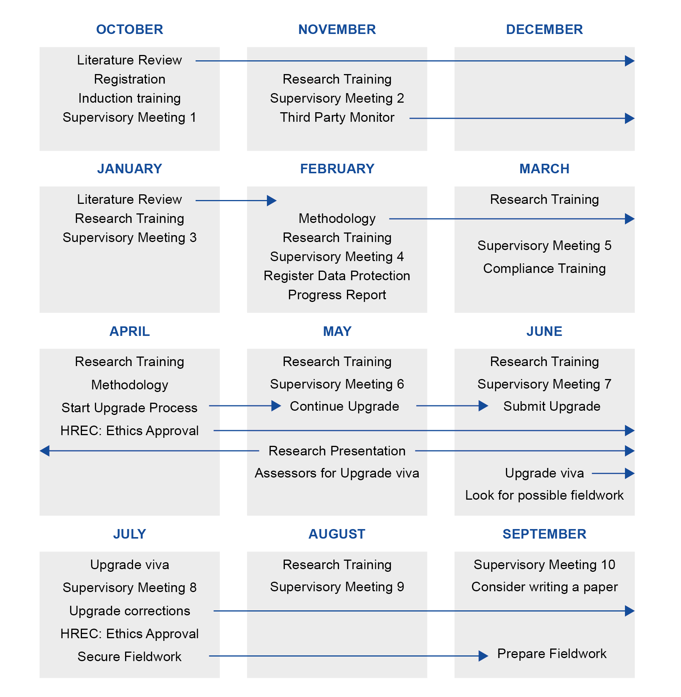Figure 3 First year full-time PhD timeline (October start)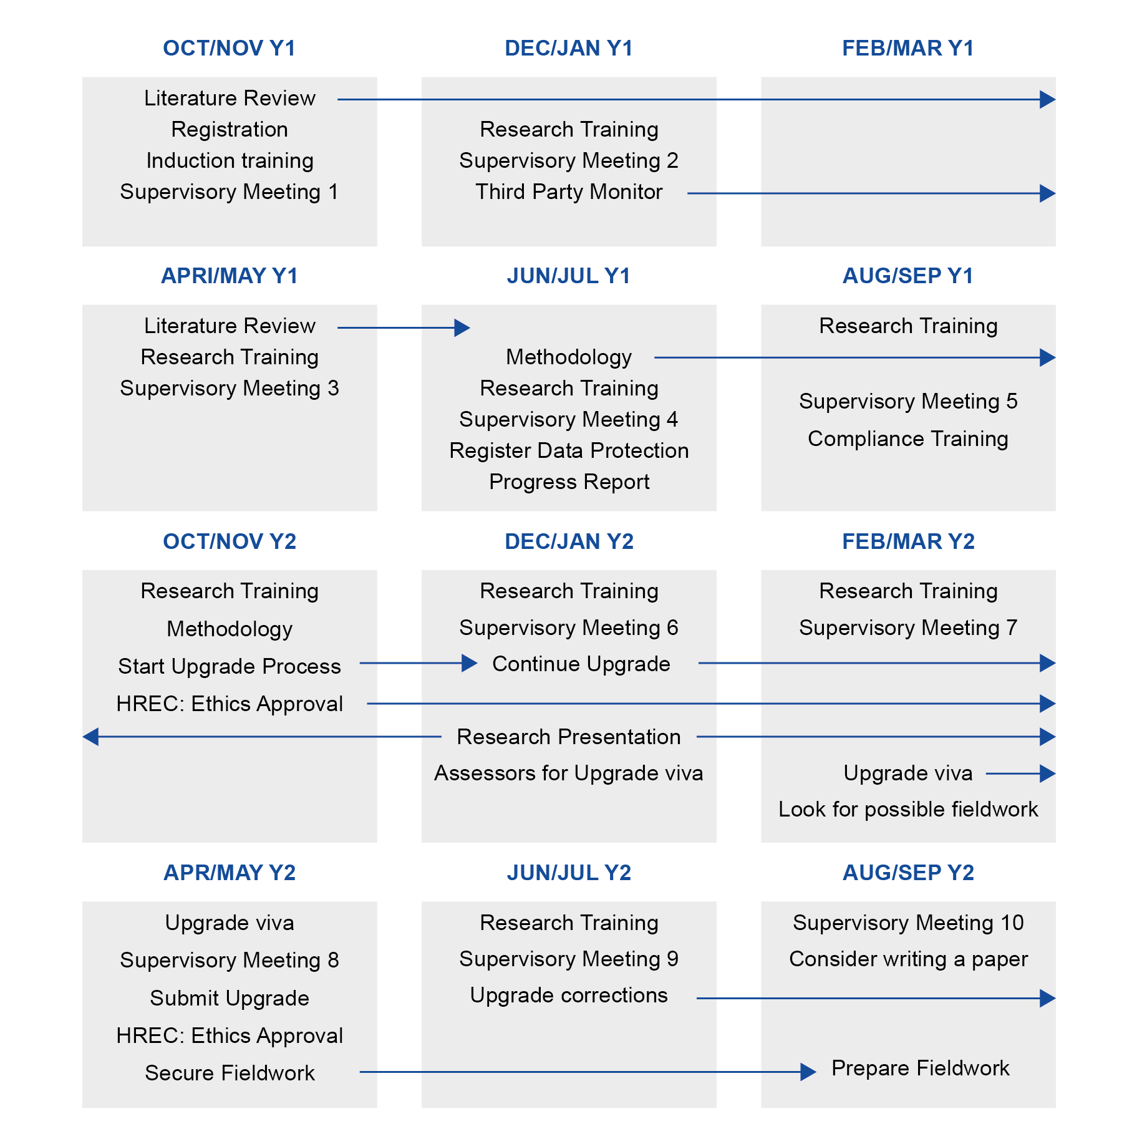
Figure 4 First two years part-time PhD timeline (October start)

