# The Open University’s Access, Participation and Success seminar ‘Words Matter 2’ – Tuesday 21 November 2023

# Presenter abstracts and bios

Chair – Mychelle Pride

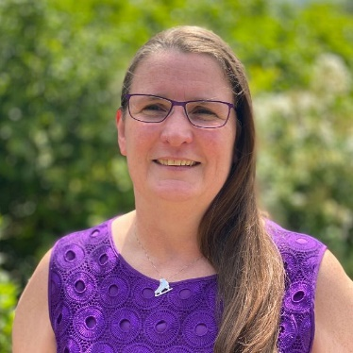With more than twenty years’ experience in the sector, Mychelle’s work has focused on enabling students to achieve to the best of their abilities. In her current role as Academic Director, PVC-Students, Mychelle provides learning, teaching & assessment direction aimed to enhance the OU study experience and to ensure high standards across the PVC-S portfolio. Previously as Associate Dean Teaching Excellence in the Faculty of Wellbeing, Education and Language Studies (WELS), Mychelle had strategic responsibility for student success, student voice/engagement, access, participation & success (APS), [recognising and rewarding teaching excellence](https://wels.open.ac.uk/news/wels-awards-2022-winners-announced), and led Teaching Excellence initiatives.

With an MA in Slavic Linguistics, a Bachelor’s in Scandinavian Studies and Russian Language and Literature and a Certificate in Teaching English to Speakers of Other Languages (CELTA), Mychelle has always had a keen interest in words. This likely stems from the fact as a young child she regularly played with children who didn’t speak English and her mother was an English teacher. At age 10, Mychelle and a friend even made up their own language.

## Presenters

University of Wolverhampton

Title of presentation: Bridging the Gap: The Limitations of Language

**Abstract:** In this presentation, I will argue that, oftentimes, there is a disconnect between the words widening access practitioners use to describe their work and the students with which they work. Terms like “underrepresented” and “disadvantaged”, which categorise students as a homogenous monolith, fail to include the multiplicities of contexts and experiences within cohorts of students and create a disconnect between learners and Higher Education. What matters to students is their own lived experiences and I will demonstrate that it is up to us as practitioners to understand these varying contexts and build connection. In this presentation, I will outline how I developed this approach through communicating my doctoral research to Year 8 to 10 pupils in non-selective state schools to give them the knowledge, skills and confidence to go onto highly selective universities. I sought to bridge the academic gap and disconnect by connecting with their own lived experiences and drawing on their pre-existing knowledge. I will also demonstrate how I continue to utilise this approach within the context of widening access campus visits and attainment raising sessions in schools.

Dr Frankie Morgan – Aspire to HE Progression Officer, University of Wolverhampton

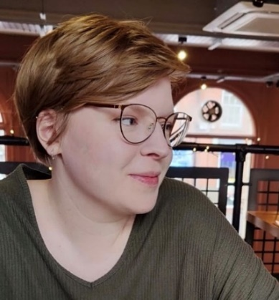Dr Frankie Morgan is a Progression Officer at the UniConnect partnership, Aspire to HE, at the University of Wolverhampton, supporting pupils across the Black Country and Telford and Wrekin to make informed decisions about their future and achieve their full potential through Higher Education. She has also worked as PhD Tutor for The Brilliant Club, delivering research-driven content and university-style sessions in non-selective state schools to give pupils from underrepresented backgrounds the skills, knowledge and confidence needed to progress to highly selective universities. As a young person, Frankie benefited from a number of widening access initiatives and so has personal experience of why “words matter” in this area. Frankie also has a PhD in Gender Studies and has researched and spoken extensively about contemporary feminist activism, social media and teaching feminism and sensitive topics within secondary schools.

# University of Leeds

Title of presentation: What can it mean to feel under-represented?

**Abstract**: This presentation explores the term “under-represented” and what it means to be a student who feels under-represented. Contrary to some perspectives which view under-representation as a deficit status and something that is problematic or an issue to be solved, this presentation seeks to celebrate and elevate the concept of under-representation. It does this by drawing on extensive reverse mentoring research undertaken in partnership with undergraduate students across disciplines who self-identify as under-represented. It explores how the language staff use when seeking to engage a diverse range of students can make a significant difference to their willingness to get involved with co-curricular initiatives. It also considers how engaging under-represented students to work on initiatives designed to enhance experiences for under-represented students at large can support those students to recognise the value in feeling and being under-represented. It celebrates the power of creating micro-communities of under-representation who together, make change happen.

Rachael O’Connor – Associate Professor in Legal Education and Academic Lead for Personal Tutoring, University of Leeds

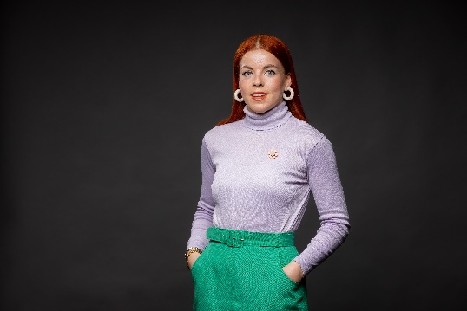Rachael (she/her) is Associate Professor in Legal Education, University Academic Lead for Personal Tutoring and LITE Fellow at the University of Leeds. Rachael is a CrossFit addict, community musical theatre performer and dedicated vegan. She comes from a working-class background and was first generation in her family to go to University. This contributes towards Rachael’s passion for improving University experiences for under-represented students and amplifying stories of under-representation. Rachael’s scholarship focuses on developing authentic staff/student relationships through reverse mentoring. She has won prizes internally and externally and published many papers on reverse mentoring. Rachael is a Senior Fellow of the Higher Education Academy and Michael Beverley Innovation Fellow. Her current work explores the intersections between reverse mentoring and academic personal tutoring. Rachael is trustee of mental health charity LawCare and is currently piloting an inclusion and wellbeing focused reverse mentoring scheme in the legal profession in partnership with LawCare.

# The Open University

Title of presentation: Who ‘Belongs’ Anyway?: Looking at APP students’ own words to explore the accuracy and purpose of the term ‘belonging’

**Abstract:** ‘Belonging’ is a widely used term across HEIs, particularly in reference to widening participation initiatives. We invite attendees to question what it means to ‘belong’ in any context but more specifically, what it means to ‘belong’ in an institution that is open to all, where there truly is ‘no typical OU student’ (Facts and figures | About The Open University). Using qualitative and quantitative student feedback that has been collected as part of the Personal Learning Advice Service’s 2022/23 Project Reviews, we invite participants to explore what is it that APP students value in their own words and the place of belonging within that.

Helen Williams **–** Senior Manager Personal Learning Advice Service

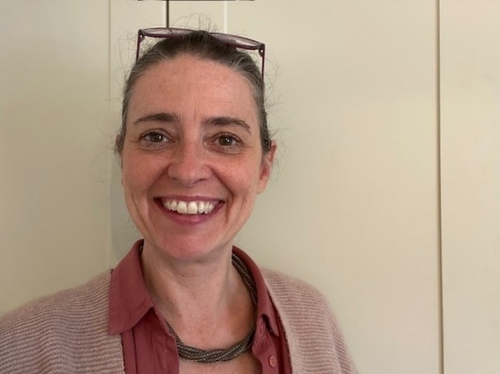Helen Williams started her career as a Geography teacher in secondary schools in Bradford just over twenty years ago. Following this she worked in a consultancy, coaching and management capacity within a local authority, the NHS and Teach First. Committed to life-long learning in the service of supporting and developing others, she holds a Masters of Arts in Special Educational Needs, PGDip HR Management, PGCert Healthcare Leadership and an ILM Level 5 Certificate in Mentoring and Coaching.

Enya-Marie Clay – Personal Learning Adviser, The Open University

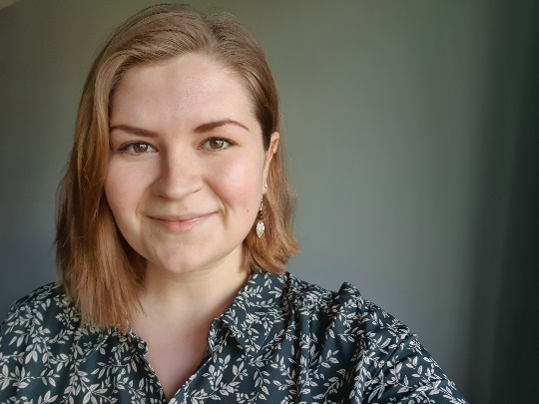Enya-Marie Clay joined the Personal Learning Advice (PLA) Service at the Open University in January 2021. Enya has trained as a Career Leader and has worked in Further Education as an Operational Careers Lead and Librarian. Prior to this, Enya worked in Higher Education in various student-facing Widening Participation roles with a focus on student engagement, mentoring, and tutoring. Enya holds a MLitt researching the ethics of Holocaust representation in children’s literature from Newcastle University, a Level 6 Certificate in Careers Leadership (RGG Associates), and a Level 2 Certificate in Counselling Skills. Enya is currently working towards a Level 5 Coaching Professional Apprenticeship (BPP) and has recently completed the AdvanceHE Aurora Women’s Leadership programme in 2023.

Enya’s key interests include improving accessibility and equitable practice within education and inspiring a love of learning through creative and collaborative staff-student approaches.

Jo Blissett **–** Personal Learning Advisor, The Open University

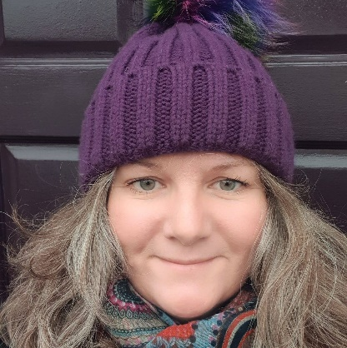Jo Blissett has over 20 years’ experience as a Learning Development professional. As a Staff Development Coach, she saw first-hand how individuals benefit from coaching; Jo has taken this knowledge and experience into Higher Education. Jo has worked as a Personal Learning Advisor (PLA) within the OU Personal Learning Advice Service since January 2021. She delivers 1:1 student coaching/mentoring support to students identified within the OU Access and Participation Plan. She is also responsible for creating and delivering a range of student group coaching workshops focussing on building study confidence and study success. Prior to joining the OU, Jo has worked for 10 years with a number of UK universities, supporting students through a range of Widening Participation projects. Jo is passionate about providing equitable access and support to meet the needs of all HE students, often challenging and questioning institutional inadequacies. She is currently undertaking a Postgraduate Certificate in Autism (Adults) with the University of Birmingham.

# The Open University

Title of presentation: ‘She’s like a mother to the Course’: a gender analysis of Student-Led Teaching Award nominations

**Abstract:** Student-Led Teaching Awards, as their current format, were introduced into Higher Education in the UK 2009/10 in a pilot scheme run by the National Union of Students and the Higher Education Academy (now called Advance HE). Student-Led Teaching Awards give an opportunity to students to nominate their lecturers for awards such as Best Lecturer and Best Supervisor. This presentation summaries a research project that aimed to use the wealth of nominations gathered for the Student-Led Teaching Awards for another purpose other than recognition. The project aimed to understand how students perceive their male and female lecturers, and how this differed. Analysis of the Student-Led Teaching Awards nominations showed that students perceived female lecturers as caregivers, family-focused, and maternal. Students perceived their male lecturers to have more free time, be career-focused and are not perceived to be fatherly. The guidance given to students when nominating, is more likely to be used in nominations for male lecturers, who are more likely to be nominated and win an award. This presentation considers how words matter, particularly in relation to gender bias in Higher Education.

Sophie Banks – Student Voice Manager/PhD Candidate, The Open University

Sophie Banks is the Student Voice Manager at the Open University and has previously worked in student voice in the Welsh Higher Education setting. She is a student on the Doctoral Programme for Education Research in Lancaster University. Her thesis focuses on how students perceive lecturers of different genders when nominating for a Student-Led Teaching Awards, which includes producing creative nonfiction to demonstrate the results. She is on set to complete her PhD early 2024 and hope to continue researching Student-Led Teaching Awards in the future.

## Panel members

Farnaz Rais (Chair) – Stakeholder Engagement and Delivery Lead – APS within the PVC-S unit, The Open University.

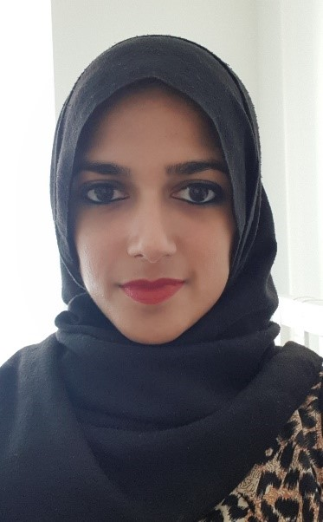Farnaz Rais is a Stakeholder Engagement and Delivery Lead in the Access, Participation and Success Team. Her work focuses on reducing inequitable education across the OU, predominantly through the implementation of the Access and Participation Plan. She liaises with colleagues to shape strategy and oversee initiatives aimed at reducing inequity. Farnaz has a passion for reducing barriers to education and as a person who has lived experience of discrimination and prejudice, she feels a responsibility to amplify the voices of those that have been marginalised. In her writing and teaching of English Language and Literature, Farnaz recognises the poignancy of words and the power they can wield.

John Brennan - Professor of Higher Education Research, The Open University

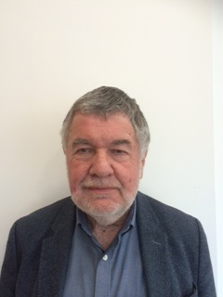John Brennan is a sociologist who has been researching higher education throughout his career. For 20 years he was Director of the Open University's Centre for Higher Education Research and Information. Since retirement, he has remained very active in higher education research, working with universities of Bath, Oxford and the LSE, as well as the OU, and on projects funded by UNESCO, the EU, the British Council and others. His interests are on the social impacts of higher education, taking account of its diversity, but also its history and the policy differences. He likes the concepts of the 'vertical' and 'horizontal' differentiation of higher education systems, with the UK system usually regarded as a good example of the former. John has published 13 books or more about higher education and has done extensive work internationally. He is a member of the ESRC Peer Review team and is currently a member of PuLSE in the Business School and of LiFHE in WELS at the Open University.

## Dr Gurnam Singh

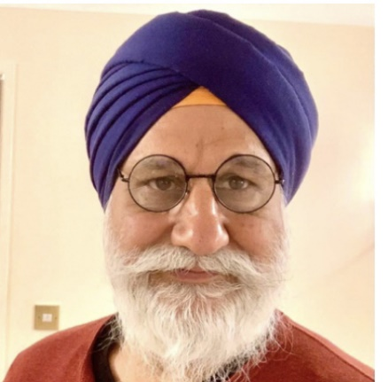Dr Gurnam Singh is an activist researcher, writer, and educator whose work is dedicated to highlighting and disrupting systems and mechanisms of power, privilege and violence that lead to human suffering and inequity. Currently, he is Hon Associate Professor of Sociology University of Warwick and Visiting Fellow in Race and Education, UAL, London. Formerly, he was Associate Professor of Education at Coventry University. In 2005 was completed a PhD at the University of Warwick focussing on anti-racist social work. In 2009 he was awarded a National Teaching Fellowship (NTF) for his work on critical pedagogy and higher education, and in 2018 was accepted as a Fellow of the Royal Society of the Arts (FRSA). He has published 4 books, over 40 peer review papers/chapters/review articles and 200 keynote conference papers on a widely range of issues, including, race, racism, anti-racism, diversity, decolonisation, ethics, higher education and social work. Currently his work is focussed on all aspects of higher education and decolonisation with a particular focus on the rise of generative AI.

Recent relevant academic outputs during the past year:

* Singh, G (2023) Decolonising bibliographies, referencing and citational practices – Keynote at the CALC (Critical Approaches to Libraries Conference 24/25 May 2023. Available at: <https://www.youtube.com/watch?v=MPfrbE484I0>
* Singh, G (2023) The age of artificial intelligence (AI) – lessons from history, presentation at the ‘Artificial Intelligence (AI), Race and Racism and Critical Pedagogies’ webinar, University of Warwick 1st June 2023. Available at: <https://warwick.ac.uk/fac/cross_fac/academy/activities/seminar/ai-and-race-webinar>
* Singh, G (2023) Has decolonisation of higher education reached a dead end? Lecture Series on Decolonising Academic Practice, 2023 Birmingham City University, 2nd May 2023. Online presentation <https://www.youtube.com/watch?v=mFl-cD7v7WU&t=22s>
* Singh. G (2023) Decolonisation and Identity Politics. Post 16 Educator. 112 July -Sept 2023. Pp12-15. Available at: <http://post16educator.org.uk/resources/archive/112/PSE-112-Singh-only.pdf>
* Singh, G. (2023) Decolonisation, whiteness, and anti-racist social work. In The Routledge Handbook of International Critical Social Work (pp. 343-357). Routledge.

Lurraine Jones - Director of EDI, The Open University

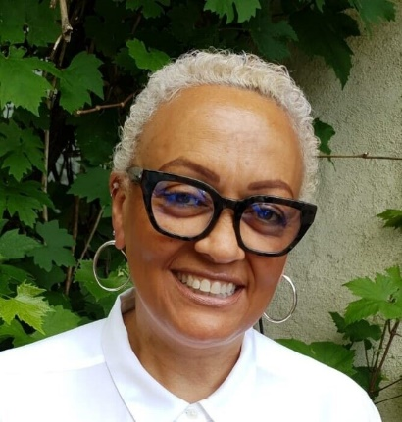Lurraine has over two decades of extensive experience working both as an academic and in management roles at the University of East London and since 2021, as Director of EDI here at the Open University. Such experience has engendered a sound understanding and performance of various pedagogical and strategic approaches to inclusive learning, teaching, recruitment and staff and student experiences. Lurraine brings an intersectional and critical perspective to her research scholarship, inclusion strategies and anti-discriminatory and anti-racism perspectives and leadership.