The Open University’s Access, Participation and Success seminar ‘Words Matter’

Presenter abstracts and bios

Chair: Prof John Butcher
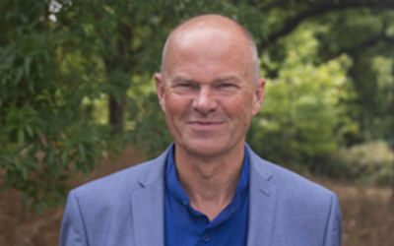
John Butcher is Professor of Inclusive Teaching in Higher Education. As Director, Access, Open and Cross-curricular Innovation at the OU, he is responsible for the development, enhancement and implementation of the institution's pan-University teaching curriculum.
John has published Developing Effective 16-19 Teaching Skills and co-edited Leading Professional Development in Education (both Routledge) and many journal articles, including those in: Widening Participation and Lifelong Learning, Journal of Further and Higher Education, International Journal of Academic Development, Innovations in Education and Teaching International, The Curriculum Journal; Journal of Education for Teaching; Teacher Development; Research Papers in Education; Open Learning; Mentoring and Tutoring. He is Managing Editor for the international journal Widening Participation and Lifelong Learning.

John is an active researcher and has successfully supervised 14 doctorates to successful completion.

Presenters

University of Warwick
Title of presentation: Doing anti-racism without doing race!

Abstract: Gurnam will be talking to his recent article which is available from the link above.

Dr Gurnam Singh
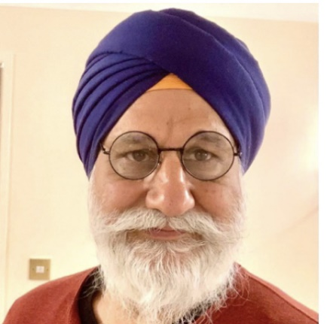
Dr Gurnam Singh is an activist researcher, writer, and educator whose work is dedicated to highlighting and disrupting systems and mechanisms of power, privilege and violence that lead to human suffering and inequity. Currently, he is Hon Associate Professor of Sociology University of Warwick and Visiting Fellow in Race and Education, UAL, London. Formerly, he was Associate Professor of Education at Coventry University. In 2005 was completed a PhD at the University of Warwick focussing on anti-racist social work. In 2009 he was awarded a National Teaching Fellowship (NTF) for his work on critical pedagogy and higher education, and in 2018 was accepted as a Fellow of the Royal Society of the Arts (FRSA). He has published 4 books, over 40 peer review papers/chapters/review articles and 200 keynote conference papers on a widely range of issues, including, race, racism, anti-racism, diversity, decolonisation, ethics, higher education and social work. Currently his work is focussed on all aspects of higher education and decolonisation with a particular focus on the rise of generative AI.
Recent relevant academic outputs during the past year:
- Singh, G (2023) Decolonising bibliographies, referencing and citational practices – Keynote at the CALC (Critical Approaches to Libraries Conference 24/25 May 2023. Available at: https://www.youtube.com/watch?v=MPfrbE484I0
- Singh, G (2023) The age of artificial intelligence (AI) – lessons from history, presentation at the ‘Artificial Intelligence (AI), Race and Racism and Critical Pedagogies’ webinar, University of Warwick 1st June 2023. Available at: https://warwick.ac.uk/fac/cross_fac/academy/activities/seminar/ai-and-race-webinar
- Singh, G (2023) Has decolonisation of higher education reached a dead end? Lecture Series on Decolonising Academic Practice, 2023 Birmingham City University, 2nd May 2023. Online presentation https://www.youtube.com/watch?v=mFl-cD7v7WU&t=22s
- Singh. G (2023) Decolonisation and Identity Politics. Post 16 Educator. 112 July -Sept 2023. Pp12-15. Available at: http://post16educator.org.uk/resources/archive/112/PSE-112-Singh-only.pdf
- Singh, G. (2023) Decolonisation, whiteness, and anti-racist social work. In The Routledge Handbook of International Critical Social Work (pp. 343-357). Routledge.

University of Manchester

Title of presentation: Coded, Loaded and Outmoded
Final abstract: The notion of 'at risk' or disadvantaged students problematises the student and stems from a deficit mindset. Rather than focussing on language that centres around disadvantage, could we seek instead to engage with an asset-based approach, speaking to the 'enabling' of students' potential and replacing the term ' disadvantaged' with less coded, less paternalistic terms which students suggest are stigmatising and embed 'stereotype threat.' As one student remarked to me, "no-one wants to see themselves as disadvantaged."
If we wish to enable students can we start with language?

Sheree Palmer (SFHEA)
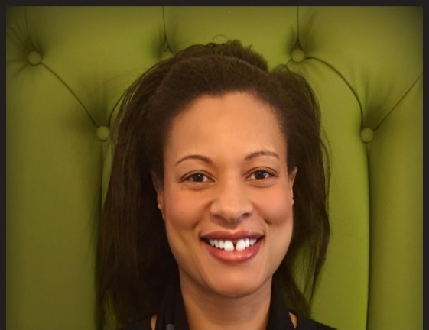
Sheree is Head of Access and Student Success for the University of Manchester and a Senior Fellow of the Higher Education Academy. Sheree is also a panellist for the Advance HE Race Equality Charter and her work is founded on equity, diversity and inclusion. She is passionate about transforming culture and enhancing practice to create inclusive spaces and to enable success for all individuals to maximise their potential.
She is a leader of high performing teams in both secondary and Higher Education. Following a successful career in secondary education, she transitioned into leadership roles in Higher Education and she led the strategy at the University of Kent Law School that closed the Black White Awarding Gap (reducing the gap from - 38% to +1%).
Sheree has a PGCE from the University of Oxford, a Masters in International Law (LLM) and is currently training as an Executive Coach with the Institute of Leadership and Management. She leads teams to innovate, test and apply best practice to achieve strategic goals.
Sheree is sought after as an inspirational speaker, consultant and executive coach for HEIs and at national conferences, including UniversitiesUK and the Open University International Biennial. In 2022, Sheree was retained as a consultant on an Office for Students and UK Research England-funded project for Student Success. Sheree consults on issues related to improving performance, educational pedagogy, closing awarding gaps and progression for underrepresented groups.
As a founding and core member of the Decolonise UoK team in 2019/20 and working alongside students as co-creators, Sheree drove institutional and cultural change, including the movement to diversify the curriculum at the University of Kent. Sheree is leading teams at the University of Manchester, to implement strategic evidence-based interventions to increase access, success on course and progression to ensure students’ potential is enabled, so they may thrive.

George Obolo – medical student and co-founder of the Black Excellence network and TedX talk presenter, University of Manchester
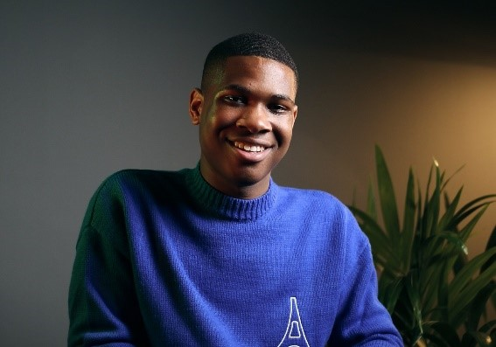
George Obolo is a multi-award-winning social entrepreneur, leader, creative, public speaker and polymath. He is a 21-year-old medical student at The University of Manchester and the Co-Founder of The Black Excellence Network, a non-profit organisation which helps to tackle the racial disparities between black students and other ethnicities within the UK, especially in their progression to higher education.
Within a year, The Black Excellence Network has built a large community of over 6,400 students across their social media, newsletters, and website, providing key career and higher education information to thousands of young black people across the UK.
Department for Education, UCAS, McKinsey & Co and MediaCom are just some of the companies George has advised on a wide range of topics.
He has been recognised by Powerlist as one of the UK’s Top 5 Future Leaders and has been presented multiple awards by the University of Manchester, most recently the New Social Enterprise award at the Venture Further Awards and the Social Responsibility award for Equality, Diversity and Inclusion at the Making a Difference Awards 2022.
Check out his website for more: https://georgeobolo.com

NERUPI
Title of Presentation: That’s Not What That Word Means…

Abstract: Woke. Intersectionality. Critical Race Theory. Equity. Decolonisation. Institutional Racism.
These words and theories were created to call attention to and explore inequalities in our society.
Every day, we watch as these words are weaponised and misappropriated, diluting their original intent and causing confusion and misunderstandings that stand in the way of productive discussion and positive change.
Following discussions in the NERUPI Student and Staff Race and Ethnicity Equity working group, the authors developed a glossary to provide precise definitions of terms that are frequently used in race and equality discourse.
The process of producing the glossary will be outlined, as well as a presentation of the Glossary itself which is designed for individuals to use in their workplaces and in everyday life.
We see the creation of this glossary as a small step towards better communication, and equity in the future.

Fatmata Daramy
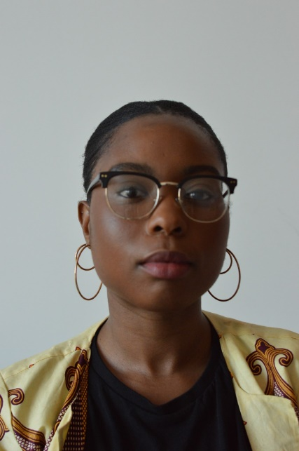
Fatmata Daramy is a co-lead of the Student and Staff Race and Ethnic Equity working group (SsREE), and a part-time research assistant for NERUPI (Network for Evaluating and Researching University Participation Interventions). She has previously worked in various roles related to widening participation for Aimhigher Plus at Aston University, at the Coventry University Group as a Widening Participation Specialist, and at The University of Law as a Widening Participation and Student Success Manager.
In previous roles, she developed her skills by designing and implementing research into the experience of Black, Asian, and Minority Ethnic students. Additionally, she has designed and delivered training for academic staff pertaining to inclusive and anti-racist curriculum design, sense of belonging, and imposter phenomenon. Fatmata is now a PhD researcher at The University of Leicester, researching mental wellbeing for domicile students of colour in Higher Education and the role of Student Wellbeing Services.

Dr Constantino Dumangane, Jr, Senior Lecturer (Assistant Professor), Education Department, University of York.
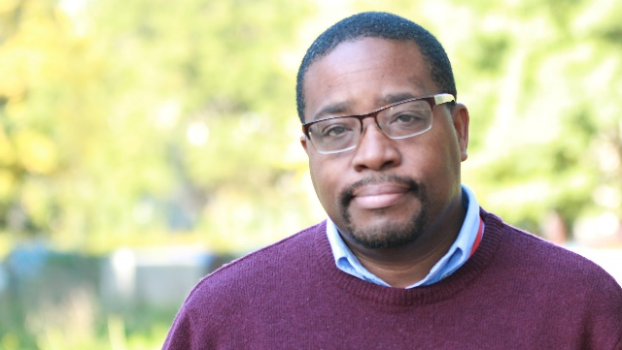
Constantino is a senior lecturer in Education at the University of York where he serves as Programme Leader for the MA in Social Justice in Education. Within the centre for Research, education and Social Justice, Constantino’s research employs Critical Race Theory and Bourdieusian concepts as he has an ongoing interest in developing transparent and comprehensive understandings of how the intersectionality (Crenshaw) of race, class, gender and faith impact Black and Minority Ethnic young people’s education trajectories. Constantino co-manages his Department’s student-staff group, ‘Decolonising Education Collective’ that works to decolonise curricula while actively improving inclusivity and recognition of ‘others’ contributions to education. He is a member of his Department’s EDI group and the University’s Staff Race Equality Forum Operations Team. Externally, Constantino is an Advisory Group member for NERUPI and for the ESRC’s EDI Board for the Wales Doctoral Training Partnership, wherein he works to promote widening participation in Higher Education.

The Open University
Title of presentation: Dismantling the discourse of degree awarding gaps
Abstract: 'We need language to tell us who we are, how we feel, what we're capable of- to explain the pains and glory of our existence'. Maya Angelou
The words we use can be powerful, demonstrate who has power and inform our epistemological view, personal history and life story. Despite language and terminology ever evolving it continues to uphold the colonial legacies of systemic and structural racism. It is these barriers which contribute most significantly to the degree awarding gaps for students who are racially minoritized. Deficit model, attainment gaps, acronyms, and many more terms are unpacked during this session to better understand how words contribute to inequitable outcomes for students and serve as a reminder of the subordination of people under imperialist rule.

Rehana Awan, Lecturer, The Open University
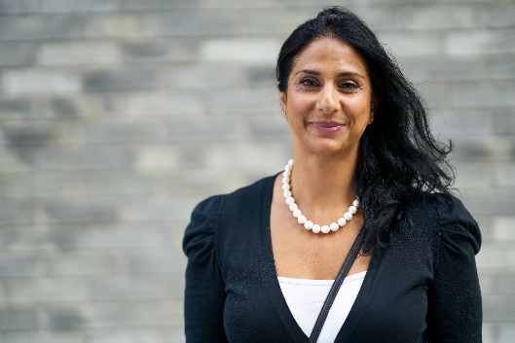
Rehana is a Lecturer in Equality, Diversity and Inclusion (EDI) Implementation in the School of Computing and Communications at the Open University with a passion for creating equitable outcomes for students and staff. With a degree in Social Sciences and Masters in Online and Distance Education (Open), Rehana has always been driven by a curiosity to explore access, participation and equity in education. As a doctoral researcher she is gathering the stories of Black and Brown students and degree awarding gaps. Over the years, she has honed her skills and knowledge and leads others to establish parity in student success and staff experiences. She has contributed significantly to the OU’s Black and Minority Ethnic Staff Network as co-chair. She is also an Associate Lecturer on an introductory Social Science module. Outside of work and study she enjoys dog walks, weekends away and independently raising two teenage girls. Rehana is excited to engage with fellow conference attendees, exchange ideas, and explore why Words Matter.

University of Greenwich

Title of presentation: The Importance of Disability Inclusive Language
Abstract: I will be discussing the important of language regarding disability in higher education. In this context, disability includes physical disabilities; neurodivergence (autism and dyslexia spectra); long term health conditions; and mental health conditions. As disability is considered an imperative for widening access/participation professionals, we all need to understand the importance of terminology and language, including the different terminology used within schools, colleges and universities. We also need ensure that ourselves and our higher education providers welcome disabled students rather than alienate this cohort due to inappropriate terminology. I will briefly discuss the prominent models of disability and introduce colleagues to the STAART Principles of Disability (SPoD) which will provide a useful synopsis of appropriate and inclusive language.

Dr Melanie Thorley, STAART Manager, Student Wellbeing Services, University of Greenwich
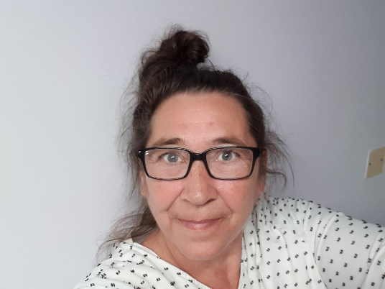
Melanie has worked within the disability sector of further and higher education since 1998. She regards herself as fortunate to have been taught by Professor Mike Oliver during her sociology undergraduate degree. Melanie also holds a MA in SEND, a MSc in Education Research Methods and a doctorate in supporting D/deaf university students. Melanie was appointed to manage the STAART (formerly *AccessAbility) initiative in 2007 providing information, advice and guidance for prospective and current disabled university students. Melanie has disseminated STAART at numerous conferences across the UK, and has also provided staff training in Egypt and Trinidad.
On a personal level, Melanie has lived with clinical depression and fibromyalgia for all of her adult life and therefore has a lived experience of disability. Melanie loves Flat Eric, Dr. Martens, her husband and cats, travelling and wildlife – not necessarily in that order.

Panel Members

Farnaz Rais – Stakeholder Engagement and Delivery Lead – APS within the PVC-S unit, The Open University.
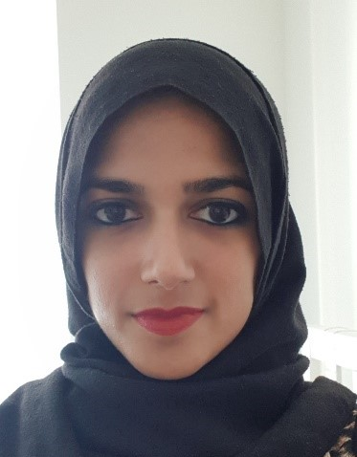
Farnaz Rais is a Stakeholder Engagement and Delivery Lead in the Access, Participation and Success Team. Her work focuses on reducing inequitable education across the OU, predominantly through the implementation of the Access and Participation Plan. She liaises with colleagues to shape strategy and oversee initiatives aimed at reducing inequity. Farnaz has a passion for reducing barriers to education and as a person who has lived experience of discrimination and prejudice, she feels a responsibility to amplify the voices of those that have been marginalised. In her writing and teaching of English Language and Literature, Farnaz recognises the poignancy of words and the power they can wield.

Dr Frankie Morgan – Aspire to HE Progression Officer, University of Wolverhampton
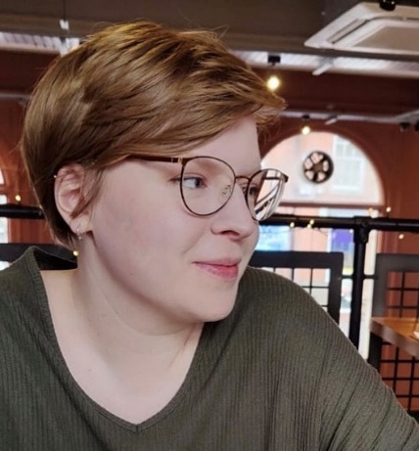
Dr Frankie Morgan is a Progression Officer at the UniConnect partnership, Aspire to HE, at the University of Wolverhampton, supporting pupils across the Black Country and Telford and Wrekin to make informed decisions about their future and achieve their full potential through Higher Education. She has also worked as PhD Tutor for The Brilliant Club, delivering research-driven content and university-style sessions in non-selective state schools to give pupils from underrepresented backgrounds the skills, knowledge and confidence needed to progress to highly selective universities. As a young person, Frankie benefited from a number of widening access initiatives and so has personal experience of why “words matter” in this area. Frankie also has a PhD in Gender Studies and has researched and spoken extensively about contemporary feminist activism, social media and teaching feminism and sensitive topics within secondary schools.

Rehana Awan – Lecturer, The Open University
Rehana is a Lecturer in Equality, Diversity and Inclusion (EDI) Implementation in the School of Computing and Communications at the Open University with a passion for creating equitable outcomes for students and staff. With a degree in Social Sciences and Masters in Online and Distance Education (Open), Rehana has always been driven by a curiosity to explore access, participation and equity in education. As a doctoral researcher she is gathering the stories of Black and Brown students and degree awarding gaps. Over the years, she has honed her skills and knowledge and leads others to establish parity in student success and staff experiences. She has contributed significantly to the OU’s Black and Minority Ethnic Staff Network as co-chair. She is also an Associate Lecturer on an introductory Social Science module. Outside of work and study she enjoys dog walks, weekends away and independently raising two teenage girls. Rehana is excited to engage with fellow conference attendees, exchange ideas, and explore why Words Matter.

Rachael O’Connor – Associate Professor in Legal Education and Academic Lead for Personal Tutoring, University of Leeds
Rachael (she/her) is Associate Professor in Legal Education, University Academic Lead for Personal Tutoring and LITE Fellow at the University of Leeds. Rachael is a CrossFit addict, community musical theatre performer and dedicated vegan. She comes from a working-class background and was first generation in her family to go to University. This contributes towards Rachael’s passion for improving University experiences for under-represented students and amplifying stories of under-representation. Rachael’s scholarship focuses on developing authentic staff/student relationships through reverse mentoring. She has won prizes internally and externally and published many papers on reverse mentoring. Rachael is a Senior Fellow of the Higher Education Academy and Michael Beverley Innovation Fellow. Her current work explores the intersections between reverse mentoring and academic personal tutoring. Rachael is trustee of mental health charity LawCare and is currently piloting an inclusion and wellbeing focused reverse mentoring scheme in the legal profession in partnership with LawCare.

Anna Tudela-Isanta – Lecturer, The Open University
Anna Tudela-Isanta is a lecturer in the School of Languages and Applied Linguistics at the Open University. She holds a PhD in Linguistic Communication and Multilingual Mediation from Universitat Pompeu Fabra. Her research interests include sociolinguistics, multilingualism, and Catalan and Spanish as foreign languages. She is a member of the multidisciplinary research center MIRCo (Multilingualism, Speech and Communication), EDiSo (Association of Studies on Speech and Society) and SERCLE (Societat d’Ensenyament i Recerca del Català com a Llengua Estrangera). She has participated in national and international publications and conferences.

